HOW TO INVEST IN ANGOLA - NATIONAL PRIVATE INVESTMENT AGENCY – ANIP
AGRICULTURE AND LIVESTOCK SECTORS
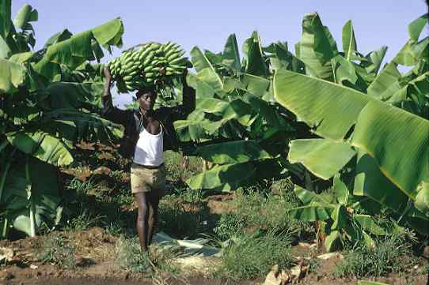
OVERVIEW
The FAO estimates over three million hectares of arable land exist. There are also large areas for pasture, especially in the southern part of the country.
Traditional sustainable crops - cassava, beans, and sweet potatoes are found in the country’s north, with corn in the central provinces, and small corn and sorghum in the southern areas. We would also mention other crops such as banana, rice, sugar cane, palm oil, cotton, coffee, sisal (hemp), tobacco, sunflower, citrines, and other fruits and vegetables.
Coffee, which up to 1973 was Angola’s major export, is well worth looking at, as it could once again become a very important factor in the Angolan economy.
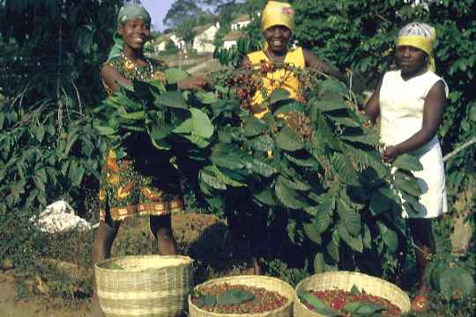
With the idea of launching an agri-business policy, as part of the government’s social and economic program for 2000, it was decided that the main effort should focus on those zones defined in the agricultural program, and on the production of the following basic staples: cereals, roots and tubercles, beans, fruits, vegetables, oil seeds, and specialty products such as green products, small ruminants, cattle breeding and meat processing, pig farming and the rearing of poultry and other birds.

Areas of interest in existence for private investment:
• Waterworks Maintenance & Management;
• Consultant Engineering ;
• All kinds of Production /Marketing Technical & Material Assistance;
• Agricultural Mechanization & Technical Assistance;
• Industrial Poultry Breeding;
• Cattle & Pig Breeding;

MAIN IRRIGATED AREAS

Provinces | Zones | Area (ha) | Crops
BENGO | Bom Jesus  Caxito | 1,300  3,000 | Roots and tubercles, cereals, horti-fruiters  Roots and tubercles, cereals, horti-fruiters
CABINDA | Vale do Yabi  (Yabi Valley) | 5,000 | Roots and tubercles, fruiters, cattle breeding
KWANZA  NORTH | Mucuso  Lucala | 315  250 | Roots and tubercles, cereals, horticultural crops  Roots and tubercles, cereals, horti-fruiters
LUANDA | Vale do Bengo  Kiminha/Funda | 25,000 | Roots and tubercles, cereals, horti-fruiters
BENGUELA | Cavaco  Catumbela | 4,1  4,5 | Roots and tubercles, cereals, horti-fruiters and tobacco  Roots and tubercles, cereals, horti-fruiters
HUÍLA | Humpata  Matala  Chibia | 1,000  3,000  1,000 | Roots and tubercles, cereals, horti-fruiters  Roots and tubercles, cereals, horticultural crops, fruiters, cattle breeding  Roots and tubercles, cereals, horti-fruiters
NAMIBE | Carunjamba, Giraul, Bero and Curoca | 600 | Grapes (wine) and citrines Tubercles, cereals, horticultural crops, industrial crops, cattle breeding
CUNENE | Manquete  Xangongo  Quiteve/Humbe  (Ombandja)  Cova do Leão  (Kahama) |  | Tubercles, cereals, horticultural crops, cattle breeding, olives

