HOW TO INVEST IN ANGOLA - NATIONAL PRIVATE INVESTMENT AGENCY – ANIP
FISHING SECTOR
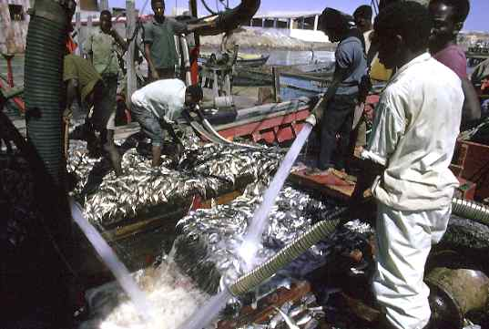
OVERVIEW
Angola boasts one of Africa’s richest coastlines, especially in the country’s south. There the cold Benguela current creates a special environment for a great variety of fish, principally mackerel, sardines, tuna, and shellfish.
The government’s immediate objectives are to reactivate productive fishing processes, increase fish-conservation activities, and renew catch capacities, as well as increase and rationalize existing cold-storage capabilities. It also plans to revamp and equip naval shipyards, dock areas and fishing ports, while improving the commercial distribution of fish on a national level. Providing technical assistance to entrepreneurs, management training, and scientific investigation is also slated.
Previously state-owned, various small fishing enterprises have already been divested to the private sector as part of a privatization program. Currently, preparation for the privatization of larger enterprises is underway.
