NATIONAL PRIVATE INVESTMENT AGENCY - ANIP

THE ONE STOP GOVERNMENT ENTITY FOR
FOREIGN INVESTMENT ISSUES

HOW TO INVEST IN ANGOLA

Organized by: Maria Luisa Abrantes
Angola Trade Representative – ANIP/USA
1925 K Street, N.W, Suite 225, Washington D.C.
United States of America
Phone: 1(202) 331 - 7604 Fax: 1(202) 331 - 7605
E-mail: milinvest@starpower.net
Website: www.anip-angola-us.org
Date: March 2006
Produced by: Zongue Production

HOW TO INVEST IN ANGOLA - NATIONAL PRIVATE INVESTMENT AGENCY – ANIP

WHO WE ARE


ENGº CARLOS FERNANDES
President of the ANIP

One of the prime tasks of the NATIONAL PRIVATE INVESTMENT AGENCY ( ANIP - Agência Nacional de Investimento Privado ) is the active promotion and selective targeting of foreign investment that might facilitate the reconstruction and economic and social development of Angola.
The accomplishment of these tasks involves the existence of internal and external conditions, which allow the dissemination of information about the legal conditions for foreign investment, available business opportunities, the range of investment operations, and general economic intelligence. In brief: a whole set of useful information to help one to decide about investing in Angola.
In the past, marketing activities promoting foreign investment did not reach a satisfactory level for the Angola authorities. But in the present situation, with peace, it becomes urgent to change Angola's image to attract international attention for foreign investment, which is essential for the reconstruction and development of the country.

By Carlos Fernandes

HOW TO INVEST IN ANGOLA - NATIONAL PRIVATE INVESTMENT AGENCY – ANIP
ANIP MISSION AND MAIN ACTIVITIES

• Promote the Government’s policy of foreign investment, agreements for technology imports, and to perform any activities that are assigned of them by the Government in this matter;

• Coordinate, guide and supervise foreign investment in Angola;

• Support the execution of contracts or agreements of technology imports;

• Promote the participation of the country in International Organizations at meetings about foreign investment and technology transfer issues;

• Undertake, either in Angola or abroad, promotional actions to attract foreign investments that are most beneficial to the country’s economy;

• Analyze foreign investment proposals and/or technology import agreements, and to grant the necessary legal authorizations;

• Intervene in evaluating, negotiating and following up phase of foreign investment agreements;

• Advise and guide investors in the installation phase, particularly when in contact with other local entities;

• Keep a register of national companies with foreign capital, foreign investment operations, and of other capital operations of foreigners in national companies.

HOW TO INVEST IN ANGOLA - NATIONAL PRIVATE INVESTMENT AGENCY – ANIP

I . ANGOLA

GENERAL DATA:

GEOGRAPHICAL DATA LOCATION: Western Coast of Southern Africa

AREA: 1,246,700 m²; 1,650 km maritime frontier; 4,837 km land frontier

FRONTIER: by land 4.837 km; Congo, Zaire, Zambia and Namibia; by sea 1.650 km Atlantic Ocean

CLIMATE: Tropical

AVERAGE TEMPERATURE OF THE AIR: 30ºC (max), 17ºC (min)

INHABITANTS: 13 500 000 inhabitants

CAPITAL: Luanda (more than 4 000 000 inhabitants)

ADMINISTRATIVE DIVISION: 18 Provinces

MAIN CITIES: Luanda, Benguela, Lobito, Lubango, Namibe and Cabinda

MAIN HARBOURS: Luanda, Lobito and Namibe

MAIN AIRPORT: the 4 de Fevereiro in Luanda

MAIN RIVERS: Kwanza, Cunene and Cubango

HIGHEST POINT: Moco Hill (2.620m) in Huambo

MAIN BEACHES: Ilha do Cabo, Palmeirinhas and Mussulo (Luanda); Baía Azul, Caota and Caotinha (Benguela); Restinga (Lobito); Miragens, Azul (Namibe)

LANGUAGE: Portuguese - official; Plus various local dialects: The main are Umbundu, Kimbundu, Kikongo, Fiote, Chokwé, etc
MAIN RELIGIONS: Catholic and Protestant

CURRENCY: Kwanza (Kz)

PRESIDENT: José Eduardo dos Santos

GOVERNMENT: Democracy led by MPLA

HOW TO INVEST IN ANGOLA - NATIONAL PRIVATE INVESTMENT AGENCY – ANIP
II. GENERAL OBJECTIVES OF THE ECONOMIC POLICY:

• Achieve and consolidate political stability;

• Maintain and consolidate the current macro-economic stability;

• Improve productive and social infrastructures;

• Revive the production of national goods and services;

• Reform the administration of the State in the whole national territory;

• Improve the social services (Education and Health);

OBJECTIVES OF THE MACRO-ECONOMIC POLICY FOR 2006:

Premises of the Economic Policy:

• Oil production: 597,1 million barrels per year

• Oil price: (USD/bbl) 45,0

Goals of the situation:

• General rate of growth of GDP: 27,9%

• Non-petroleum GVA growth rate: 11,9%

• Petroleum GVA growth rate: 37,2%

• Annual inflation rate: 10%

Fiscal (Percentage of GDP):

• Revenue: 41,8%

• Expenditure: 48,3%

• Public deficit: 6%
HOW TO INVEST IN ANGOLA - NATIONAL PRIVATE INVESTMENT AGENCY – ANIP
III. HOW TO INVEST

To invest in Angola, under the Law 11/03 – Basic Law for private investment, investors must:
• Submit a proposal to the Agência Nacional para o Investimento Privado (National Agency for Private Investment - ANIP), together with the documentation necessary to identify and characterize the investor's legal standing and the planned investment. For investments of up to USD 5 million, such proposals can be submitted by filling out a “Declaração Prévia” (“Prior Declaration”) form available at ANIP.
• Submit a Certificate of Admissibility for firms planning to set up a company in Angola;
• Submit a social commitment for the future company, and, when appropriate, attach a power of attorney when acting through a legal representative;
• Submit a Criminal Record Certificate (for individual investors);
• Submit a list of the equipment and facilities to be incorporated into the project, when appropriate;
• Attach By-Laws and Corporate Minutes to the process if the investor plans to become a partner in an existing company.
• Access to tax incentives is guaranteed for investments of at least 50,000 dollars domiciled in Angola, and at least 100,000 dollars domiciled in other countries, regardless of the investor's nationality.

* Once the investment has been approved, ANIP will issue a Certificate of Registration for Private Investment (CRIP), a copy of which will be sent to the National Bank of Angola (BNA) for the effects of authorizing the entry of foreign capital through a loan institution authorized to operate in the exchange business.
Angola's policy on private investments includes guaranteed incentives and other facilities, equal treatment for foreigners and Angolan nationals, and safeguards and protection of investments, as well as respect for and full compliance with international accords and treaties. Investors are free to choose which zone or area to invest in, except for those areas reserved for the State by law.

HOW TO INVEST IN ANGOLA - NATIONAL PRIVATE INVESTMENT AGENCY – ANIP
IV. PROTECTION FOR BUSINESSES
1. The Government of Angola guarantees that all private investors have access to Angolan courts of law to defend their rights, and they are also guaranteed the right to due legal process.
2. In the case of expropriation of assets that are the object of private investment, due to force major and with full legal justification, the Government guarantees that payment of fair compensation will be made promptly and effectively, the amount of which will be determined in accordance with the applicable rules and regulations.
3. The assets of private investors cannot be nationalized.
4. If there is any change in the nation's political or economic regime that results in exceptional nationalization measures, the Government guarantees that investors will receive fair and prompt monetary compensation.
5. The government guarantees that corporations and business entities established for the purposes of making private investments will enjoy full protection and respect for their professional, banking and business privacy and confidentiality.
6. The rights granted to private investors under the terms of this law are guaranteed without prejudice to any other rights resulting from accords and conventions to which the Government of Angola is a full party.

HOW TO INVEST IN ANGOLA - NATIONAL PRIVATE INVESTMENT AGENCY – ANIP
V. INVESTMENT AREAS RESERVED EXCLUSIVELY BY THE ANGOLAN GOVERNMENT:
• Production, distribution and sale of materials of war;
• Central Bank and matters related to the national currency;
• Ownership of seaports and airports;
• Basic infrastructure for the national telecommunications network.

VI. SECTORS IN WHICH THE GOVERNMENT MUST BE A MAJORITY OR SENIOR PARTNER:
• Local infrastructure, when part of the basic telecommunications system;
• Postal Service.

HOW TO INVEST IN ANGOLA - NATIONAL PRIVATE INVESTMENT AGENCY – ANIP
VII. MOST IMPORTANT BENEFITS, IN THE BASIC LAW FOR PRIVATE INVESTMENT – LAW 11/03 OF 13th JULY 2003
TAX ON CAPITAL INVESTMENTS
Investors may be exempted from taxes on capital investments for a 5-year period if they invest in zone A, 10 years for zone B, and 15 years for zone C. When acquiring land and real estate for the purposes of their projects, investors are also exempted from tax on the transfer real-estate (SISA).
OTHER INVESTMENTS
Customs taxes and other duties can be reduced by half for equipment imported for construction, spare parts, vehicles weighting up to 3.5 metric tons and raw materials for investments ranging from 50,000 to 250,000 dollars. The tax reduction can be up to 75 percent for imports of used equipment.
This class of investments includes priority sectors or zone C, projects that guarantee more than 10 job positions for Angolan nationals and new enterprises that will positively impact the region, including construction and or rehabilitation of economic or social infrastructure facilities.
When made in zone C, investments in new ventures as well as the rehabilitation of destroyed or stalled ventures will be exempted from the industrial tax for 10 years. This 10-year tax exemption will also be granted to investments in the food industry, farming, livestock husbandry and investments that create 50 or more job positions for Angolan nationals.

TRANSFER OF PROFITS
Under the terms and conditions established by the Currency Exchange Law, investors can transfer distributed dividends and profits abroad after deducting legal amortizations and taxes due on them, in accordance with their respective shares in the equity of the corporation or business entity.
They can also transfer the results of the liquidation of their investments (after paying any taxes owed), the results of compensations, royalties or other revenue obtained from indirect investments associated with technology transfer. Investors may also transfer any amounts owed them as stipulated in private investment agreements, following the deduction of any taxes due on them.
Investments in diamonds, petroleum and Financial Institutions are covered by specific legislation.

HOW TO INVEST IN ANGOLA - NATIONAL PRIVATE INVESTMENT AGENCY – ANIP
VIII. TAX INCENTIVES^{(*)}
IMPRTS OF TAX-EXEMPT MACHINERY AND EQUIPMENT:
• A Certificate of Registration for Private Investment (CRIP) must be submitted, together with the authorization for customs tax incentives, a copy of which is sent to the Customs Authority by ANIP, in conjunction with a list of the equipment to be incorporated into the project.
• The entry of machinery, equipment, accessories and other materials is documented on the basis of its CIF (cost, insurance and freight) value in foreign currency, and its equivalent value in Angolan currency, at the exchange rate of the date of arrival in Angola.
• Proof of the prices declared for machinery and equipment must be provided in the form of authorized documentation approved by the pre-shipment inspection agency.
• There is a 50% reduction for used machinery, equipment and accessories, instead of a customs tax exemption. There is a 100% exemption for new and unused goods.

OTHER ADVANTAGES OF INVESTING IN ANGOLA:
• Exemption for up to six years from payment of customs tariffs and other taxes on goods and equipment, including heavy and technological vehicles, from the date of arrival until the beginning of operations for investments. Investors are only required to pay the tax stamp and service charges.
• Five-year exemptions from payments of customs tariffs for merchandise incorporated into or directly consumed in the act of producing other products, including during the test stage. This does not include equipment, accessories, surplus parts and raw materials produced in Angola. For these goods, investors are only required to pay the tax stamp and service charges;

_____________________________________________________
(*) LAW 17/03 OF 25TH OF JULY – LAW ON INCENTIVE TAXES AND CUSTOMS
HOW TO INVEST IN ANGOLA - NATIONAL PRIVATE INVESTMENT AGENCY – ANIP
• Up to 15 years' exemption from industrial tax(**) for profits on investments, as well as the industrial tax on the price of the venture and subcontractors employed to carry out the investor's business activities;
• Expenses incurred to build roads, railroads, install telecommunications facilities, water supply systems and social infrastructure facilities for workers, their families and communities, as well as expenses for professional training and investments in the arts and culture, in addition to the purchase of works of art from Angolan artists, will be considered tax-deductible expenses.

__________________________________________________________________
(**) THE SYSTEM OF TAX INDUSTRIAL IMMUNITY RATE IS OF 35%

HOW TO INVEST IN ANGOLA - NATIONAL PRIVATE INVESTMENT AGENCY – ANIP
IX. DUTIES
Under the terms of Decree no. 29/92 of July 3, and Executive Decree no. 23/93 of October 29, all foreign investors intending to carry out activities in Angola must register with the Ministry of Finance and obtain a tax identification number and card as of the date they begin operations.
Depending on the magnitude and kind of activity being undertaken in Angola, if foreign investors intend to establish a physical presence in the country, they can choose to register as a representative office or establish a corporation or business entity under Angolan law.

REPRESENTATIVE OFFICE:
• A representative office is established for the sole purpose of looking out for the interests of the foreign firm it represents, following up on and providing assistance to that firm's business operations in Angola;
• A representative office has no independent legal authority to do business in its own name;
• It may have a maximum of 6 employees on its staff.
Because this kind of organization is subject to a number of restrictions, it is not advisable for foreign investors wishing to engage in regular, long-term economic activities in Angola, or intending to make major investments.

BRANCH OFFICE:
• Branch offices are the most common form of representation for foreign firms in Angola, because they permits foreign investors to do business in Angola on the same terms and under the same conditions as firms legally established in Angola;
• A branch office lacks an independent legal identity, although it is considered a legal person and can go to court or be the target of legal action under given circumstances.

HOW TO INVEST IN ANGOLA - NATIONAL PRIVATE INVESTMENT AGENCY – ANIP
CORPORATE OR BUSINESS ENTITIES ESTABLISHED UNDER ANGOLAN LAW:
• A corporate or business entity is a legal person whose objective is to do business;
• In Angola, foreign investors may choose from among five types of corporate or business entities established by law:
Corporations:
- Limited partnerships
- Limited co-partnerships
- General partnerships
- Limited co-partnerships by shares
For further information, see - Law no. 1/04, DR no.13
• Provisionally, any of the corporate or business entities established under Angolan law require several partners, but individual investors can also operate as merchants in their own names under the terms of Angola's business law.

HOW TO INVEST IN ANGOLA - NATIONAL PRIVATE INVESTMENT AGENCY – ANIP

X. PRIORITY AREAS FOR FOREIGN INVESTMENT:

• Railroad ; road ; seaport and airport infrastructures

• Industry , notably the production of construction materials , manufacture of packages , equipment , tools and accessories ; recycling of iron and non-iron materials ; production of textiles ; clothing and footwear ; manufacture of wood and its by-products ; production of foodstuff ; information technologies and communications

• Transportation

• Agricultural and cattle breeding

• Telecommunications

• Energy and waters

• Fishing industry and by-products , including the construction of boats and fishing nets

HOW TO INVEST IN ANGOLA - NATIONAL PRIVATE INVESTMENT AGENCY – ANIP
BUSINESS OPPORTUNITIES

THE CONSTRUCTION AND INFRASTRUCTURE SECTORS
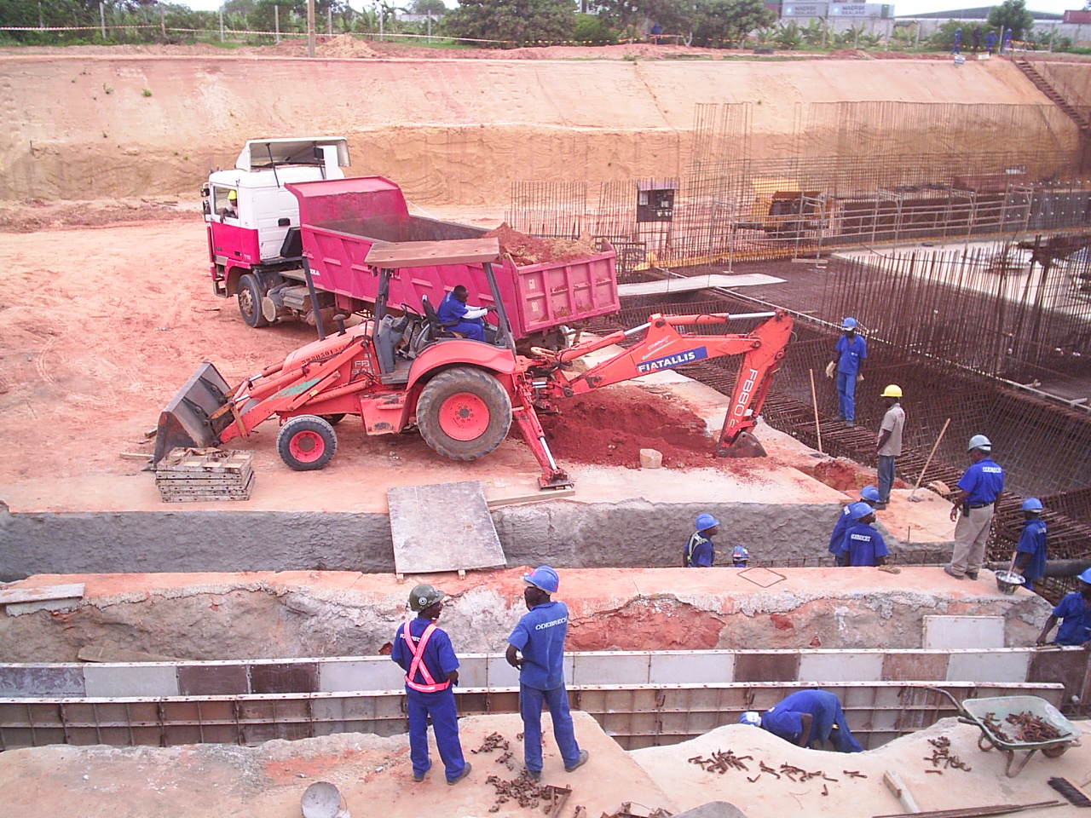
OVERVIEW
There is an urgent need for construction or rehabilitation of roads, houses, schools and industry.
Shortage of housing is a chronic problem that has led to widespread slum development particularly in and around the capital, Luanda, a city built to sustain a population of 700,000 and now home to around 4 million people.
MAIN PLAYERS:
• Portuguese companies are well established in Angola's construction sector, the major players are Soares da Costa, Teixeira Duarte, and Mota & Ca. These companies have the greatest share of the market construction contracts;
• The Brazilian Odebrecht group, already present in Angola in other areas for several years, has been positioning itself in the construction sector and is already winning contracts
• Dar Consultants (UK) Ltd, part of the Dar al-Handasah Group, and a member of the BCCB, is the government's favoured consultant on project construction and design.

HOW TO INVEST IN ANGOLA - NATIONAL PRIVATE INVESTMENT AGENCY – ANIP
CONSTRUCTION MATERIALS:
With very little in the way of domestic materials production, construction companies in Angola currently have to import most of their own materials and equipment

INFRASTRUCTURES:
• Almost the entire road network, both primary and secondary, is in poor or very poor condition;
• Port infrastructures are operating below capacity because of obsolete equipment and outdated working practices;
• Less than 5% of the railway system is currently operational;
• The main airports require considerable upgrading and/or repairs;
• The urban water supply and drainage systems currently reach only a small proportion of the population, and the existing systems are in poor condition;
• The rural environment lacks infrastructure to support production and transportation;
• The housing stock is highly degraded and falls well short of demand. The challenge is to address this, and to cope with a population growth of 7% per year;
• The construction and construction materials market is in its infancy and therefore undeveloped.
• There is insufficient monitoring and quality control. Materials and know how are in short supply.
HOUSING PROJECTS:
• Luanda Sul Self-financed Urban Infrastructure Programme
This is a major new housing project to provide houses for 5,000 families, with supporting infrastructure, at a new site 20 kms to the south of Luanda.
HOW TO INVEST IN ANGOLA - NATIONAL PRIVATE INVESTMENT AGENCY – ANIP
• Nova Vida
This US$100m project will provide 2,448 housing units (flats and houses) on a 26 square km site located 18 kms south of Luanda airport.
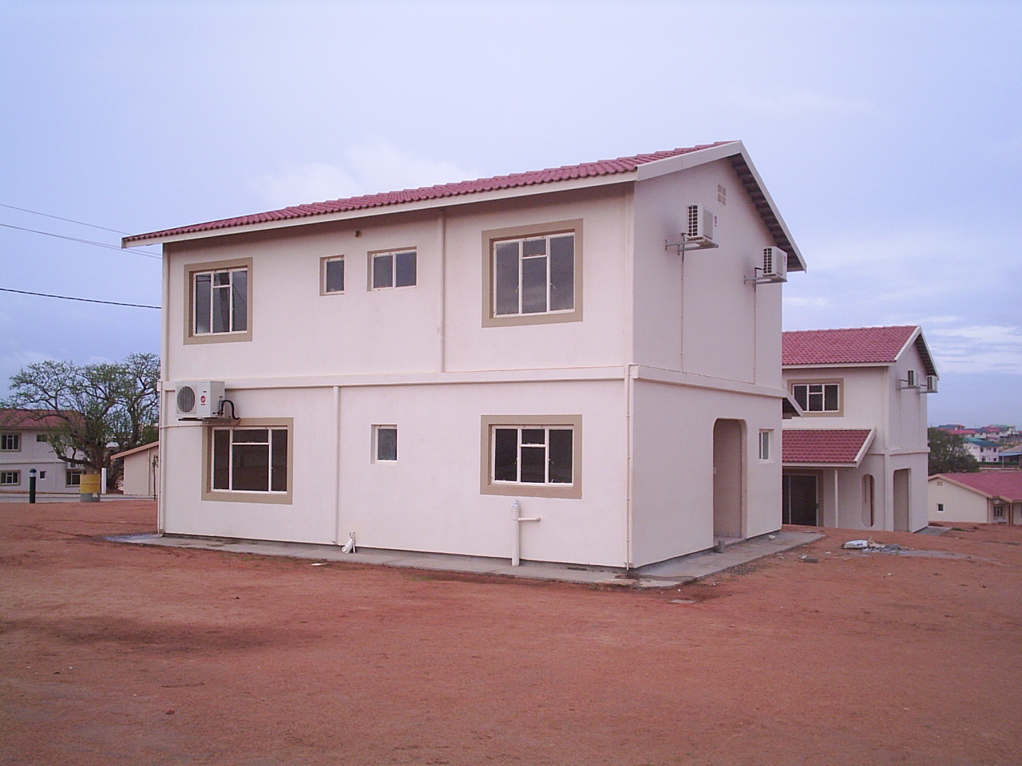

• Agostinho Neto University development
Work on stage one of the US$ 108.5m construction of the Luanda University campus. The campus is part of the state-run Agostinho Neto University, the country's only public higher education institution.
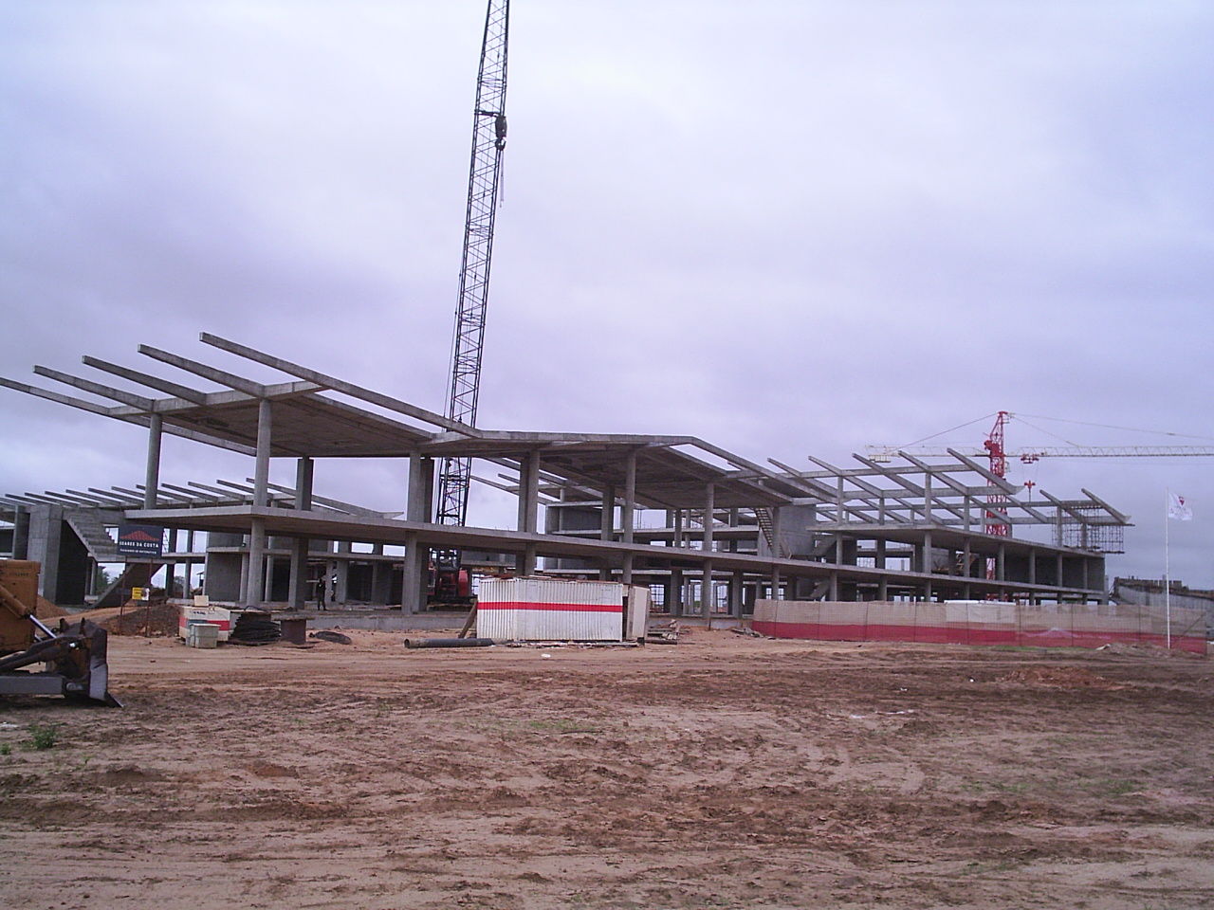
HOW TO INVEST IN ANGOLA - NATIONAL PRIVATE INVESTMENT AGENCY – ANIP
PROSPECTS:
• Estimates obtained from government sources indicate that the cost of implementing the strategic construction and public works programme is around US$9.9 billion over the ten year period 2000-2009, which implies an annual expenditure of US$990 million, equivalent to 11% of the country's GDP;
• Of the above US$9.9 billion, rehabilitation of the transportation infrastructure (roads, railways, bridges, airports) would consume more than half of the total at US$5.3 billion, with the remaining US$4.6 billion spent on social infrastructure projects such as schools, education, housing, urbanisation.

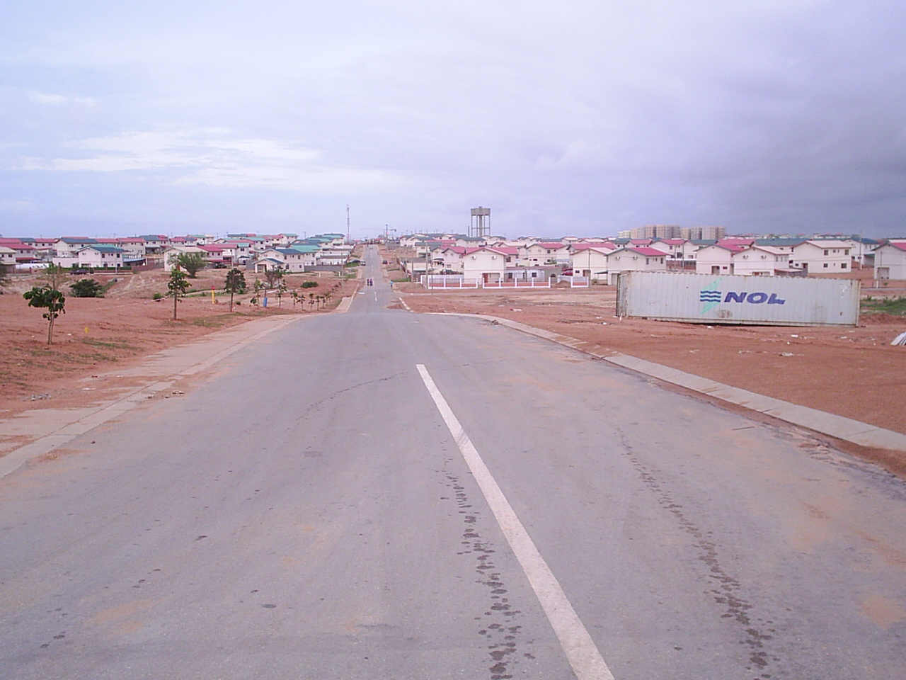

HOW TO INVEST IN ANGOLA - NATIONAL PRIVATE INVESTMENT AGENCY – ANIP
THE TRANSPORTATION SECTOR

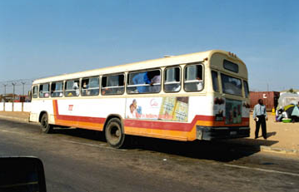
OVERVIEW
In every economy, the transportation infrastructure and transportation system itself, incorporating the road, rail, aviation and shipping components as a whole, constitute the core sector underpinning any development process.

CURRENT SITUATION:

• Destruction of a large part of infrastructure because of the war;
• Deterioration of infrastructure due to lack of maintenance;
• Technically out-of-date;
• Destruction and ageing of fleet;
• Weak maintenance structure;
• Low level of professional qualification.

STRATEGY:

• Construction of an integrated transportation network;
• Introduction of a role for privatization, so that resources managed by the State can be transferred to the private sector;
HOW TO INVEST IN ANGOLA - NATIONAL PRIVATE INVESTMENT AGENCY – ANIP

• Integration of Angolan transportation network into the SADC network;

• Creation of authorities on an institutional level for the planning of the road network;

• Creation of Public Institutes as regulatory bodies for different transportation subsectors .

POLICY:

• Be guided by the principle of “less State, a better State”;
• Open up corporate sector areas that, up until now, have remained the reserve of the State or of the state public sector;
• Lay groundwork for private capital to play a part in the sector.

OBJECTIVES:

• Guarantee the integrated functioning of all modes of transportation;
• Guarantee a suitable system of urban transportation in the principal cities, especially Luanda;
• Develop the 3 main corridors originating from ports by regenerating the CFL, CFB and CFM (rail companies);

• Revamp the shipping sector, bringing in private enterprise and an adequate administration to re-establish the competitiveness of national companies;
• Revamp and modernize ports : Luanda, Lobito, Namibe, Cabinda, Soyo and Porto Aboim;
• Modernize current air transportation system;
• Institutional reorganization and strengthening.

HOW TO INVEST IN ANGOLA - NATIONAL PRIVATE INVESTMENT AGENCY – ANIP
AREAS OF INVESTMENT – ROAD TRANSPORTATION:

• Liberalized activity
• Tax incentives exist for investments in:
o Urban public transportation (heavy);
o Inter-provincial and inter-municipal passenger transportation (heavy);
o Medium and long haul transportation of goods (intermediate and heavy);
• The implementation of incentives for investment in a personalized taxi system is being studied.

AREAS OF INVESTMENT – RAILWAYS:

• State ownership and operation, through the CFL, CFB and CFM (rail companies);
• Marked degradation of infrastructure and rolling stock;
• Constitute a priority for the Angolan Government;
• Area open to private investment in the concession process, arranging of funds, technical assistance and repairs, and supply of rolling stock, communications, etc.

• The government has approved a preliminary study, titled “ANGO FERRO”, to refurbish, upgrade, construct and extend the whole of Angola’s rail network, the implementation of which will be put in place in 4 phases:
I. Regeneration of current network;
II. Upgrading of network, bringing it into line with SADC and international standards;
III. Inter-connection of the different railways in Angola;
IV. Construction of new line, extension and link to neighboring States.

HOW TO INVEST IN ANGOLA - NATIONAL PRIVATE INVESTMENT AGENCY – ANIP

Angola: Current Railway Network

INCLUDEPICTURE "cid:007901c55a62$ad6c2dd0$6601a8c0@cp683548a" \* MERGEFORMATINET SHAPE \* MERGEFORMAT 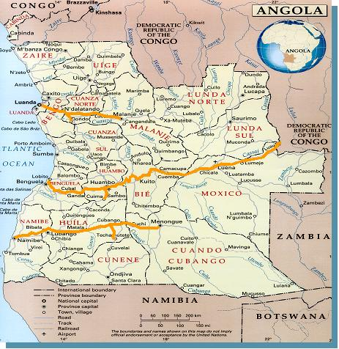 INCLUDEPICTURE "cid:007a01c55a62$ad6f3b10$6601a8c0@cp683548a" \* MERGEFORMATINET 
The Ango-Ferro Project (Phases)

INCLUDEPICTURE "cid:007b01c55a62$ad724850$6601a8c0@cp683548a" \* MERGEFORMATINET 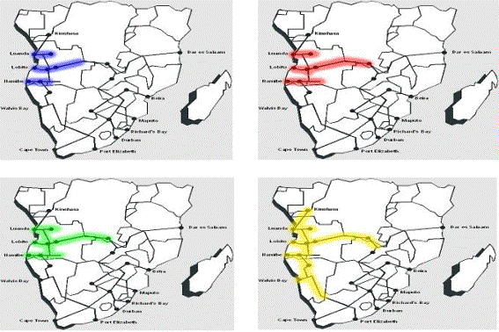 INCLUDEPICTURE "cid:007c01c55a62$ad724850$6601a8c0@cp683548a" \* MERGEFORMATINET 
HOW TO INVEST IN ANGOLA - NATIONAL PRIVATE INVESTMENT AGENCY – ANIP

AREAS OF INVESTMENT – DEVELOPMENT CORRIDORS:
• Malange, Lobito and Namibe;
• It is the government’s view that the 3 corridors warrant the same degree of priority and constitute an open area in which both public and private investment can operate, since they act as a support for the development of the national economy, access to the sea for land-locked countries, and stimulate regional development;

INCLUDEPICTURE "cid:007d01c55a62$ad73cef0$6601a8c0@cp683548a" \* MERGEFORMATINET SHAPE \* MERGEFORMAT 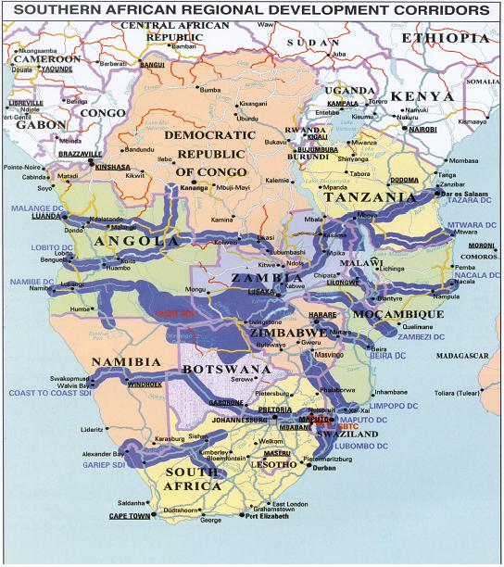 INCLUDEPICTURE "cid:007e01c55a62$ad755590$6601a8c0@cp683548a" \* MERGEFORMATINET 

HOW TO INVEST IN ANGOLA - NATIONAL PRIVATE INVESTMENT AGENCY – ANIP
AREAS OF INVESTMENT – PORTS

• Port system: Luanda, Lobito, Namibe, Cabinda, Soyo and Porto Amboim;
• Independent commercial companies;
• Leasing port: - Luanda;
• Operating port: - Lobito, Namibe, Cabinda, Soyo and Porto Amboim;
Area open to private investment in the concession process, arranging of funds, technical assistance, supply of equipment, communications, etc.

AREAS OF INVESTMENT – SHIPPING:
• Both coastal shipping and international maritime transportation in Angola are liberalized activities.

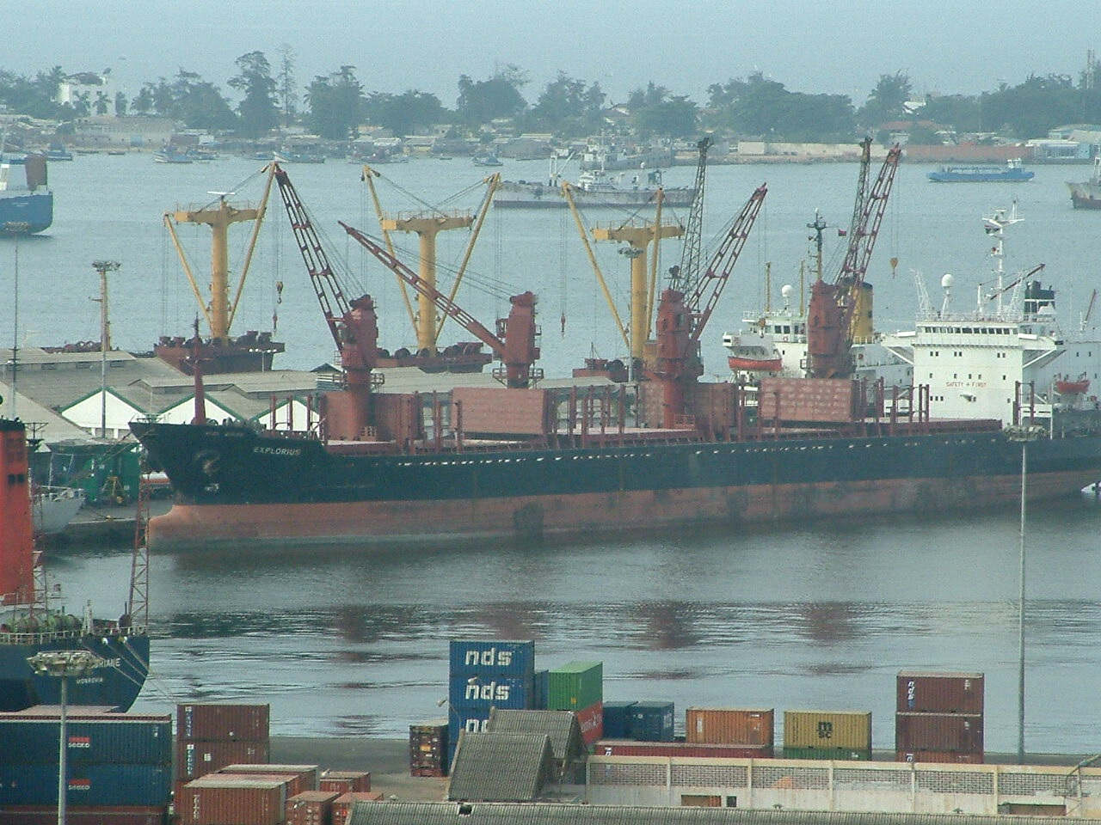

AREAS OF INVESTMENT – AVIATION

• Liberalized activity for domestic aviation;
• International air transportation is an activity conditioned by the exercise of traffic rights to be negotiated with the national flag-carrier.

In both cases ground services can be operated by private companies
HOW TO INVEST IN ANGOLA - NATIONAL PRIVATE INVESTMENT AGENCY – ANIP
AREAS OF INVESTMENT – AIRPORTS

• Airport infrastructures are the absolute reserve of the State and are operated by by Empresa Nacional de Navegação Aérea (ENANA);
• Private investment is possible in the infrastructure-refurbishment process and provision of services.

PROJECTS:

• Increase road-transportation capacity;
• Refurbishment of Luanda Railway (CFL);
• Refurbishment of Benguela Railway (CFB);
• Refurbishment of Moçâmedes Railway (CFM);
• Implementation of the SITLOB Project;
• Refurbishment of the Port of Lobito;
• Refurbishment of the Port of Namibe;
• Refurbishment of the Port of Amboim;
• Refurbishment of the Port of Soyo;
• Construction of Viana Dry Dock;
• Acquisition of Marine Navigational Aid equipment;
• Regeneration of aeronautical infrastructure;

• Acquisition of Aviation Navigational Aid equipment;

• Professional training

HOW TO INVEST IN ANGOLA - NATIONAL PRIVATE INVESTMENT AGENCY – ANIP

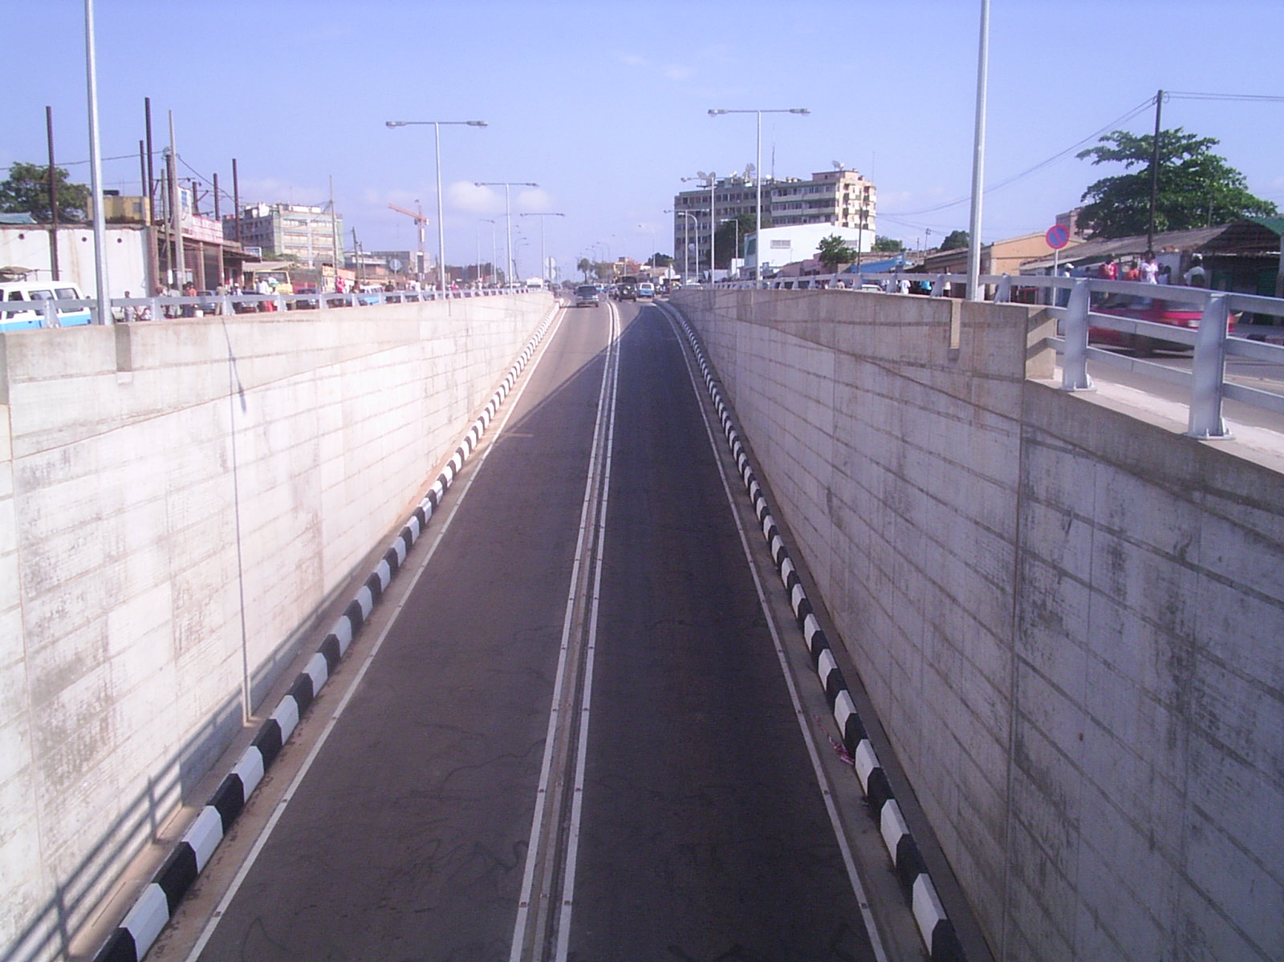

CONCLUSION:

The transportation sector considers private enterprise to be its strategic partner, which it can look to in helping with the regeneration, upgrade and expansion process of its infrastructure and services.

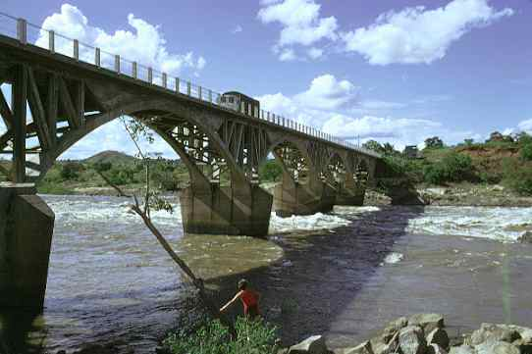

HOW TO INVEST IN ANGOLA - NATIONAL PRIVATE INVESTMENT AGENCY – ANIP
AGRICULTURE AND LIVESTOCK SECTORS
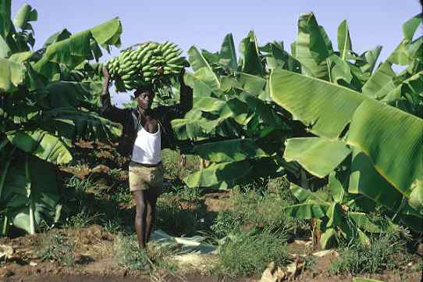
OVERVIEW
The FAO estimates over three million hectares of arable land exist. There are also large areas for pasture, especially in the southern part of the country.
Traditional sustainable crops - cassava, beans, and sweet potatoes are found in the country’s north, with corn in the central provinces, and small corn and sorghum in the southern areas. We would also mention other crops such as banana, rice, sugar cane, palm oil, cotton, coffee, sisal (hemp), tobacco, sunflower, citrines, and other fruits and vegetables.
Coffee, which up to 1973 was Angola’s major export, is well worth looking at, as it could once again become a very important factor in the Angolan economy.
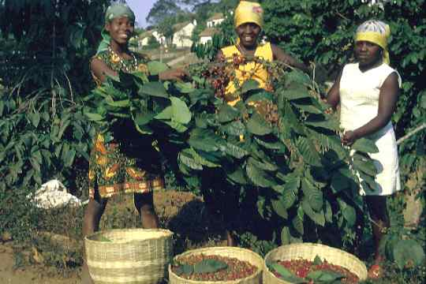
With the idea of launching an agri-business policy, as part of the government’s social and economic program for 2000, it was decided that the main effort should focus on those zones defined in the agricultural program, and on the production of the following basic staples: cereals, roots and tubercles, beans, fruits, vegetables, oil seeds, and specialty products such as green products, small ruminants, cattle breeding and meat processing, pig farming and the rearing of poultry and other birds.
HOW TO INVEST IN ANGOLA - NATIONAL PRIVATE INVESTMENT AGENCY – ANIP
Areas of interest in existence for private investment:
• Waterworks Maintenance & Management;
• Consultant Engineering ;
• All kinds of Production /Marketing Technical & Material Assistance;
• Agricultural Mechanization & Technical Assistance;
• Industrial Poultry Breeding;
• Cattle & Pig Breeding;

MAIN IRRIGATED AREAS

Provinces | Zones | Area (ha) | Crops
BENGO | Bom Jesus  Caxito | 1,300  3,000 | Roots and tubercles, cereals, horti-fruiters  Roots and tubercles, cereals, horti-fruiters
CABINDA | Vale do Yabi  (Yabi Valley) | 5,000 | Roots and tubercles, fruiters, cattle breeding
KWANZA  NORTH | Mucuso  Lucala | 315  250 | Roots and tubercles, cereals, horticultural crops  Roots and tubercles, cereals, horti-fruiters
LUANDA | Vale do Bengo  Kiminha/Funda | 25,000 | Roots and tubercles, cereals, horti-fruiters
BENGUELA | Cavaco  Catumbela | 4,1  4,5 | Roots and tubercles, cereals, horti-fruiters and tobacco  Roots and tubercles, cereals, horti-fruiters
HUÍLA | Humpata  Matala  Chibia | 1,000  3,000  1,000 | Roots and tubercles, cereals, horti-fruiters  Roots and tubercles, cereals, horticultural crops, fruiters, cattle breeding  Roots and tubercles, cereals, horti-fruiters
NAMIBE | Carunjamba, Giraul, Bero and Curoca | 600 | Grapes (wine) and citrines Tubercles, cereals, horticultural crops, industrial crops, cattle breeding
CUNENE | Manquete  Xangongo  Quiteve/Humbe  (Ombandja)  Cova do Leão  (Kahama) |  | Tubercles, cereals, horticultural crops, cattle breeding, olives
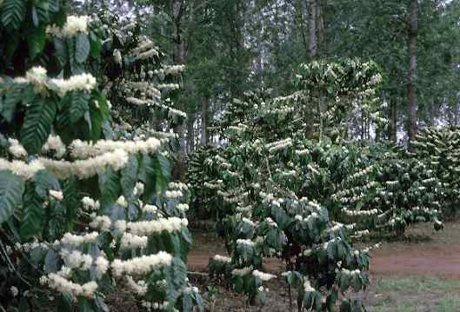
HOW TO INVEST IN ANGOLA - NATIONAL PRIVATE INVESTMENT AGENCY – ANIP
THE TELECOMMUNICATIONS SECTOR

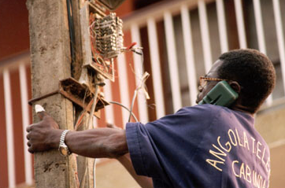
OVERVIEW
Fixed Telephone Market:
• Nation-wide the latent demand of fixed telephone is estimated at more than 500.000;
• In ten cities there are a total of only 291 public telephone boxes;
• Angola Telecom was the only player in the fixed telephony market. Two private firms were licensed: Telesel and Wezacom;
• Wezacom started operating with 5,000 lines, serving Luanda and Benguela with an initial investment of US$8,3 million;
• Telesel started operating with 12,000 lines, with an initial investment of US$2,26 million, initially in Luanda;
• Angola is a partner in the SA T3 that will link Africa to Portugal, which has cost Angola $ 24 million USD.

HOW TO INVEST IN ANGOLA - NATIONAL PRIVATE INVESTMENT AGENCY – ANIP
Mobile Telephone:
• There are currently only some 100,000 subscribers and the estimated demand is for double that number;
• Angola Telecom (Movicel) has 40% of the market, UNITEL the balance;
• Angola Telecom uses both analogue AMPS and digital CDMA systems and UNITEL uses GSM technology.
Satellite:
• Given the size of Angola and the destruction wrought by war, satellite is a logical transmission means. Angosat, which uses space rented from Intelsat in IS 605 located in the geostationary orbit 332.E AOR, provides this means, using 18 earth stations;
About 90% of the Angosat traffic is for Luanda. The rest of the traffic is Inter-provincial that requires a double hop via Luanda
Foreign Involvement:
• Italy granted US$20 million for telecommunications projects in Kwanza Sul, China for projects in Huila, Namibe and Lunda Norte, Japan through Sumitomo and Commuture Corporation;
• On the 16th Apri1 2003, Angola Telecom launched 10.600 new telephone lines in Luanda a project funded by Japan.
Internet Service Providers (lSPs):
• Internet services begin in Angola in 1996 when Pacomm was licensed to install the EBONET network. Now there are nine licensed ISPs, although only three are active. As well as EBONET, Sistec started Netangola in 1997 and NCR started Snet in 1998;
• Further development of internet facilities in Angola needs significant investment;
• Total national market is estimated at 25,000 subscribers in 2002.

HOW TO INVEST IN ANGOLA - NATIONAL PRIVATE INVESTMENT AGENCY – ANIP
THE MARKET & REGULATORY AUTHORITY
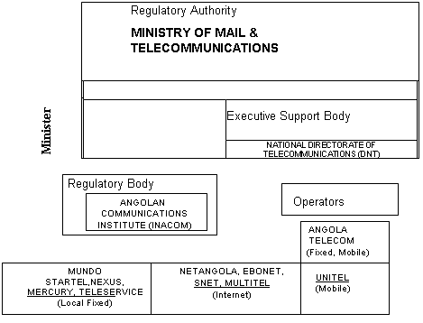
LEGAL FRAMEWORK
PURPOSE | REFERENCE Nº |  | COMMENTS
Law Defining Scope of Business Sectors | Law Nº5/02 of 16 /3 |  | Maintains basic network as absolute reserve only, enabling competition as far as services are concerned, including basic service as an extension of the basic network at a local level.
Basic Telecommunications Law | Law Nº 8/01 of 11/5 |  | Lays the groundwork for sector’s liberalization.
Regulating Access to Provision of Telecommunications  Services | Decree Nº 44/02 of 6/9 |  | Regulates liberalization of sector provided for in the higher-ranking laws, especially Basic Law.
Regulating Public Telecom-munications Services | Decree Nº 45/02 of 10/9 |  | Establishes rights and obligations for operators and users
Basic Private Investment Law | Law Nº 11/03 of 13/05 | 6.00%  All local administrative authorities
Privatization Law | Law Nº 10/94 of 31 of August | Reformulated by Law Nº 8/03 of 18/4, Law Amending Privatization Law.
PENETRATION OF SERVICES
 | SERVICE
 | FIXED |  | MOBILE |  | INTERNET
 | 2003 | 2005 | 2003 | 2005 | 2003 | 2005
LUANDA | X | X | X | X | X | X
BENGUELA | X | X | X | X | X | X
HUILA | X | X | X | X | X | X
HUAMBO | X | X | X | X |  | X
BIÉ | X | X |  | X |  | X
MALANGE | X | X |  | X |  | X
KUANZA SUL | X | X |  | X |  | X
HUIGE | X | X |  | X |  | X
KUANZA NORTE | X | X |  | X |  | X
BENGO | X | X | X | X |  | X
LUNDA NORTE | X | X |  | X |  | X
MOXICO | X | X |  | X |  | X
NAMIBE | X | X | X | X |  | X
CUNENE | X | X | X | X |  | X
KUANDO KUBANGO | X | X |  | X |  | X
LUNDA SUL | X | X |  | X |  | X
CABINDA | X | X | X | X | X | X
ZAIRE | X | X | X | X |  | X
MARKET & SERVICES
Basic Telecommunications Growth Rate Sectorial/Consumer
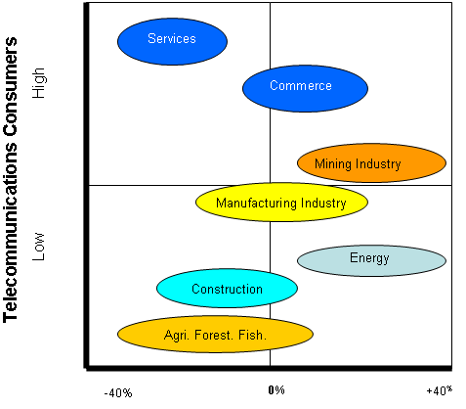
HOW TO INVEST IN ANGOLA - NATIONAL PRIVATE INVESTMENT AGENCY – ANIP
NETWORK DEVELOPMENT PLAN (2001 - 2015)
Transmission Backbone (SDH):
• Fiber Optic: Main routing;
• Hertzian Beams: Secondary routing;
• Satellite: Remote and tertiary zones.

Switching (migration to NGN)
• Voice underpinned by TDM and IP;
• Data underpinned by IP;
• Circuits rented to corporate entities.

Inter-municipal and rural network
• VSAT – Independent of backbone;
• Local switching via PABX;
• Local network with FWA.

Access network
• Primary network in fiber optic;
• Secondary network in copper;
• Peri-urban network : Wireless Local Loop.

HOW TO INVEST IN ANGOLA - NATIONAL PRIVATE INVESTMENT AGENCY – ANIP
FIXED SERVICES DEVELOPMENT PROGRAM
Year | Population | Teledensity | Lines to Installed | Investment  (1000 USD)
2001 | 15,068,242 | 0.47% | 3,345 | 8,363
2002 | 15,549,371 | 0.47% | 3,511 | 8,778
2003 | 16,045,862 | 0.53% | 1,106 | 27,658
2004 | 16,558,207 | 0.59% | 12,721 | 31,803
2005 | 17,086,910 | 0.80% | 39,013 | 97,533
Up to 2010 | 19,994,692 | 2.52% | 310,162 | 775,405
Up to 2015 | 23,397,309 | 5.45% | 545,139 | 1,362,848
Total |  |  | 924,954 | 2,312,388
Average annual investment |  |  |  | 154,159
Average investment per line |  |  |  | 2,500

BASIC NETWORK DEVELOPMENT PROGRAM 2004 - 2008
INTEGRATED NETWORK
ACCESS NETWORK | SWITCHING | LONG-DISTANCE TRANSMISSION
ACCESS NETWORK | SWITCHING | RELAY | DEFINITIVE (BACKBONE)
In copper or wireless (WLL)  NB: Must be executed simultaneously with switching | TDM and NGN  Must be executed simultaneously with access networks | System complemented by Satellite:  -F2 land stations for provincial capitalsVSATs DAMA or other systems for local authorities. | Backbone in fiber optic
Vital aspect: Ensure financing for whole program

HOW TO INVEST IN ANGOLA - NATIONAL PRIVATE INVESTMENT AGENCY – ANIP
BASIC NETWORK DEVELOPMENT PROGRAM 2004 - 2008
BENCHMARK COSTS (USD)
ACCESS NETWORK | SWITCHING | LONG-DISTANCE TRANSMISSION |  | BUDGET FOR SERVICES
ACCESS NETWORK | SWITCHING | RELAY | BACKBONE | BUDGET FOR SERVICES
Underpinned by Backbone:  150,000 Lines  150,000 ∗ 1,500 = 225 million USD |  | F2 Land Stations  USD 6 million  VSATs Terminals  USD 15 million | 8,000 Km in Fiber Optic  8,000 ∗ 20,000 = 160 million USD | Consultants 16.24 million  Training 2.03 million  Tech. Assist. 3.045 million
BENCHMARK COSTS (USD)
225 million |  | 21million | 160 million | 21.315 million
TOTAL: 427.315 million
SAT3/WASC/SAFE PROJECT
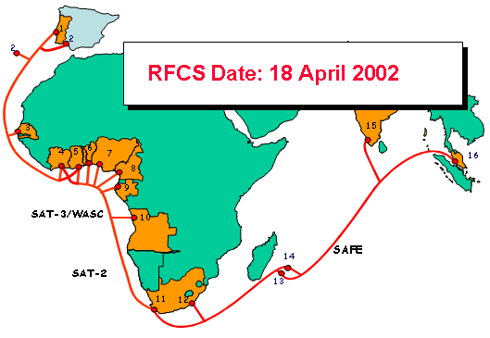 |  | Landing Points  1. Portugal  2. Spain/Canary Is.  3. Senegal  4. Côte d'Ivoire  5. Ghana  6. Benin  7. Nigeria  8. Cameroon  9. Gabon  10. Angola  11. South Africa (1)  12. South Africa (2)  13. Reunion  14. Mauritius  15. Malaysia

HOW TO INVEST IN ANGOLA - NATIONAL PRIVATE INVESTMENT AGENCY – ANIP
THE POWER SECTOR
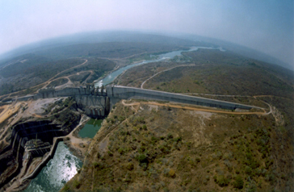
OVERVIEW
Angola currently has approximately 500 MW of generating capacity. Electric current in Angola is 220 volts, 50 cycle.
Significant portions of the power generation and transmission systems have suffered serious damage as a result of the long war. In consequence there is, outside Luanda, only local generation and no distribution network.
GENERATION
The Angolan power generation systems consist of three separate systems and some small isolated ones. The North system covers Luanda and the provinces of Bengo, Malanje, Kwanza Norte and Kwanza Sul. The Centre system covers the provinces of Benguela and Huambo and the South system covers the provinces of Huila and Namibe.
HYDRO
Angola is blessed with significant hydro resources. But, as with all of the nation's infrastructure, the hydro sector has been severely damaged or neglected during the war.
Angola plans to spend more than US$500 million over the next 20 years on building and restoring power facilities.

HOW TO INVEST IN ANGOLA - NATIONAL PRIVATE INVESTMENT AGENCY – ANIP
SUMMARY OF HYDRO CAPACITY
Scheme | Location | River | Nº of Groups | Installed Power | Present Situation
Capanda | Malanje | Kwanza | 4 | 520 MW | Operational
Cambambe | K.Norte | Kwanza | 4 | 180 MW | Operational-for rehabilitation
Matala | Huila | Cunene | 3 | 40.8 MW | 2 operational in rehabilitation
Lomaum | Benguela | Catumbela | 3 | 35 MW | Not operational-for rehabilitation
Mabubas | Bengo | Dande | 4 | 17.8 MW | Not operational-for rehabilitation
Biópio | Benguela | Catumbela | 4 | 14.4 MW | 3 operational in rehabilitation
Chicapa | L. Sul | Chicapa | 4 | 20 MW | About to be built
Source: ENE (2001) - In 2001, hydropower generation represented 62% (1.017 GWh) of ENE total power generation.

THERMAL
Given the damage done to the hydro generating capacity, thermal power generation has become an important alternative source of generation. Most local governments outside Luanda, rely on diesel generators. Luanda has significant thermal generating capacity and oil companies rely heavily on it for their activities.
Angola Thermal Power Generation
Scheme Unit Type Power(MW) Present Situation
LUANDA
Group 1 Gas Turbine 24,4 operational
Group 2 Gas Turbine 28.8 operational
Group 4 Gas Turbine 24.5 operational
Group 5 Gas Turbine 24.5 operational
P.do Bispo Diesel 20x1,2 18 are operational
Congolenses Diesel 5x1 ,46 operational
Quartéis Diesel 10x1,2 6 operational
CABINDA
GTG Malongo Gas Turbine 10 Capital revision
Malon.Wakesha Gas Turbine 5x2,2 operational
Kholer S/E Diesel 5x1,2 operational
Caterpillar S/E Diesel 2x1 ,4+1,0 Not operational
MOXICO
CT Moxico Diesel 1x1,0 Being installed
Guascor Diesel 1x0,56 Being repaired
HOW TO INVEST IN ANGOLA - NATIONAL PRIVATE INVESTMENT AGENCY – ANIP
Angola Thermal Power Generation
Scheme Unit Type Power(MW) Present Situation
K.SUL
Caterp. P .Amboim Diesel 2x1,5 operational
Perkins Gabela Diesel 2xO,2 operational
Caterp. Peskuanza Diesel 3x1,5 Not operational
Kholer Sumbe Diesel 2x1,5 1 operational
Caterpillar Sumbe Diesel 2x1,5 1 operational
MALANJE
Perkins Diesel 1x1,0 Being repaired
Caterpillar 2x0,72 Operational
Caterpillar 1x1,0 Operational
UIGE
Cent,P. FGW Diesel 2x1,0 Not operational
Disp. Kholer Diesel 1x0,36 Not Operational
MTU 1x1 Operational
Disp.Kholer 1x1 Operational
LUNDA S.
CT Saurimo Diesel 1x2,8 Capital revision
BENGUELA
GTG Biópio Gas Turbine 1x22,8 Capital revision
CT Lobito (6PA6) Diesel 4x5 3 operational
CT Lobito MTU Diesel 8x1,2 5 operational
Cummins Diesel 4 x1,1 Not available
C Cavaco Diesel 2x1,250 Not available
HUAMBO
GTG Gas Turbine 10 Not operational
CAT Diesel 3x1,2 operational
CAT Diesel 1x0,8 operational
CUMMINS Diesel 1x0,8 operational
CUMMINS Diesel 1x1,6 Not operational
CAT Caala Diesel 1 x0,4 operational
BIÉ
Diesel PT-1 Diesel 1x0,48 Not operational
CT Kuito Diesel 1 x1 ,48 operational
Perkins Diesel 1x1 operational
Caterpillar Diesel 1x1 operational
NAMIBE
CT Xitoto Diesel 2x5,6
Diesel Tômbwa Diesel 2x1,2
6PA4 Tômbwa Diesel 1x0,56
HUÍLA
CT Lubango MTU Diesel 6x1,2
HOW TO INVEST IN ANGOLA - NATIONAL PRIVATE INVESTMENT AGENCY – ANIP
TRANSMISSION
The lack of capacity of the distribution network is due to natural ageing of the equipment, its poor maintenance and lack of investment, as well as the effects of war. As a consequence, the supply is unstable and coverage very poor.
The northern transmission network is limited to the 220 kV line linking the Cambambe dam to Luanda and the 60KV line from Luanda to Kifangondo.

SUBSTATIONS
Luanda has two substations. That at Viana is only partially in service due to sabotage. It is served by two 220 kV lines, one coming from Cazenga and other from Cambambe. Cambambe dam, together with five thermal stations, feeds the Cazenga substation.

PROSPECTS
According to ENE, the total rehabilitation of the entire electricity system requires an estimated investment of about US$1billion, of which US$334 million is for generation, US$236 million for transmission and US$75 million for substations.

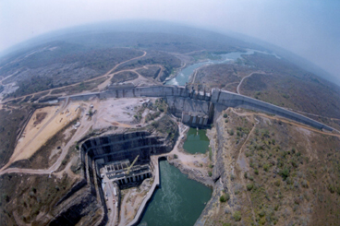
CAPANDA
HOW TO INVEST IN ANGOLA - NATIONAL PRIVATE INVESTMENT AGENCY – ANIP
THE WATER SECTOR
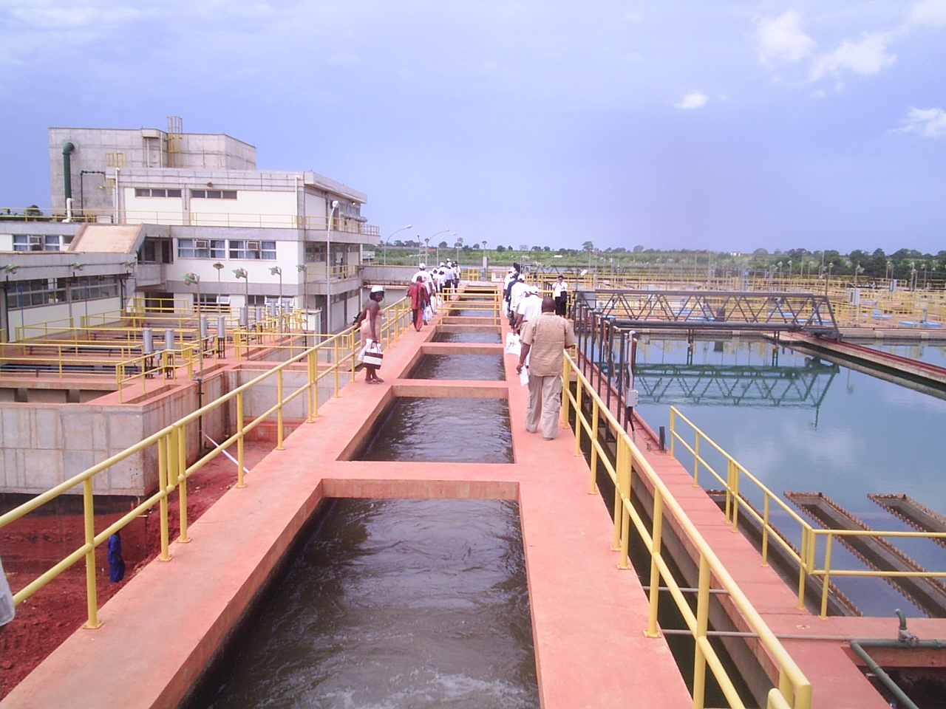
OVERVIEW
Angola is the second most endowed country in Africa in terms of water resources with intense rainfall in almost all of the country. 60% of Angola records an average annual rain of about 1 000 mm.
In the north rainfall reaches levels of over 1,800 mm per year. Despite that, the great majority of the population do not have access to piped or treated water. Equally, there are severely limited sewage treatment facilities.
WATER:
• In urban areas, estimates indicate that 50 % of the population has access to potable water, but only 16 % have piped water;
• The remainder relies on water standpipes or trucks. In rural areas, no more than 15% of the population have access to drinkable water.
LUANDA WATER:
• Most of the millions of people in rural Angola who fled the war sought safety in Luanda, a city built for well under a million people, today has 4 million;
HOW TO INVEST IN ANGOLA - NATIONAL PRIVATE INVESTMENT AGENCY – ANIP
• This influx placed a huge strain on Luanda's infrastructure, stretching grids, water treatment and supplies to the limit. It is worth looking at the capital's problems in detail.



SEWAGE:
• The sewage system, anywhere in Angola, was installed in colonial times. Since then, although the population has grown, there has been little, if any, maintenance and virtually no investment;
• Consequently the sewage system is in a state of total disrepair, with frequent spillage of sewage and blockages.

HOW TO INVEST IN ANGOLA - NATIONAL PRIVATE INVESTMENT AGENCY – ANIP
THE MINING SECTOR
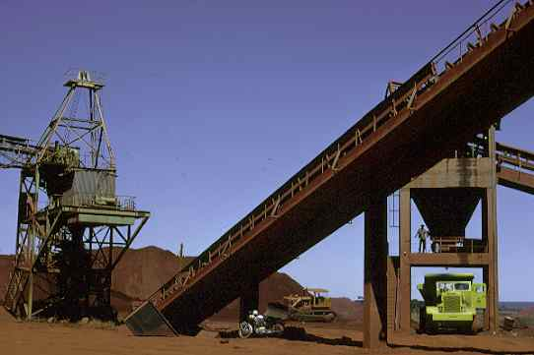
OVERVIEW
Angola has numerous mineral deposits, including diamonds, iron, gold, phosphates, manganese, copper, lead, zinc, tin, wolfram, tungsten/vanadium, titanium, chrome, beryllium, kaolin, quartz, gypsum, marble, granite and uranium.
The full extent of these resources has yet to be fully evaluated. Since independence mining activity has been limited to diamonds and, on a smaller scale, to the extraction of marble and granite.
The supply industry for mining activity is thus not well developed at all and, as with many other activities, companies that are now beginning to operate in Angola are sourcing equipment from South Africa.
PRECIOUS METALS
GOLD
The Maiombe region of Cabinda Province accounts for 90% of gold production in Angola.
There are other alluvial gold deposits in Cuanza Norte, Huila and Cunene Provinces.
PLATINUM
Platinum has been reported in association with norite complexes in the Cunene Complex in south-western Angola.
HOW TO INVEST IN ANGOLA - NATIONAL PRIVATE INVESTMENT AGENCY – ANIP
BASE METALS
Copper production has largely been from the high-grade ore ofthe Tetelo-Mavoio Bembe region. Lead and zinc have also been recorded in this region.
Copper deposits of potential economic value occur in the coastal plain (e.g. the Cachoeiras and Loeto deposits) and copper of volcanic origin has been identified in the Menongue district of south-east Angola.
Vanadium has been mined at Lueca and Kinzo.
FERROUS METALS
IRON
Most iron mined in the past in Angola has been from the Cassinga Mine in Huila Province, where the high-grade portion of the reserve has been largely depleted.
A slump in global iron ore prices, coupled with the onset of the war when the rail link connecting the mine at Cassinga to the port of Mocamedes (now Namibe) was destroyed, saw production end.
MANGANESE
Numerous small manganese deposits occur scattered throughout Angola. The most economically of them is known as the Lucala manganese triangle, and is situated in Cuanza Norte and Malanje Provinces.
Numerous small manganese deposits occur in this region, concentrated in alluvial or near surface deposits.
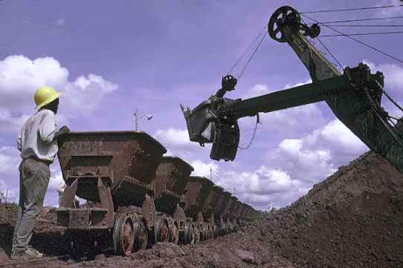
HOW TO INVEST IN ANGOLA - NATIONAL PRIVATE INVESTMENT AGENCY – ANIP
DIAMONDS
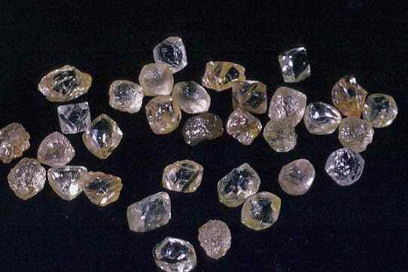
In Angola, both kimberlite and alluvial diamonds occur. Some 700 known kimberlites occur in Angola and are aligned in a northeast-southwest direction across the country.
The kimberlites vary in shape from rounded to elongate and diamond grade increases with depth. The Camafuca and Catoca kimberlites are the best known.
A number of kimberlite pipes occur in Lunda Norte Province. These include the economicalIy interesting Camafuca, Camatchia and Camagico and Camatue pipes.
Most alluvial diamonds in Angola originate from erosion of kimberlites. The Lunda Norte and Lunda Sul areas of north-eastern Angola host rich alluvial diamond fields.

HOW TO INVEST IN ANGOLA - NATIONAL PRIVATE INVESTMENT AGENCY – ANIP
INDUSTRIAL MINERALS
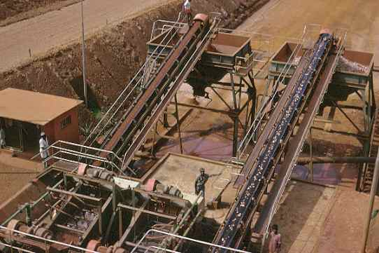

DECORATIVE STONE
Good quality red and black granites are exported from Angola.
These rocks occur in Namibe and Huila Provinces in south-eastern Angola.
These provinces are also known for deposits of crystalline quartz and marble.
PHOSPHATES
Substantial phosphate resources have been found in Cabinda and Zaire Provinces.
KAOLIN
Kaolin has been found in Bengo, Huila, Bie and Uige Provinces.
CEMENT AND RAW MATERIALS
Although large volumes of limestone, sands, sandstone and clays occur, production has not been substantial.
HOW TO INVEST IN ANGOLA - NATIONAL PRIVATE INVESTMENT AGENCY – ANIP
MANUFACTURING INDUSTRY SECTOR
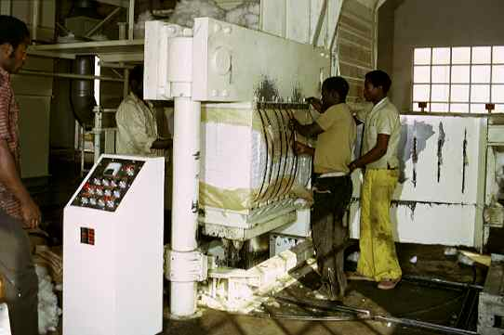
OVERVIEW
The agriculture-industrial sector, due to its productivity, contributed to place Angola among the most self-sufficient countries in basic products in the period of time before independence. It is a sector that simply doesn’t work, because agriculture has stopped supplying the essential raw materials.
OILS AND SOAPS
The sub-sector of oils and margarines comprises three units, whose production reached about 12.000 and 7.000 tonnes/year of vegetable oil, as well as 6.000 and 2.000 margarine tonnes/year in 1989 and 1992 respectively.
MILLING INDUSTRY (CORN, CASSAVA AND WHEAT FLOUR)
The sub-branch of bakeries (wheat) is responsible for 382.320 tonnes of the production, corresponding approximately to 80.5% of the total. However, to archive this bread production, the consumption of wheat flour is estimated at about 337.500 tonnes, of which 72.00 tonnes could be produced in the country.
This means that the remaining 265.500 tonnes have to be imported due to the weak capacity of local processing.
Cassava flour is produced in the informal sector through small mills and the production capacity is fairly insignificant. All the existing milling industries are under administration contracts and will soon be privatised.

HOW TO INVEST IN ANGOLA - NATIONAL PRIVATE INVESTMENT AGENCY – ANIP
SUGAR INDUSTRY
With the occupation of an area of about 13.800 hectares of sugarcane, Angola possessed four factories that produced about 110.000 tonnes/year, in 1985, having reached the historical value of 70.000 tonnes of commercial sugar in 1974.
TEXTILE INDUSTRY
The textile industry includes all the activities connected with cotton for clothing, and of cottonseed for the industry of foodstuffs (oils and fats).
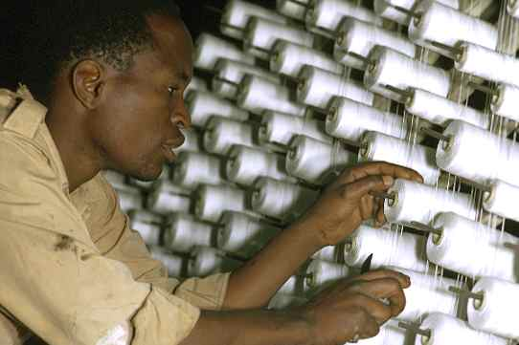
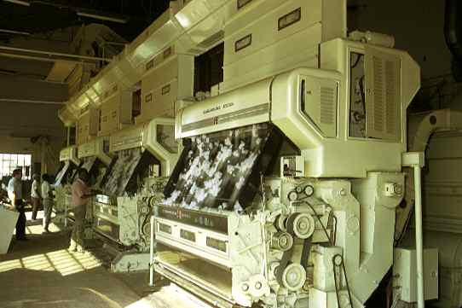

HOW TO INVEST IN ANGOLA - NATIONAL PRIVATE INVESTMENT AGENCY – ANIP
FISHING SECTOR
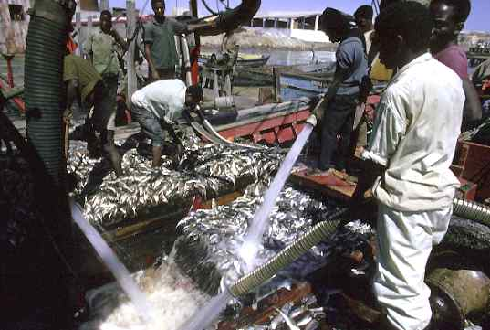
OVERVIEW
Angola boasts one of Africa’s richest coastlines, especially in the country’s south. There the cold Benguela current creates a special environment for a great variety of fish, principally mackerel, sardines, tuna, and shellfish.
The government’s immediate objectives are to reactivate productive fishing processes, increase fish-conservation activities, and renew catch capacities, as well as increase and rationalize existing cold-storage capabilities. It also plans to revamp and equip naval shipyards, dock areas and fishing ports, while improving the commercial distribution of fish on a national level. Providing technical assistance to entrepreneurs, management training, and scientific investigation is also slated.
Previously state-owned, various small fishing enterprises have already been divested to the private sector as part of a privatization program. Currently, preparation for the privatization of larger enterprises is underway.
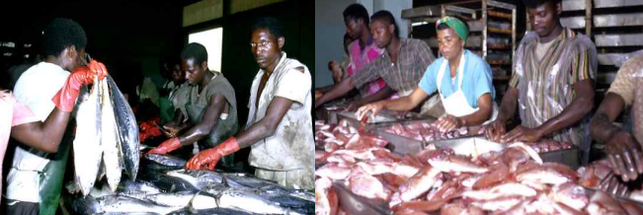
HOW TO INVEST IN ANGOLA - NATIONAL PRIVATE INVESTMENT AGENCY – ANIP
THE OIL SECTOR
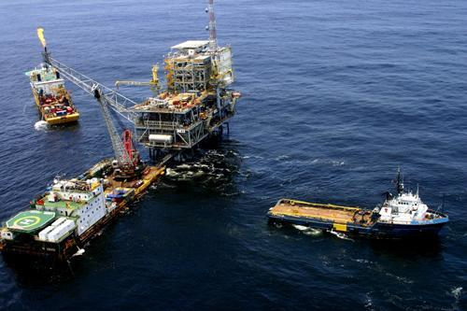
OVERVIEW
Angola is one of the major oil producing countries of Africa. After Nigeria, is the most significant producer in Sub-Saharan Africa with more than 1 million barrels per day. The crude oil production is expected to reach nearly 2 million barrels per day in 2008.

The Refinery Project
Much of the crude oil produced in Angola is of light sweet quality and can be marketed to refiners around the world. However, a significant portion of the new crude production in few years is expected to be heavy and acidic Kuito and Dalia. Due to the properties of these crude, they will have to be processed in a reside upgrading refinery which has appropriate metallurgy.
In order to monetize such crude to the maximum extent possible, the Angolan Government is proposing to develop a new refinery capable of processing this heavy acidic crude.
Preliminary studies show that the utilization of this kind of heavy acidic crude oil enhances the Refinery Project profitability.
Currently, there is a 57,500 barrels per stream day (BPSD) refining capacity in Angola. The major refinery, having a capacity of 45,000 BPSD, is in Luanda, operated by TotalFinaElf and partially fulfils the demand for refined products in Angola.
HOW TO INVEST IN ANGOLA - NATIONAL PRIVATE INVESTMENT AGENCY – ANIP
Malongo refinery, located in Cabinda province has an approximate capacity of 12,500 BPSD and is essentially used to support the oil activities in the region.
These refineries are not capable of processing the heavy acidic crude such as Kuito and Dalia. The capacity of the new refinery project is of 200,000 barrels per day.
The Sociedade Nacional de Combustíveis de Angola, Empresa Pública (SONANGOL E.P.), principal promoter of the project, was created in 1976 as the national oil company of Angola, It is 100% owned by the State and serves as the business arm of the Angolan Government, being responsible for coordinating and controlling all petroleum activities.
In this capacity, SONANGOL E.P. is currently leading the development activities for the New Refinery Project.
The Angolan LNG Project
Along with oil production, around 1.2 BSCFD of associated gas is produced of which, 60% is flared.
Flaring of associated gas represent a significant economic loss and combustion products make a major contribution to environment damage.
A major project will be implemented to reverse the current situation.
The Angolan LNG Project will:
• Facilitate fields development without flaring of the associated gas.
• Generate revenues from a resource that used to be considered as a by – product in Petroleum operations.
• Allow Sonangol to enter to a new business area.
• Be an anchor project for future opportunities in gas utilization and industrial development.
• Generate new jobs opportunities for nationals.
HOW TO INVEST IN ANGOLA - NATIONAL PRIVATE INVESTMENT AGENCY – ANIP
TOURISM, HOSPITALITY AND SERVICES
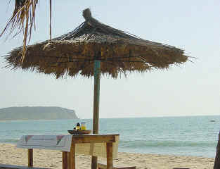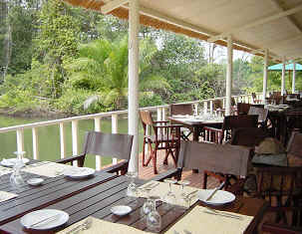
TOURISM
Angola is potentially a country ripe for the development of the tourism sector, offering the following:
• 1,650 km. of coastline, a long summer season and beautiful, natural sandy-beaches with excellent conditions for swimming and water sports;
• Rich and varied fauna with a system of parks and natural reservations;
• Fantastically beautiful, poster-inspiring, landscapes boasting mountains and waterfalls;
• Rivers with waterfalls, rapids, and lakes - some navigable.
National game parks and natural reserves constitute hubs of attraction for investment.
PROTECTED AREAS IN ANGOLA

HOW TO INVEST IN ANGOLA - NATIONAL PRIVATE INVESTMENT AGENCY – ANIP
NATIONAL PARKS & NATURAL RESERVES
NAME  Quissama National Park  Bikuar National Park  Kangandala National Park  Iona National Park  Kameia National Park  Mupa National Park  Chimalavera Nat. Park  Luando Natural Reserve  Ilhéu Natural Bird Reserve  Moçâmedes Natural Reserve  Mavinga Natural Reserve  Luiana Natural Reserve  Bufalo Natural Reserve | PROVINCE  Bengo  Malange  Huíla  Namibe  Moxico  Cunene  Benguela  Malange/Bié  Luanda  Namibe  Kuando Kubango  Kuando Kubango  Benguela | AREA (KM²)  9,960  630  7,900  15,150  14,450  6,600  100  8,280  2  4,450  5,950  8,400  400 | MAIN SPECIES  Manatee, Red Palanca, Pacaça  Black Giant Palanca, Red Palanca  Elephant, Buffalo  Zebras, Guelengue, Lion, Ostrich  Cacu, Boi-Cavalo  Giraffe, Cahoma  Cabra de Leque  Black Giant Palanca  Migratory Birds  Ostrich, Cabra de Leque  Elephants, Palanca, Southwestern Palanca  Elephants, Palanca.  Southwestern P., Rhino, Black Bufalo

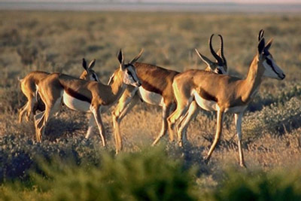

HOW TO INVEST IN ANGOLA - NATIONAL PRIVATE INVESTMENT AGENCY – ANIP
HOSPITALITY
About 50% of the hospitality sector’s infrastructure needs to be revamped. Of 105 hotels of varying categories, less than half of it are active, and even so, these are all located along the country’s coastal areas.
SERVICES
Services present exciting prospects, since trade and tourism are expanding. The transportation and communication sectors point to high potential, while banking and insurance began coming to the fore, especially after 1991.
- In 2005, 12 banks were in existence, of which six were private ones. Three of them are foreign banks;
- Two Investment Funds, FDES which is a development Fund and FIPA, the first venture Capital Fund in Angola;
- Two insurance companies operates - Empresa Nacional de Seguros de Angola ENSA and Angola Agora e Amanhã – AAA. The state monopoly ended in 2000 by law 1/00 of 3rd of February 2000;
Ensuring the availability of essential consumer goods, hindered by low national production, calls for the setting up and development of a solid commercial structure, integrating the production, import, transportation, and distribution segments.

HOW TO INVEST IN ANGOLA - NATIONAL PRIVATE INVESTMENT AGENCY – ANIP
PRIVATIZATIONS
SECTORS / COMPANIES | SIZE | MISSION | FINAL OBJECTIVE
FISHERIES SECTOR
Province of Luanda
EDIPESCA | Small | Naval shipyards | Privatization
ex-FARINOL
SOCONAL
ERMANAL
ENATIP
Province of Benguela
ESTALEIROS DEOLINDA RODRIGUES
ALA - ARRIBA
Province of Kwanza-Sul
PESKWANZA | Large | Marketing and distribution of fish | Privatization
Province of Namibe
EDIPESCA
EMPROMAR KUROCA
EMPROMAR KAPIANDALO
FROPESCA | Large | Marketing and distribution of fish | Privatization
COMMERCIAL SECTOR
Province of Luanda
MECANANG | Large | Distribution and marketing of equipment | Privatization
HOTEL & TOURISM SECTOR
HOTEL KATEKERO | Large | Tourism services | Privatization underway
PALACE HOTEL (Huambo) | Large | Hotel & tourism services | Privatization
HOTEL PANORAMA | Large | Hotel & tourism services | Privatization
PUBLIC WORKS & URBANISM SECTOR
Province of Luanda
TECNOTÚNEL | Medium | Drilling & surveying tunnels | Privatization
CCA - Companhia de Cerâmica de Angola | Medium | Ceramic industry | Privatization
EMPROE + (Fábrica Mármore e Cantarias - Peq.dimensão) | Large | Engineering works | Privatization
ENDIMAC | Medium | Distribution of construction materials | Privatization
GEOTÉCNICA + (U.P. CAVAN - Pequena dimensão) | Large | Drilling, soundings, foundations | Privatization
MANUTÉCNICA | Medium | Manufacture light engineering products | " "
TECNOGIRON | Medium | Engineering works | " "
I C E R | Small | Ceramic manufacture | " "
CONSTRÓI + (Carpintaria - Pequena dimensão) | Medium | Civil construction works | Privatization
UNICERÂMICA | Medium | Ceramic manufacture | Partial privatization
NOVOBRA | Small | Civil construction works | Privatization
RUC | Small | Facing works | Privatization
ECOSENG | Small | Surveying, drilling | Privatization
ENCOI | Small | Civil construction works | Privatization
PUBLIC WORKS & URBANISM SECTOR
Province of Luanda
INSTAL | Small | Installation of elevators, etc. | Privatization
CERÂMICA CATETE | Small | Manufacture of pottery materials | Privatization
CERÂMICA KIBALA | Small | Manufacture of pottery materials | Privatization
JOSÉ RODRIGUES | Small | Manufacture of pottery materials | Privatization
Province of Kwanza-Norte
CERÂMICA LUCALA | Small | Manufacture of pottery materials | Privatization
Province of Namibe
EMPREDI | Small | Civil construction undertakings | Privatization
AGRICULTURAL SECTOR
Province of Uíge
UIGIMEX | Medium | Roasting coffee | Privatization underway
Province of Luanda
CAFANGOL | Large | Roasting coffee
PROCAFÉ | Medium | Roasting coffee
TRANSPORTATION SECTOR
SÉCIL MARÍTIMA | Large | Maritime transportation services | Transf.commercial company
ANGONAVE | Large | Maritime transportation | Extinction
CABOTANG | Medium | Maritime transportation | Transf.commercial company
ABAMAT | Large | Technical/material supplies | Transf.commercial company
MANAUTOS | Small | Auto repair & maintenance | Restructuring/Privatization
ETP´S | Small | Road transportation | Privatization
ETIM´S | Medium | Long-haul road transportation | Privatization
TRANSNORTE | Medium | Road transportation | Transf.commercial company
CONDAUTOS | Small | Driving schools | Privatization
AGENANG | Medium | Shipping agency | Privatization
INDUSTRIAL SECTOR
Province of Luanda
MABOR | Large | Manufacture of inner tubes & tires | Privatization
PANGA-PANGA | Large | Manufacture of agglomerates & plywood | Partial privatization
ENTEX (Textang I, Fiangol, Facobang, Satec) | Large | Manufacture of fabrics | Partial privatization
COMETA (I, II, III) | Large | Assembly of cisterns | Restructuring/Privatization
ENACMA (U.P. Kunene, Kuito, Keve, Afrimax) | Large | Assembly of vehicles | Restructuring/Privatization
BOLAMA (Combal, Villares I e Villares II) | Medium | Manufacture of pastas & biscuits | Partial privatization
LIMOCA (Liangol) | Medium | Freeze-drying coffee | Partially privatized
ETM | Medium | Manufacture of wooden furniture | Privatization underway
CONGERAL | Medium | Manufacture of oils & soaps | Privatization underway
PROMIL/MOAGENS DE CAHAMA | Medium | Milling of cereals (corn, wheat) | Privatization
MOAGEX | Medium | Milling of cereals (corn, wheat) | Privatization
INDUSTRIAL SECTOR
Province of Luanda
TEXTANG II | Large | Manufacture of fabrics | Partial privatization
SIDERURGIA | Large | Manufacture of steel rails | Partial privatization
ENEPA | Large | Manufacture of PVC and plastic items | Restruct./Partial privatization
FATA | Medium | Manufacture of galvanized pipes | Privatization
METANG | Medium | Manufacture of zinc sheets | Privatization
CUCA/Luanda (CERVAL) | Large | Manufacture of beverages (beer, soft drinks, wine, etc.) | Partial privatization
EKA | Medium | Manufacture of beer | Partial privatization
NOCAL | Medium | Manufacture of beer | Partial privatization
Province of Benguela
ÁFRICA TÊXTIL | Large | Manufacture of fabrics | Partial privatization
AÇUCAREIRA DO DOMBE Large (OSUKA) | Large | Manufacture of sugar, syrup, etc | Partial privatization
EMP. REG. CONSERVAS (Agrícola Portelas, Faz.Prazeres,Sede) | Medium | Canned fruits | Privatization
Province da Huíla
SAIDY MINGAS | Small | Milling of cereals (corn, wheat) | Privatization underway
ALIANÇA | Small | Milling of cereals (corn, wheat) | Privatization underway
EMABOL | Medium | Manufacture of pastas & biscuits | Privatization underway
OIL SECTOR
EMBAL | Medium | Manufacture of metal packaging | Partial privatization
GEOLOGY & MINES SECTOR
ROREMINA | Medium | Survey and processing of ornamental stone | Management agreement
FERRANGOL | Large | Survey and processing of iron
EMPRESAS DA ENDIAMA
- ENDITRADE - Comércio Geral, Importação e Exportação, Lda. | Small |  | Privatization
- SODAP - Sociedade Desenvolvimento Agro-Pecuário, Lda. | Small |  | Privatization
- TRANSDIAMA - Empresa de Transportes Rodoviários, Lda. | Small |  | Privatization
- ECIVIL - Empresa de Construção Civil do Dundo, Lda. | Small |  | Privatization
- TRANSNORDESTE - Empresa de Transportes do Nordeste, Lda. | Small |  | Privatization
- MABAIA - Empresa de Madeira do Dundo, Lda. | Small |  | Privatization
- ELECTROCLIMA - Empresa de Electrónica e | Small |  | Privatization
- Climatização do Dundo, Lda.
- FOTIPO - Empresa de Fotografia e Tipografia do Dundo, Lda. | Small |  | Privatization
- EDNA - Empresa de Electricidade do Nordeste, Lda. | Small |  | Privatization
- E A S - Empresa de Saneamento Básico do Dundo, Lda. | Small |  | Privatization
HIDROMINA | Medium |  | Extinction
ENERGY & WATER SECTOR
ENCEL | Medium | Production of electrical equipment | Privatization
MAIL & TELECOMMUNICATIONS SECTOR
ANGOLA TELECOM | Large | Communications Services | Partial privatization
FINANCIAL SECTOR
BCI | " | Financial transactions | Partial privatization

HOW TO INVEST IN ANGOLA - NATIONAL PRIVATE INVESTMENT AGENCY – ANIP
COMPANIES IN NEED OF FINANCING
GEOLOGICAL AND MINES
Fatima Garnacho-Engelke representative in Washington of the Consortium Luachimo Mining, Lda., a Society of Angolan citizens, located in Luanda in Rua Roberto Shields, n. 17, 3º andar, porta C., with social objective for study of Geological Activities and Mines, in particular the prospecting, exploitation, treatment and commercial aspects of diamonds, gold and other minerals in the Country and outside.
License of Prospect: Granted by the Republic of Angola, Ministry of Geologyand Mine, Institute Geologic of Angola.
Name of the Project: Massangano / Gold
Titular of the Permission: The Miner Consortium of Luachimo Mining, Lda.
Permission of the prospect: N.072/IGEO/MGM/99
Period of validity: 3(tree) years
Acreage of the conceded area: 334, 9 square Km.
Location: Municipality of Cambambe, Province of Kwanza Norte
Registration number: 072
Date of issue: August/01/2002
Luachino Mining, Lda
For Contacts:
Fatima Garnacho-Engelke
132 N. Fillmore Street Arlington, VA, 22201
Tel: ++1-703-243-2038 ++1-202-297-9039
Fax: ++1-703-243-2038 e-mail:Fengelke@comcast.net
AGRICULTURE AND CATTLE BREEDING
GRUPO LONGA N’HIA – De Domingos Joaquim Products and Services of the Project: palm tree, coffee and other agricultural products
Location: Quilenda, Kwanza Sul
Implementation area: 9807 ha (5000 of palm tree in production)
Estimated cost of the Project: US$ 500,000
Financing purpose: rehabilitation of infrastructures
Type of partnership: joint venture
COOPERATIVA AGRÍCOLA DO CACUACO
Products and Services of the Project: horticultural, fruit, roots, tubers, fowls, cattle (both swine and bovine)
Location: Cacuaco, Luanda
Implementation area: 5454 ha
Estimated cost of the Project: US$ 2,990,000
Financing purpose: rehabilitation and expansion of infrastructures
Type of partnership: joint venture

HOW TO INVEST IN ANGOLA - NATIONAL PRIVATE INVESTMENT AGENCY – ANIP
ORGANIZAÇÕES OSSIWANA SANHANGANA
Products and Services of the project: horticultural, fruit, cereals and cattle
Location: Kuvelai, Kunene
Implementation area: 700 ha
Estimated cost of the Project: US$ 471,439
Financing purpose: rehabilitation of infrastructures
Type of partnership: joint venture
FAZENDA AGRO-PECUÁRIA MATECA & IRMÃOS
Products and Services of the project: horticultural, fruit, roots and tubers, cereals, cattle and palm tree
Location: Dande, Bengo
Implementation area: 2219 ha
Estimated cost of the Project: US$ 476,000
Financing purpose: rehabilitation of infrastructures
Type of partnership: joint venture

MANUFACTURING INDUSTRY
ALVES & FILHOS
Products and Services of the project: milk and dairy products
Location: Kwanza Sul
Implementation area:
Estimated cost of the Project: US$ 1,797,000
Financing purpose: industrialization of milk
Type of partnership: joint venture or administration contract
ELECTRO G.E.
Products and Services of the project: electric articles
Location: Luanda
Implementation area:
Estimated cost of the Project: US$ 500,000
Financing purpose; installation of a unit of electric materials
Type of partnership: joint venture or administration contract
JOVEUNA
Products and Services of the project: footwear
Location: Huíla
Implementation area:
Estimated cost of the Project: US$ 1,000,000
Financing purpose: tannery
Type of partnership: joint venture or administration contract

HOW TO INVEST IN ANGOLA - NATIONAL PRIVATE INVESTMENT AGENCY – ANIP
INDUFER
Products and Services of the project: black tube and corrugated zinc plate
Location: Luanda
Implementation area:
Estimated cost of the Project: US$ 2,786,244
Financing purpose: rehabilitation of the unit of tube and zinc plate production
Type of partnership: joint venture or administration contract

MATERIAL FOR BUILDING INDUSTRY
SIMCAL
Products and Services of the project: cement
Location: Luanda
Implementation area:
Estimated cost of the Project: US$ 150,000
Financing purpose: installation of a cement factory
Type of partnership: joint venture or administration contract
SAFIL, LDA.
Products and Services of the project: ceramic
Location: Lunda Norte
Implementation area:
Estimated cost of the Project: US$ 1,500,000
Financing purpose: implementation of a ceramic unit
Type of partnership: joint venture or administration contract

STEELEDALE, ANGOLA
Products and Services of the project: zinc coated plate
Location: Luanda
Implementation area:
Estimated cost of the Project: US$ 1,500,000
Financing purpose: implementation of a ceramic unit
Type of partnership: joint venture

HOW TO INVEST IN ANGOLA - NATIONAL PRIVATE INVESTMENT AGENCY – ANIP
INSIDE ANGOLA

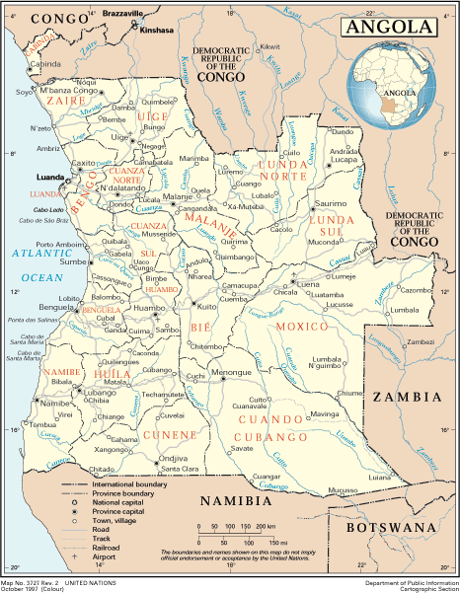

HOW TO INVEST IN ANGOLA - NATIONAL PRIVATE INVESTMENT AGENCY – ANIP
THE PROVINCE OF LUANDA

Luanda is the capital city of the Republic of Angola. The climate is tropical, with two seasons: the rainy season between January and May and September to December and the dry season between June and August. The average temperature is 25° C. It has an area of 2,257 Km2, where is 1% of the national territory and is 60 metres above sea level. Luanda has the first industrial park and the second main port.

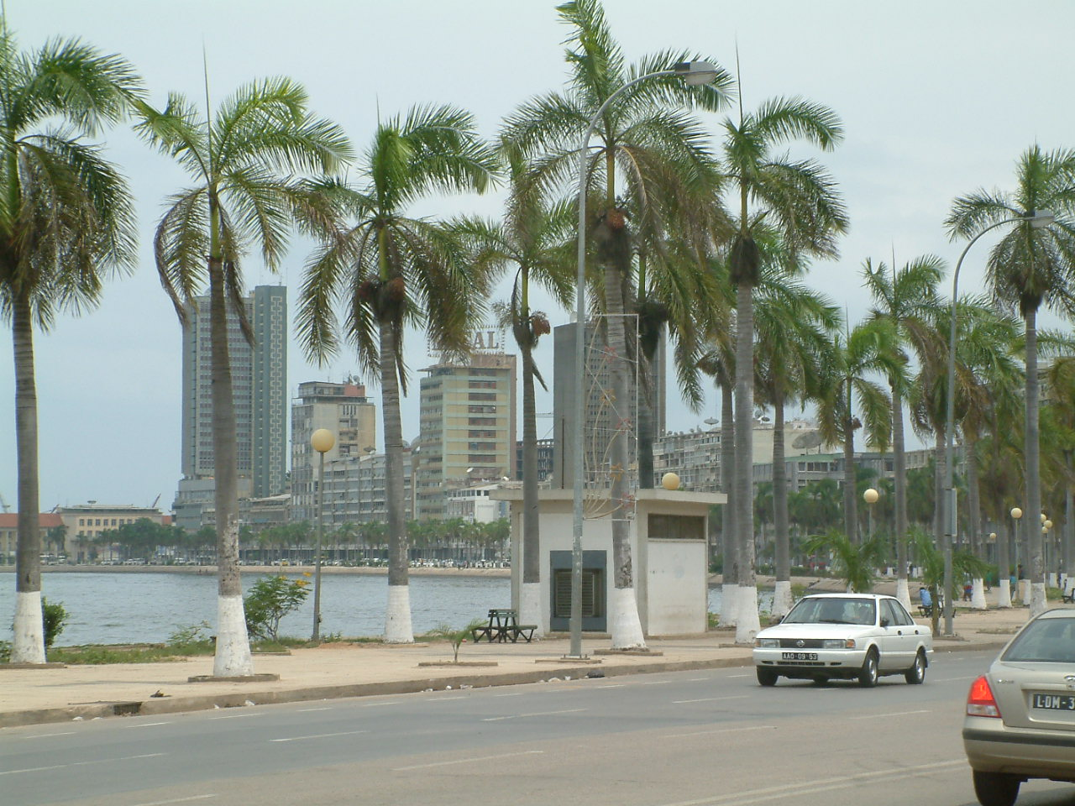

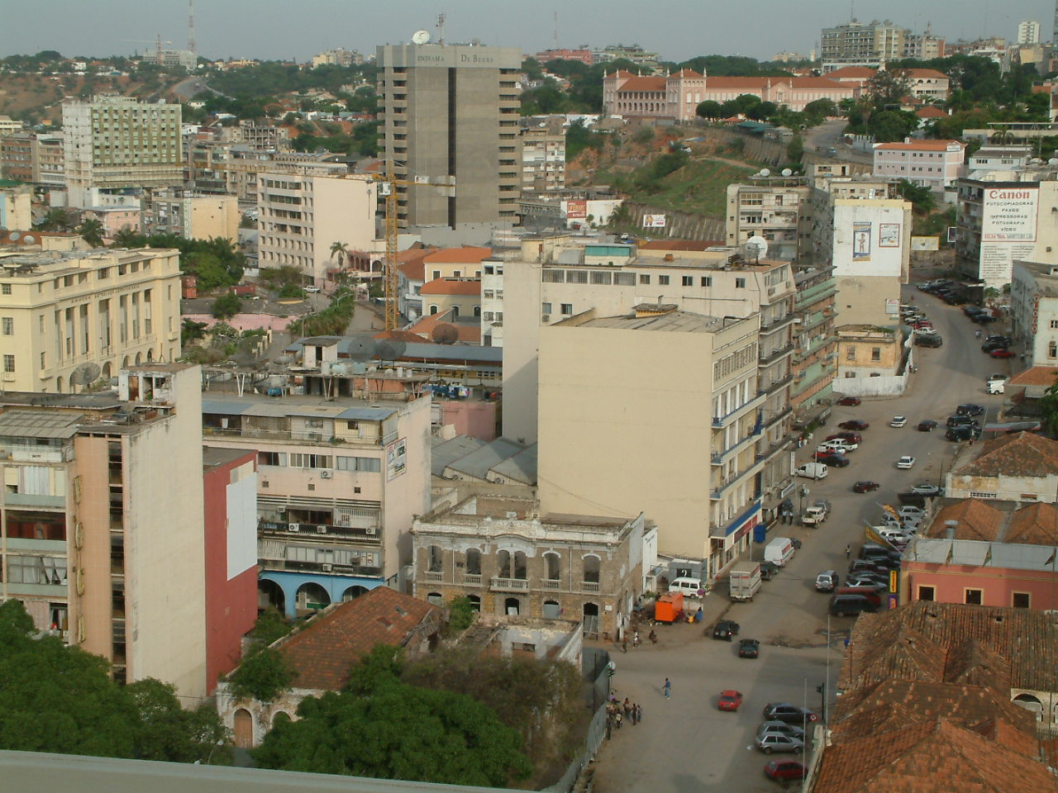
HOW TO INVEST IN ANGOLA - NATIONAL PRIVATE INVESTMENT AGENCY – ANIP
THE PROVINCE OF BENGO

The main advantage this province presents to the visitor is its proximity to Luanda, the capital city of Angola. Caxito is the capital city of this province, which has an area of 33,016 km2. Sixty kilometres from Luanda, it has a tropical, dry climate with an average temperature of 25°C, March being the hottest month (33°C) and July being the coldest (17°C). The main municipalities are Dande, Arnbriz, Icolo e Bengo, Muxima and Nambuangongo. Other important places are Cabo Ledo, Lagoa do Panguila, Porto Kipiri and Funda. The main economic activity is agriculture.

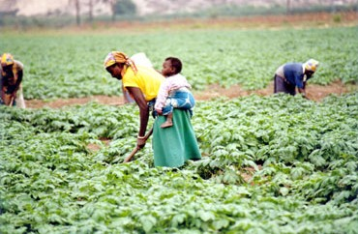

THE PROVINCE OF BENGUELA

Famous for its beaches, Benguela is situated on the coast in the centre of Angola. It has a tremendous geographical diversity and owes its name to the Benguela cold stream which runs from Antarctica, creating a special environment for a great variety of fish. Its location makes Benguela an important connection between the country's different regions.

Benguela is the second Angolan industrial park. The main cities of the province of Benguela are the cities of Benguela, Lobito, were the main Angolan Port is located and Baía Farta.

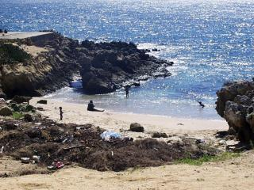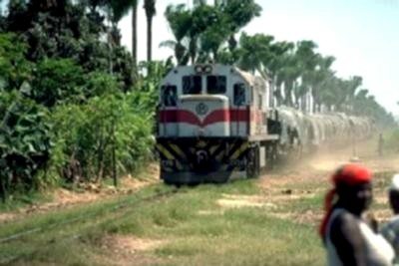
HOW TO INVEST IN ANGOLA - NATIONAL PRIVATE INVESTMENT AGENCY – ANIP
THE PROVINCE OF CABINDA

Cabinda has been a City since 28th May, 1956. It is 209 m above sea level. The people are of Bakongo origin, composed by the following ethnic groups: Bawoyo, Bacongo, Babaling, Bassundi, Bavili and Bacotche. Cabinda has an area of 7.270 km2, and has four municipalities: Cabinda, Cacongo, Buco-Zau and Belize. It has an equatorial climate, the average temperature being 25ºC, with an altitude of 209 metres. The mainstay of the province's income is oil and timber.

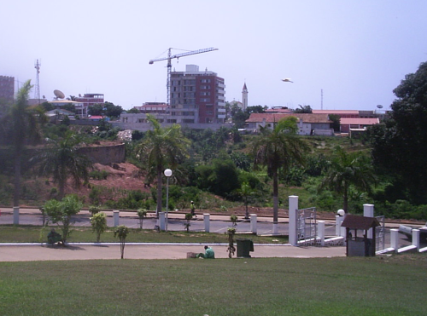

THE PROVINCE OF KUANZA SUL

Founded in 1769 of the mouth of the River Ngunza by Dom Francisco Inocêncio de Sousa Coutinho, at the time General Governor of Angola. Sumbe is the capital city of the province of Kuanza Sul, which has a surface of 55, 660 km2. The province has mountainous areas and plains with a varied relief. The altitude is between zero and 500 metres, as in the municipalities of Sumbe and Porto Amboim. Most of the province is between 1,000 and 15,000 metres high. Fishing is the main economic activity.

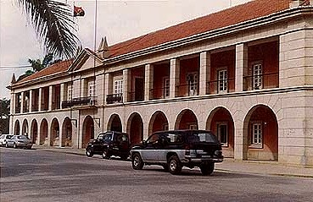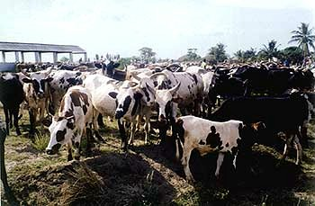
HOW TO INVEST IN ANGOLA - NATIONAL PRIVATE INVESTMENT AGENCY – ANIP
THE PROVINCE OF NAMIBE

This is the greatest fishing centre of Angola, the province of Namibe is named after the desert which occupies the majority of its area. It is famous around the world for a rare plant which is found here, the Welwitchia Mirabilis. Its capital is in an enormous bay which deadens the fury of the Atlantic waves, creating some of the finest beaches in the world. The Moçâmedes railway (CFM) leaves the port of Namibe, connecting the coastline to the iron mines of Jamba in Huíla. The main cities are Namibe and Tômbwa.

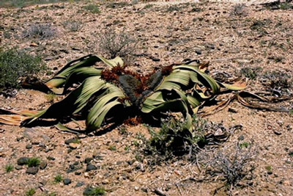
THE PROVINCE OF HUÍLA

Lubango is the capital city of the province of Huíla, which has an area or 75, 002 km2. The main municipalities are Quilengues, Lubango, Humpata, Chibia, Chiange, Quipungo, Caluquembe, Caconda, Chicomba, Matala, lamba, Chipindo and Kuvango. The municipality of Humpata has great tourist potential. It was where the first colonies were set up, due to the natural beauty of the area. The Fenda do Alto Bambi, the Cristo Rei Belvedere, the Barragens (Dams) das Neves show other spots which are an absolute must for the tourist. The main economic activities are agriculture and rearing of stock.

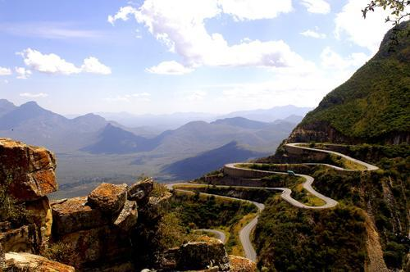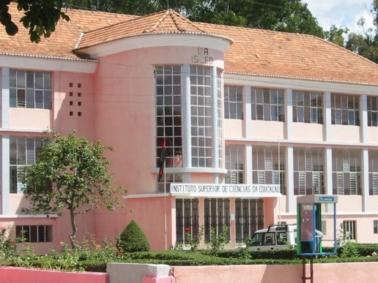
HOW TO INVEST IN ANGOLA - NATIONAL PRIVATE INVESTMENT AGENCY – ANIP
THE PROVINCE OF ZAIRE

The river Congo runs along the frontier between this province in northern Angola and the Democratic Republic of the Congo, which separates the enclave of Cabinda from the rest of Angola. To the east, the province of Zaire is flanked by Uíge, to the south, by Bengo and to the west by the Atlantic Ocean.
The lush vegetation oscillates between forest and savannah. The main agricultural product is manioc, but the agreeable climate also favours the farming of coffee, citrus fruits, sisal and other fruits. Traditional fishing methods are practised along the coast and at N'Zeto, there are a great number of salt flats. However, the oil industry provides this province with its greatest source of wealth.

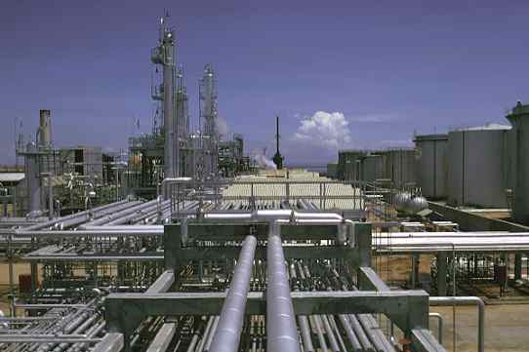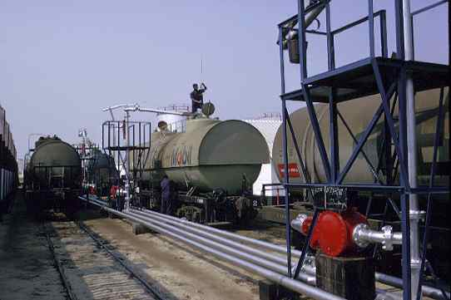

THE PROVINCE OF UÍGE

345 km from Luanda, it has an area of 58.698 km2, and its population is estimated at 800.000 in habitants. The main economic activity is agriculture. Uige was the heartland of Angola’s coffee production during the colonial era. The province was divided into vast rocas (plantations) by the Portuguese who found the soil and climate ideal for robusta coffee.

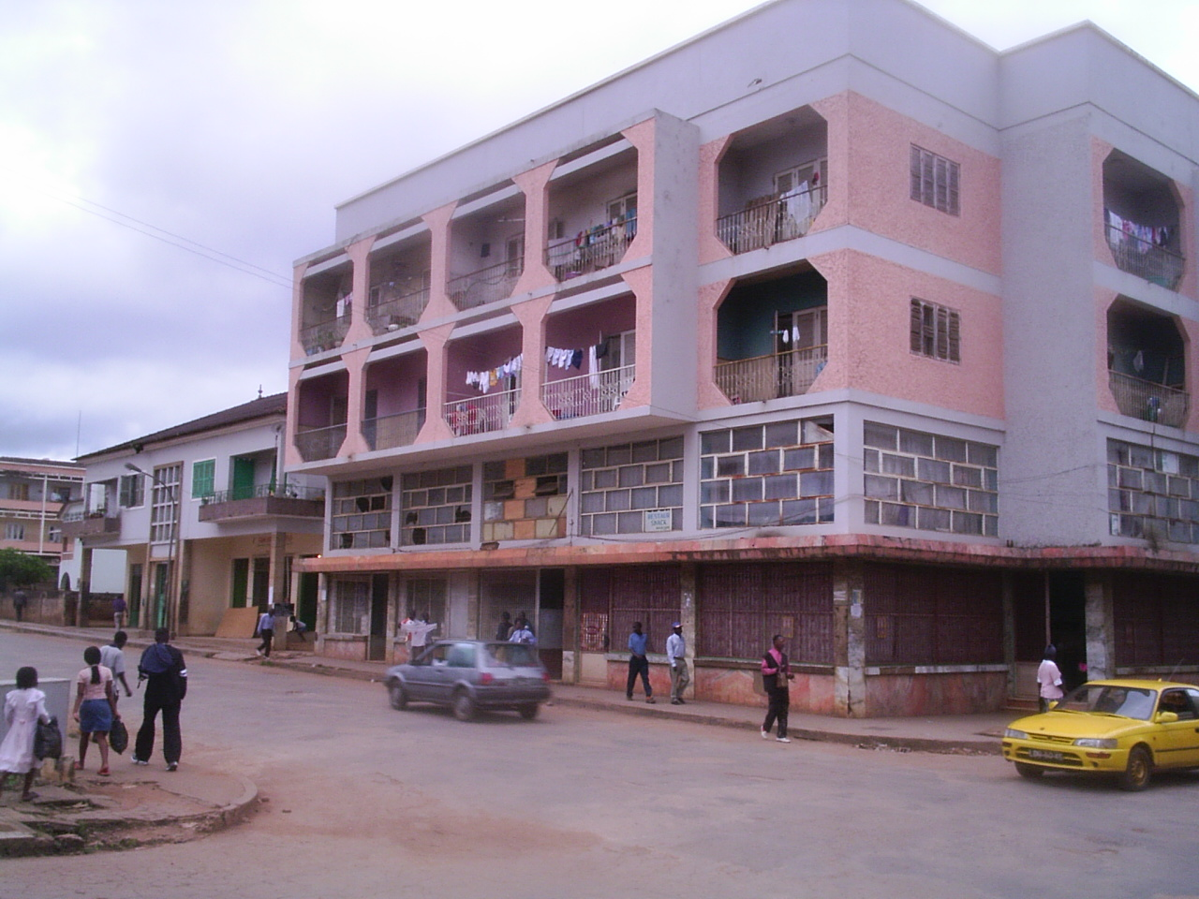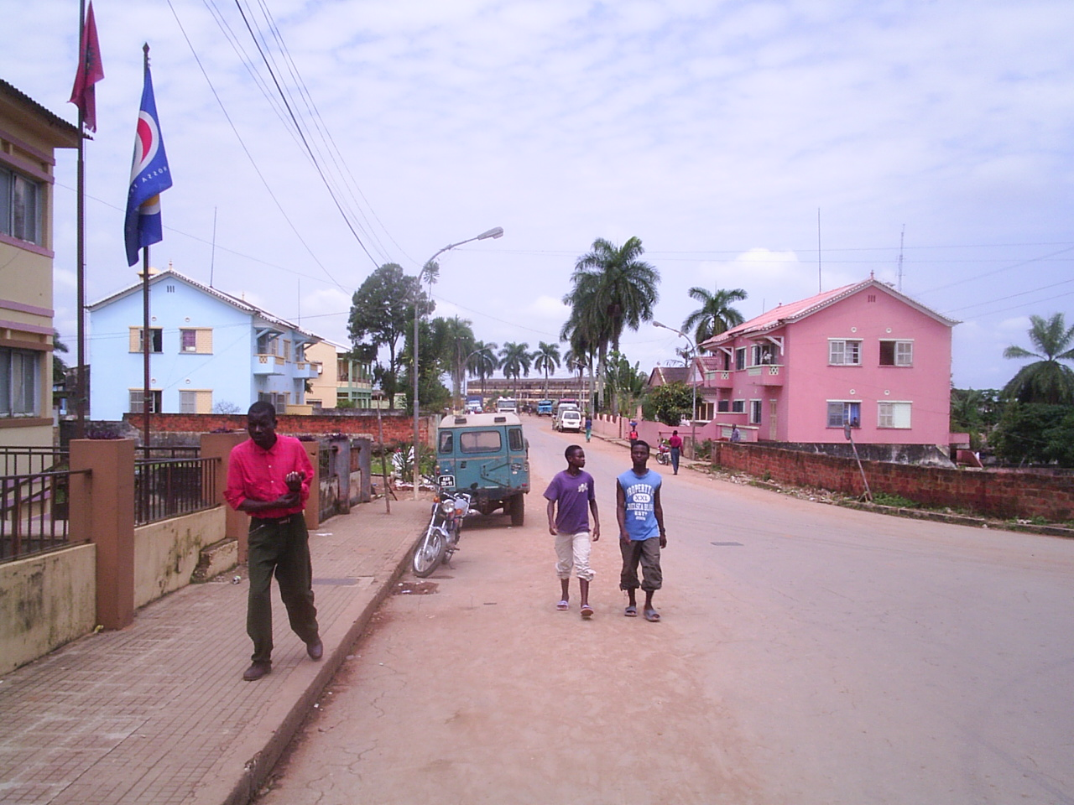

HOW TO INVEST IN ANGOLA - NATIONAL PRIVATE INVESTMENT AGENCY – ANIP
THE PROVINCE OF HUAMBO

The capital city of this province, which has an area of 34, 270 km2, has the same name. The main economic activity is agriculture. Paiva Coteiro was the first specialist to study the region of Huambo and he arrived at the conclusion that it has all the conditions to accommodate urban centres, due to its excellent climate, geographical position favourable for agriculture, a good hydrographic grid, friendly population and network of rivers for fishing and swimming. Before independence Huambo has the third industrial park.

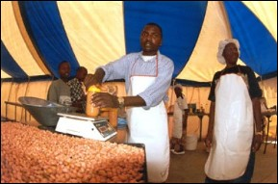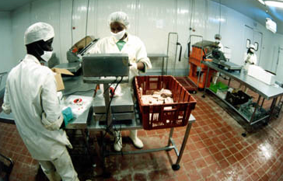

THE PROVINCE OF KUANZA NORTE

248 km east of Luanda is N'dalatando, capital of the province of Kwanza Norte, which is flanked by Bengo to the west, Uige to the north, Malange to the east and Kwanza Sul to the south. This region is characterised by plains and forests and has a tropical, humid climate, with an average temperature of between 22 and 24°C. The province has an area of 24 110 km2 and has 13 municipalities. The reason why the main industrial complex in Cambambe is due to the fact that here is the largest hydro-electric dam in Angola, which supplies water to the northem provinces and Luanda. Kwanza Norte also has various mineral resources, such as copper, iron, manganese and diamonds.

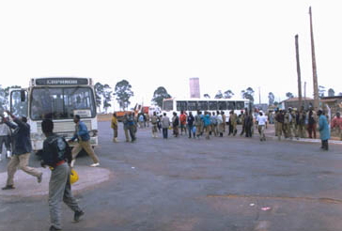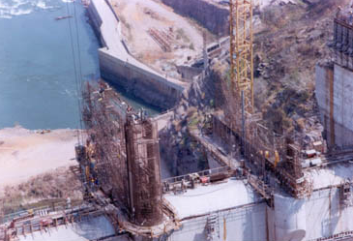

HOW TO INVEST IN ANGOLA - NATIONAL PRIVATE INVESTMENT AGENCY – ANIP
THE PROVINCE OF KUANDO KUBANGO

Kuando Kubango is the second largest province in Angola, after Moxico. It is situated in the south-west of the country and borders on the provinces of Bié and Moxico to the north, with Huíla and Cunene to the west, with Moxico and the Republic of Zambia to the east and the Republic of Namibia to the south.

The city of Menongue was founded on the banks of the River Kuebe and due to the tremendous efforts of its inhabitants, offers the visitor an architectural beauty which is second to none, apart from breathtaking landscapes which can be seen at the wonderful Dório Cambumbe Dam, eight kilometres outside the city, the River Kuebe swimming pool, the zoo and the Trade Fair in the city centre. It has an area of 199,049 km² and the population lives mainly from agriculture.

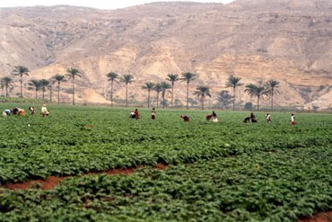
THE PROVINCE OF BÍE

Bié is a vast plain with an area of 70,314 km², in the shape of a heart, in the geographical centre of Angola, in the municipality of Kamacupa, where the colonial power set up a statue of Christ the King. To the north, the province is flanked by Malanje; to the north-east, Lunda Sul; to the east, Moxico; to the south-west, Huíla; to the east, Huambo; to the north-west, Kwanza Sul and to the south, the province of Kuando Kubango. The main economic activity is agriculture.
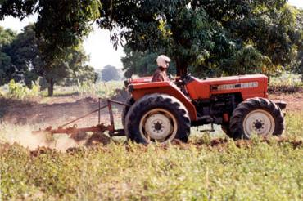
HOW TO INVEST IN ANGOLA - NATIONAL PRIVATE INVESTMENT AGENCY – ANIP
THE PROVINCE OF LUNDA SUL

The provínce of Lunda Sul (area 77.637 km²) was founded by Decree Law Nr.48/78, of the then Revolutionary Council which divided Lunda into two provinces, Lunda Norte and Lunda Sul. In prehistoric times, Cassai Sul was the place where the emigrants from the Lunda-Tchokwe Empire settled and Zona Cucumbi, Mona Quimbundo, Sueji and Itengo were the areas where the first military penetration by the Portuguese took place. The main economic activities nowadays are agriculture and mineral extraction. The main foodstuffs are mandioc, com, sweet potato and yam. Other activities are handicraft, fishing, diamond panning and handicraft.

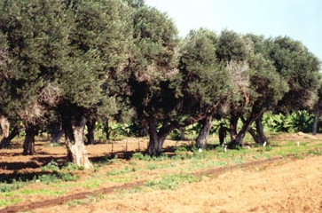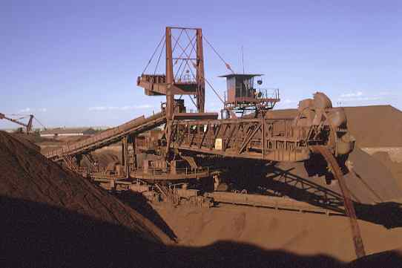

THE PROVINCE OF LUNDA NORTE

This province has an area of 102,783 km². It borders on the Republic of Zaire to the north, with Malanje to the east and with Lunda Sul to the south. A series of rivers and tributaries of the River Zaire crosses the province from south .to north, giving Lunda Norte great potential concerning water resources. A feature of these waterways are the important diamond deposits, which are an important source of wealth for the province.

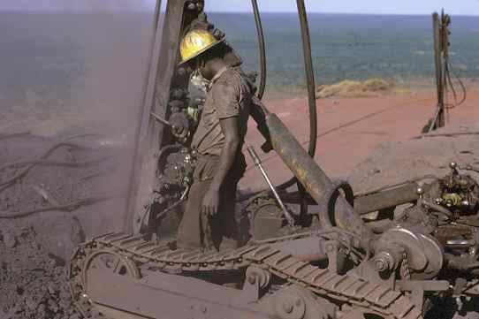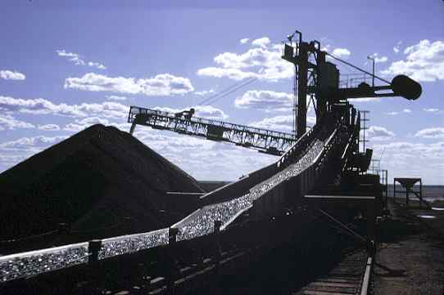

HOW TO INVEST IN ANGOLA - NATIONAL PRIVATE INVESTMENT AGENCY – ANIP
THE PROVINCE OF MALANGE

Malanje has a great number of tourist attractions, like the Pedras Negras de PungoAndongo, Morro do Bongo, Mesa da Rainha Ginga (Queen Ginga's Table), among others. Agriculture is the main economic activity, the main ingredients of the local diet are kizaca, usse, game, kihanza, ginguinga, which are always accompanied by mandioc or com porridge. There are three production centres of handicraft in Malanje, in the municipalities of Marimba, Quirima and Massango, where the products manufactured are baskets, sofás, dolls, seives, pestles and mortars and the hats of the sobas, or chiefs, called kijunga, wooden combs, pipes and many other objects.



THE PROVINCE OF MOXICO

Luena is the capital of Moxico, which has an area of 223.023 km². The main economic activity is agriculture. The people of this region practise hunting, fishing and subsistence agriculture. There is also a variety of handicraft, in pottery, fibres and sculpture. Coal, Copper, Manganese, Diamonds, Iron, Gold, Wolframite, Tin and Molybdenum, Uranium, Lignite can and be found in the province.
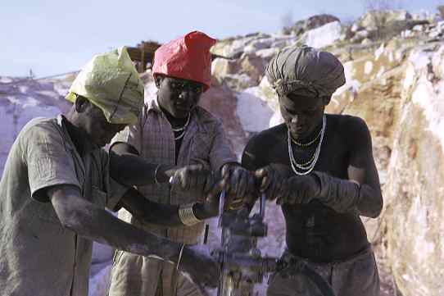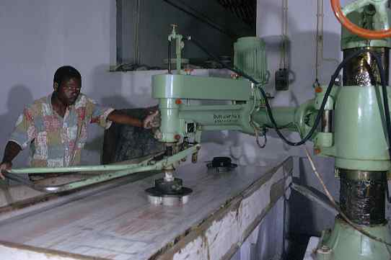
HOW TO INVEST IN ANGOLA - NATIONAL PRIVATE INVESTMENT AGENCY – ANIP
THE PROVINCE OF CUNENE

Ondjiva is the capital city of this province situated in the south of Angola, which has a dry tropical climate. The main economic activities being agriculture and cattle rearing. The province of Cunene, was founded on 10th July, 1970. It has a population of 487,687, of Koysan origin, most of the people living in rural communities.

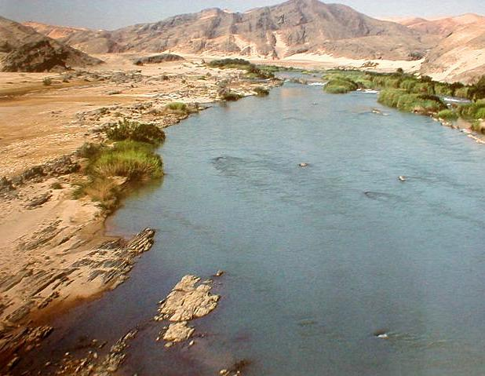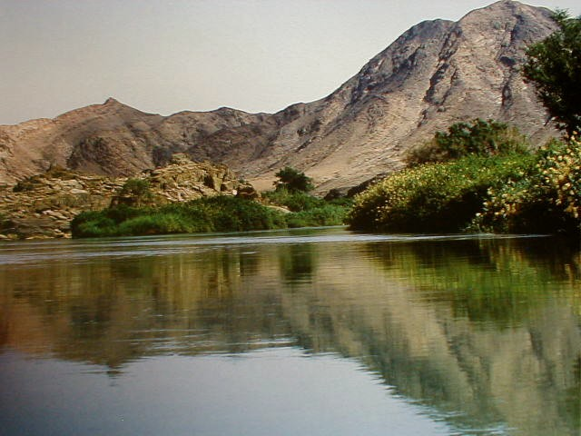

HOW TO INVEST IN ANGOLA - NATIONAL PRIVATE INVESTMENT AGENCY – ANIP
CONTACTS

www.parlamento.ao Assembleia Nacional
www.comissao-constitucional.gv.ao Angolan National Assembly's Constitutional Commission
www.mind-angola.com Angolan Ministry of Industry
www.mirex.ebonet.net Ministério das Relações Exteriores
www.minfin.gv.ao Ministério das Finanças
www.netangola.com/mcs Ministério da Comunicação Social
http://mineduc.snet.co.ao Ministério da Educação e Cultura
http://minfam.netangola.com Ministério da Família e Promoção da Mulher
www.mapess.gv.ao Ministério da Administração Publica, Emprego e Segurança Social

www.angola.org Embassy of Angola, Washington
www.angola.org.uk Embassy of Angola In The United Kingdom of Great Britain and Northern Ireland
www.embangola-can.org Republic of Angola, Embassy in Canada
www.angola.or.jp Embaixada da República de Angola no Japão
www.angola.org.br Embaixada da Republica de Angola no Brasil
www.embaixadadeangola.org Embaixada da República de Angola em Portugal
http://angolarussia.ru Embaixada de Angola na Rússia
www.embajadadeangola.com Embajada de Angola en el Reino de España
www.angolaembassyindia.com Embaixada de Angola na India
www.nzinga-mbandi.cu Embajada de Angola en Cuba
www.ambasciatangola.it Ambasciata della Repubblica di Angola presso la Repubblica Italiana
www.botschaftangola.de Embaixada da Republica de Angola na Alemanha
HOW TO INVEST IN ANGOLA - NATIONAL PRIVATE INVESTMENT AGENCY – ANIP
www.un.int/angola Missão Permanente da República de Angola nas Nações Unida
www.angola-consulate.org Consulado Geral de Angola em Houston
www.bna.ao National Bank of Angola
www.bpc.ao Banco de Poupança e credito
www.bancobai.com Banco Africano de Investimento
www.bfa.ao Banco Fomento Angola
www.bankeve.com Banco Regional do Keve
www.nexus.ao NeXus - Provedor Angolano de Internet
www.netangola.com NetAngola -Provedor Angolano de Internet
www.snet.co.ao Snet - Provedor de Serviços de Internet
www.angobusca.com Portal Angolano de Pesquisa e de Informação
www.abseicforum.com Angola Business, Social, Economic, Industrial, and Cultural Forum

www.mca.gov Millennium Challenge Corporation
www.agoa.gov African Growth and Opportunity Act
www.netangola.com/afi Associação Fiscal Angolana
www.imf.org/external/country/AGO/index.htm Angola and the IMF
www.cplp.org/paises/paises.html CPLP - Comunidade de Países de Língua Portuguesa
www.ccia.ebonet.net/english/main.html Angola Chamber of Commerce and Industry
www.aia-filda.com Angola Industrial Association
www2.ebonet.net/gpl/index.htm Luanda On-Line
www.luanda-roteiro.com Luanda Roteiro
www.benguela.net Benguela On-Line
www.netangola.com/kuanza-sul/ Kuanza Sul On-Line
HOW TO INVEST IN ANGOLA - NATIONAL PRIVATE INVESTMENT AGENCY – ANIP
www.classificados-angola.com Classificados de Angola On-Line
www.jornaldeangola.com Jornal de Angola
www.angolapress-angop.ao Angola Press
www.angolaenergy.com Angola Offshore
www.lobito.com Angola News
www.tpa.ao TPA On-line
www.rna.ao Angolan National Radio
www.ibinda.com Cabinda Digital

www.lemeridien-luanda.com Hotel Le Meridien - Luanda
www.hoteltivoli.com Hotel Tivoli - Luanda
www.netangola.com/hforum/ Hotel Forum
www.netangola.com/hcontinental/ Hotel Continental
www.geocities.com/hotel_avenida/ Hotel Avenida
www.royal-prestige.net Royal Prestige Luanda Chauffeurs
weather.yahoo.com/regional/AOXX.html Angola Weather (Yahoo)
www.fesa.og.ao Fundação Eduardo dos Santos
www.focoa-angola.org Friends of Children of Angola
www.aeaf.org Angola Educational Assistance Fund
www.kissama.org Kissama National Park Fund
www.oaang.org Ordem dos Advogados de Angola
www.inacom.og.ao Instituto Nacional de Telecomunicações
www.angolatelecom.com Angola Telecom
www.taag-airlines.com Taag Air Lines of Angola
www.sonangol.co.ao Sonangol Web Site
HOW TO INVEST IN ANGOLA - NATIONAL PRIVATE INVESTMENT AGENCY – ANIP
www.sonangol-usa.com Sonangol USA ("SONUSA")
www.sonils.co.ao SONILS - Sonangol Integrated Logistic Services
www.sonairsarl.com Sonair
www.endiama-angola.com Endiama - Empresa Nacional de Diamantes de Angola
www.catoca.com Sociedade Mineira de Catoca , Lda
www.chevron.com Crude Oil Marketing
www.cca.ws Commercial Communications Associates
www.inacom.og.ao Inacom On-line
www.planad.co.ao Planad On-line
www.orey.com/angola/english Orey Angola
www.toangola.com Portal Angolano de Emprego

Academic Institutions
www.avu.org – African Virtual University
www.ucan.edu - Universidade Católica de Angola
www.ist.utl.pt - Instituto Superior Técnico de Lisboa
csis.org/africa/angola.html - Center for Strategics and International Studies -CSIS
www.ndu.edu/inss/strforum/h6.html Woodrow Wilson Center

International Business, Small Business, World Trade

www.houston.org - Houston Chamber of Commerce
www.usachamber.com/houston - Chamber of Commerce of Houston ( Texas )
www.greatermiami.com - Greater Miami Chamber of Commerce
www.corpwatch.org – Education and activism , issues on human rights, labor rights and environmental justice
www.networkinggroups.com – Chambers of Commerce in the Metropolitan area around Washington D.C.
HOW TO INVEST IN ANGOLA - NATIONAL PRIVATE INVESTMENT AGENCY – ANIP
www.us-angola.org Us - Angola Chamber of Commerce
www.ibrooklyn.com - Brooklyn Chamber of Commerce ( New York )

www.worldchambers.com - Network of Chambers of Commerce
www.uncdf.org/mfmatters MicroFinance
www.traderoots.org - Trade with all countries in the world is what will keep our global economy strong. After the events of September 11th it is evident that those countries that we trade with are those that are our friends. Opening trade barriers will lead to peace among nations.
www.calchamber.com - The goal of the California Chamber of Commerce is to serve as a resource and advocate for California employers. We have more than 100 years of experience helping California business do business. Representing more than 13,000 companies of all types and sizes, the California Chamber is one of the state's largest broad-based non-profit organizations.
www.flchamber.com - By working with local chambers of commerce across Florida, the Federation develops member benefits packages with substantial cost savings promoting new member growth and retention. The Federation also maximizes the collective strength of the participating chambers in the legislative process by providing them with information on key business issues and developing grassroots support when needed.
www.gccc.com - The Greater Cincinnati Chamber of Commerce is an organization of nearly 7,000 businesses in the eight-county Greater Cincinnati area of Southwestern Ohio, Northern Kentucky, and Southeastern Indiana. The Chamber works to enhance the economic vitality and quality of life, providing a wide array of programs, products and services that benefit the bottom line for members and others.
www.elpaso.org - The Greater El Paso Chamber of Commerce, the primary advocate for El Paso’s business community, is dedicated to building a strong economy and improving the quality of life in our regional, bi-national community.
www.kcchamber.com - There are a few things you should know about us. The Greater Kansas City Chamber of Commerce is the oldest, largest business organization serving the bistate area. Specifically, we encompass 47 staffers, an executive committee and board of directors serving and working with over 2,400 member companies in our bistate region.
www.lascruces.org - The Chamber's mission is achieved through the efforts of many volunteers, board members, and a professional fulltime staff of four, working together to make the Las Cruces business community better than ever. The work of the Chamber is divided into six divisions: Finance and Audit, Member Services, Marketing and Communications, Business Development, Governmental Affairs, and a newly added division, Special Events and Fund Raising.

HOW TO INVEST IN ANGOLA - NATIONAL PRIVATE INVESTMENT AGENCY – ANIP
www.greaterlouisville.com - Greater Louisville Inc., Metro Chamber of Commerce (KY)
www.rnychamber.com - Greater Rochester Metro Chamber of Commerce (NY)
www.wacochamber.com - Greater Waco Chamber of Commerce (TX)
www.intrade.org - The International Trade Alliance is an economic development organization of the Spokane Region. Our mission is to develop and expand international markets and trade for businesses while enhancing the image and competitiveness of the region as an international community with global attitude, awareness and communication strategies.
www.orangeny.org -The Chamber of Commerce of Orange County, Inc. is an organization of business and professional men and women who have joined together to promote the commercial and civic progress of our community. The Chamber's mission is to be recognized as the region's leading organization committed to building a strong, unified business community.
www.johnsoncitytn.com - Johnson City/Jonesborough/Washington County Chamber of Commerce (TN)
www.myjaxchamber.com - Jacksonville Chamber of Commerce (FL)
www.naita.org - The North Alabama International Trade Association (NAITA) was created in the early 80's by forward thinking individuals in the Madison County Commission, namely Chairman Mike Gillespie, Ms. Peggy Barnard, and Ms. Anne Burkett.
www.mobilechamber.com - Mobile Chamber of Commerce (AL)
www.naperville.net - Naperville Area Chamber of Commerce (IL)
www.gnofn.org - New Orleans Chamber of Commerce (LA)
www.norcalwtc.org - The Northern California World Trade Center (NCWTC), located in the Capital City, serves as the regions premier international business development resource. Licensed by the World Trade Center Association (WTCA) in New York City, the NCWTC is affiliated with an international network of over 500,000 WTC members and 350 centers around the world.
www.nkychamber.com - Northern Kentucky is a vibrant region with great job opportunities, exciting visitor attractions and an exceptional quality of life. The Northern Kentucky Chamber of Commerce is the largest business organization in our region. Our members are actively involved in every aspect of our community.
www.orlando.org - The Orlando Regional Chamber of Commerce, Florida's largest Chamber with more than 8,500 member businesses, is the region's largest pro-business advocate. A wide range of outstanding business programs for members is offered throughout the seven county region.
www.winchesterva.org - The Winchester/Frederick County Chamber serves over 1,200 members, representing 40,000 employees. The Chamber supports economic development in our region by representing the interests of business in the government arena.
www.sdc.org - Socorro Chamber of Commerce (NM)
HOW TO INVEST IN ANGOLA - NATIONAL PRIVATE INVESTMENT AGENCY – ANIP
www.uncdf.org/mfmatters Microfinance MATTERS, the bi-monthly web publication from the United Nations Capital Development Fund
Business
www.cnctek.com - Web Database - provides database software to manage the information on the web site, methods to port the data stored on a PC database to the web site at a minimum coast. Set up and manage an on line members database with log in, log out and accounts management.
www.chamberbiz.com – Small business, resource offering news and educational information
www.usatrade.gov - Assistance to help business export goods and services to markets worldwide. They have also global listings of trade events and information on international trade research.
www.buyusa.com - Learn more about this unique e-marketplace created by the U.S. Department of Commerce and IBM.
www.interprest.com - Interprest Automation Inc
Financial International Institutions
www.miga.org - Established in 1995 as part of the Multilateral Investment Guarantee Agency (MIGA's) mandate to enhance foreign direct investment (FDI) in developing regions, the Investment Promotion Network (IPAnet) is the leading international investment-specific portal website providing free access to online foreign investment and privatization resources. Angola is member of MIGA.
www.opic.gov - OPIC's mission is "to mobilize and facilitate the participation of United States private capital and skills in the economic and social development of less developed countries and areas, and countries in transition from nonmarket to market economies, thereby complementing the development assistance objectives…"
www.imf.org - The IMF is an international organization of 183 member countries, established to promote international monetary cooperation, exchange stability, and orderly exchange arrangements; to foster economic growth and high levels of employment; and to provide temporary financial assistance.
www.worldbank.org - The World Bank Group is one of the world's largest sources of development assistance. In Fiscal Year 2001, the institution provided more than US$17 billion in loans to its client countries. It works in more than 100 developing economies with the primary focus of helping the poorest people and the poorest countries.
www.tda.gov - The U.S. Trade and Development Agency assists in the creation of jobs for Americans by helping U.S. companies pursue overseas business opportunities. Through the funding of feasibility studies, orientation visits, specialized training grants, business workshops, and various forms of technical assistance, we enable American businesses to compete for infrastructure and industrial projects in middle-income and developing countries.

ANGOLAN COMPANIES
Sistec – Sistemas Tecnologia e Indústria, SARL  Av. Che Guevara, 184- 195 – Luanda  PBX: 338776/336235/448700  Tels: 330404/325350 Fax: 332488  E-mail: sistec@netangola.com  Filiais: Benguela, Lobito, Lubango, Huambo, Cabinda, Sumbe e Gabela. www.sistec.co.ao  ECIL  Avenida 4 de Fevereiro, nº 35-36 – Luanda  Tel: 311236 Fax: 310417  Rua Comandante Valódia, nº 238 – Luanda  Tel: 449458  E-mail: ecil@ecilangola.com  Estilo a seu alcance, lar e escritório  Socogrel  Rua Américo Boa Vida, nº 59 – Luanda  Tel: 398791 Fax: 398792  E-mail: socogrel@snet.co.ao  Venda de Mobiliário, Lar e escritório, Consumíveis e Medicamentos Hospitalares  Abílio de Amorim e Filhos, Lda  Rua Comércio – Cabinda  Tel: 22293 Fax: 23729  E-mail: a.amorim@ebonet.net  Extracção, Concentração e Transporte de Madeira em Bruto. Semi transformação.  Serrados. Caixilharia. Paletes e Mobiliário  SML – Sociedade Mineira de Lucapa  Av. Lenin, nº 10 – Luanda  Tel: 371284 Fax: 398752  E-mail: sml@ebonet.net  Prospecção, Pesquisa, Exploração e Comercialização de Diamantes  Embal – Indústria de Embalagens Metálicas, SARL.  Rua do Farol das Lagostas, km 1 CP 1580 – Cacuaco – Luanda  Tels: 840139/840087 Fax: 840716 TM: 091500420  E-mail: embal@netangola.com  Embalagens metálicas para enchimentos de óleos/ lubrificantes, etc  Tecnometal  Estrada Cacuaco Km 4,5 CP 5376 – Luanda  Tel: 840064 Fax: 840632  E-mail: tecnometal@ebonet.net  Mobiliário Metálico Escolar e Hospitalar  Socográfica – Sociedade Comer. E Gráfica de Angola, Lda  Rua Santa Bárbara – Bairro do Kinanga – CP 6998 – Luanda  Tel: 350357 Fax: 351556  E-mail: socografica@co.ao  Trabalhos Gráficos  SDM – Sociedade de Desenv. Mineiro de Angola, SARL  Parque Empresarial Odebrecht – Avenida Pedro de Castro Van-Dunem “Loy”, S/N  Bloco D- Luanda Sul  Tels: 398001/676772/676782 Fax: 676729  E-mail: stinfo@sdm.net  Empresa que aposta no futuro e contribui para o desenvolvimento de Angola  Socolas – Sociedade Industrial de Colas, Lda  Avenida de Portugal, nº 45 – Luanda  Tels: 333260/333892 Fax: 391429  E-mail: socolas.lda@hotmail.com  Fábrica: Estrada de cacuaco Km 3, Tel: 840057  Colas de Contacto, Cola Branca, Colas para Escritórios e Escolas. Especiais para PVC, Encadernação. Rotulagem. Embalagens, etc.  Catoca – Sociedade Mineira de Catoca, Lda  Rua Major Kanhangulo, nº 100 – 4ºA Edifício Endiama – Luanda  Tels: 676990/1/2/3 Fax: 394378  Chemine Catoca Tels: 676000/399394  Investindo na educação e no conhecimento, valores tão inestimáveis e duradouros quanto os nossos diamantes www.catoca.com  Cipal - Companhia Industrial de Plásticos de Angola  Rua N`Gola, nº 440 – 1º Esq CP 741 – Luanda  Tels: 381330/381265 Fax: 381338  E-mail: enepa@ebonet.net  Indústria de Plástico. Artigos injectados : menage e industriais. Artigos extrudidos e insuflados.  Sonangola Distribuidora  Rua Amílcar Cabral, nº 110 – Luanda  Tel: 392190 Fax: 392190  Qualidade, Confiança e Desenvolvimento  Octo Mar, Lda. – Serviços Marítimos  Rua Engenheiro Costa Serrão, nº 13 CP 2889 – Luanda  Tels: 390417/390713/390279 Fax: 390007  E-mail: octomar@snet.co.ao  Prestação de Serviços à Indústria Petrolífera www.octomar.com  Siga – Sociedade Industrial de Grossarias de Angola, SARL  Rua Porto Santo, nº 24C – CP 2450 – Luanda  Tels: 380051/2 Fax: 382159  E-mail: siga@netangola.com  Sacaria de plástico alta e baixa densidade. Impressão em flexografia. Produtos injectados, ménage e industriais.  Pride Foramer (Sucursal Angola)  Rua do Futungo, nº 54 – Luanda  Tels: 262127/262130 Fax: 260074  E-mail: secretary@pridegloball.com  Prestação de Serviços à Indústria Petrolífera (perfuração e manutenção petrolífera)  Statoil Angola, SA  Rua de Benguela, nº 17 R/c – Bairro Patrície Lumumba – Luanda  Tels: 448080/448203 Fax: 448203  E-mail: stewes@netangola.com  Pesquisa e Produção de Petróleo  Confecções Éden  Rua das Forças Armadas, junto ao Centro Emissor, Bairro Gika, CP 487 – Cabinda  TM: 091547360/092510149/092424503 Fax: (2442)399494  E-mail: cbuza@hotmail.com  Filiais: Representação em Luanda  Rua dos Militares, 66 – Prenda Tel: (02) 353842/091207584/092510149 Indústria de Confecções. Calçado.  Leonel Miguel – Atelier  Rua Sebastião Desta Vez, nº 35 R/c Esq Bairro Valódia - Luanda  Tel: 446571 TM: 091520925/092326871  E-mail: leomiguel@hotmail.com  Roupa por medida para homens e senhoras. Roupas clássicas. Uniformes e trajes académicos, togas e peças em série  Maconclass  Base Golfo – Luanda  Tels : 470520/470660  E-mail : macontaxi@macon.netangola.com  Ideal para empresários, executivos e turistas que exigem conforto e privacidade. Disponíveis 24 horas por dia, vêm equipados com ar condicionado.  Azzurra Viagens e Turismo, Lda  Rua Américo Boavida, nº 127, (junto aos cinemas alfa) – Luanda  Tels: 396332/393282 Fax: 393287  E-mail: azzurrz@ebonet.net  Intours – Viagens e Turismo, Lda  Rua Martin Luther King, nº 57- 67, CP 2464 – Luanda  Tels: 244-2-393777/396650 Fax: 244-2-394297  Progest – Projectos Técnicos, Consultoria e Gestão, Lda  Rua Rainha Ginga, nº 147 – 2º Andar Dtº. – Luanda  Tels: 392246/397337  E-mail: progest@ebonet.net  Execução de projectos de arquitectura e engenharia. Direcção, fiscalização e gestão de obras.  Consult – Sociedade de Estudos e Consultoria, Lda  Rua Rei Katiavala, nº 33 – 1º Andar – Luanda  Tel: 448775 Fax: 442766  Rua Amílcar Cabral, nº 27 – 1º Andar – Luanda  Tels: 335394/335395 Fax: 335396  Rua Comdt. Kassage, nº 86 – Benguela  Tel: (072) 34667  Rua Dr. Lacerda, nº 75- 76 – Cidade Alta – Huambo  Tel: (041) 20246  Consultoria em Economia. Engenharia e Advocacia. Auditorias. Estudos de viabilidades. Elaboração de projectos. Processamento de contabilidade. Formação profissional.  Anglodente Policlínica  Rua da Caripande 1ª Travessa, nº 7 Bairro da Maianga  Tels: 331080/336445/337914/398005 Fax: 398007  E-mail: anglodente@netangola.com/anglodente-dg@hotmail.com  Serviços de Saúde. Especialidade: Odonto-estomatologia. Imatologia. Laboratórios.  Centro de Medicina Física e reabilitação  Rua da Samba, nº 19 – Luanda  Tel: 352110 Fax: 354389  E-mail: emfr@ebonet.net  Dulcaf – Equipamento Médico, Lda  Rua Rainha Ginga, nº 64 – Luanda  Tel: 398878 Fax: 399349  E-mail: dulcaf@netangola.com  Comércio de medicamentos e equipamentos médicos.  Clínica Sagrada Esperança – Endiama  Avenida Murtala Mohamed – Ilha de Luanda  Tels: 309034/309360/309379/309688 Fax: 309033 TM: 091501348  E-mail: sagradaesp@ebonet.net  Cuidados Intensivos. Emergência. Estomatologia. Bloco Operatório. Tac. Fisioterapia. Hidroterapia. Serviço de Ambulância.  Tecnimed – Equipamento e Material Hospitalar, Lda  Av. Comandante Gika, nº 237- 239 – CP 4082 – Luanda  Tels: 321898/324816/324826/324838 Fax: 321898/324816/384826  TM: 091502456/091500872/092400600  E-mail: tecnimed@snet.co.ao  Vocacionada para servir Hospitais, Clínicas e Centros de Saúde. Fornece e Instala Equipamentos de alta Tecnologia “Siemens”, “Kodak”, “Sirona”, “Zeiss” e “Radiometer”.  Africa Pharmacy, Lda  Estrada de Cacuaco Km 4 e 5, Armazéns da Siccal, Mulemba – Luanda  Tel: (02) 841733  E-mail: shalina@netangola.com  Distribuidor dos Produtos Shalina Medicamentos de qualidade a preços acessíveis. www.shalina.com  Ervanária Ferreira  Rua Augusto Tadeu Bastos, nº 1D R/c – CP 12159 – Luanda  Tel: 335427 Fax: 335427  Comércio e retalho. Produtos Naturais.  Campos Oculista  Rua 1º Congresso do MPLA, nº13A – Luanda  Tel: 336038 Fax: 336038  E-mail: camposoculista@hotmail.com  Rapidez mais eficiência. Lentes e armações.  Colégio Gregório Semedo  Rua Kwame N´krumah, nº 16-18 – Luanda  Fax: 394668  Colégio Isaac Newton  Rua Hélder Neto, nº 50 – Alvalade – Luanda  Tel: 323399 Fax: 323399 TM: 091221072  Colégio Winnie Solange  Rua Comandante Daky Doy, nº 76-78 – Luanda  Tel: 355051 Fax: 377582 TM: 091501725  Botão de Gente – Creche  Rua Américo Júlio de carvalho, nº 137 – Bairro Azul – Luanda  Tel: 351407  Transporte e piscina.  Escola de Condução a Benigna, Lda  Rua Moisés Cardoso, nº 69 Cave – Maianga – Luanda  Tel. 370706 Fax: 370706 TM: 091206447  E-mail: abenigna@snet.co.ao  Instrução auto  Angoalissar Comercial  Rua Luís da Mota Feo – Luanda  Tel: 395349 Fax: 395378  Comércio e Serviços  Angop – Agência Angola Press  Rua Rei Katiavala, nº 120-122 – Luanda  Tel: 447343 Fax: 447343  E-mail: angop@netangola.com  Jornal de Angola, Edições Novembro E.P  Rua Rainha Ginga, nº 18724 – CP 1312 – Luanda  Tels: 33334/3335105/331619 Fax: 331679  E-mail: jornaldeangola@netangola.com  Lac – Luanda – Antena Comercial  Praceta Luther King, nº 5 CP 3521 – Luanda  Tel: 395040 Fax: 396229  E-mail: lac@ebonet.net  Imprima Brindes Publicitários, Lda  Rua Cónego Manuel das Neves, nº 160 – 1º Andar – Luanda  Tel: 447729 Fax: 446806  E-mail: imprima@snet.co.ao  Impressão em bonés, esferográficas, isqueiros, porta-chaves, autocolantes, fardas, equipamentos desportivos, etc.  Postglogal, Informática Impor & Expor, Lda  Rua Moisés Cardoso, nº 67-72 – Luanda  Comandante Valódia – Luanda  Tels: 390288/335424 Fax: 335667 TM: 092304766  E-mail: postglobal@netangola.com  Novagest – Serviços e Gestão, Lda  Av. Lenine, nº 78 R/c – Luanda  Tels: 371270/371307 Fax: 372019  E-mail: novagest@multitel.co.ao  Gestão hoteleira/catering  Alameda Hotel Escola  Alameda Manuel Van-Dunem, nº 109 – Luanda  Tel: 444850 Fax: 442410  E-mail: hotelalameda@netangola.com  Hotel Continental  Rua Rainha Ginga, nº 18-21 – Luanda  Tel: 334241 Fax: 392735  E-mail: hotelcontinentallda@netangola.com  Rua Manuel Fernando Caldeira, nº 2 – CP 5150 – Luanda  Tels: 334241/334244/392384/395735  Faxs: 392735/392890  Pensão Invicta – Sermaesa, Lda  Rua Comandante Valódia, nº 46-52 – CP 3544 – Luanda Tels: 446377/447853 Fax: 447853 TM: 091503654 E-mail: smes@netangola.com  Pensão Salalé  Rua Fernando Pessoa, nº 110 – Vila Alice – Luanda  Tel: 321308 Fax: 321303 TM: 091208621/092344393  E-mail: pensalalale@yahoo.com  Restaurante Bar Escondidinho  Rua Cândido dos Reis, nº 7-9 CP 1893 – Benguela  Tel: 7233206 Fax: 7233206 TM: 091575546  E-mail: escondidinho@netangola.com  Restaurante, Turismo e Rent Car.  AIR GEMINI, Angola – companhia Transportes Aéreos, Lda  Guilherme Pereira Inglês, nº 43 – 3ºB – Luanda  Tels: 355511/355779/336199/336405/336426  Operações: Avenida 21 de Janeiro  E-mail: airgemini@ebonet.net  Transporte Aéreo com Segurança, Pontualidade, Inovação e Nível Internacional.  SONAIR – Serviço Aéreo  Aeroporto Internacional 4 de Fevereiro – Luanda  Tel: 633502 Fax: 321995  E-mail: sonair@sonangol.co.ao  AMI – Angola, Lda  Rua Rei Katiavala, nº 65- 71 – Luanda  Tel: 444516 Fax: 441352  E-mail: ami@ebonet.net/ami@ami.ebonet.net  Secil Marítima  Avenida 4 de Fevereiro, nº 42 1ºA – CP 5910 – Luanda  Tels: 311334/310950 Fax: 311784 TM: 092606029  E-mail:  ameliarita@secil.snet.co.ao / dircomercial23@msn.com / secilmaritima@msn.com  Transportes Marítimos, de Passageiros e Cargas. Transitários. Agências de Navegação. Gestão Imobiliária.  Porto do Lobito  Av. Da Independência, nº 16 CP 16 – Lobito  Tel: 22712 Fax: 22718  E-mail: eplolobito@ebonet.net www.eplobito.com  Rodoviang – Rodoviária de Angola, Lda  Travessa André Vidal de Negreiros, nº 22-24 – Luanda  Tel: 392893 Fax: 336886  TCUL – Transporte Colectivo Urbano de Angola  Direcção Geral/ Serviços Comerciais  Base do Cazenga – Luanda  Tels: 381930/382117/382176/382009/382248  Fax/TM: 091501516  António Francisco António  Rua Luís Mota Feo, nº 2º - Apto.8 – Luanda  Tel: 310123 Fax: 311199 TM: 091505630  E-mail: kadila@snet.co.ao  Despachante Oficial – Alfândega de Luanda  Domingos Inácio Peres Barra  Rua Joaquim Kapango, nº 16-18 CP 984 – Luanda  Tel/Fax: 333725 TM: 091203799  Despachante Oficial.  Fausto mesquita Morais  Av. 4 de Fevereiro, nº 57 1º Andar sala 3 – Luanda  Tels: 337103/397352/3 Fax: 397352 TM: 092400681  E-mail: fmorais@snet.co.ao  Despachante Oficial  Neotrânsitos Transitários, Lda  Rua Francisco das Necessidades Castelo Branco, nº 75-77 – Luanda  Tel: 394978 Fax: 397686 TM: 092401803  E-mail: neotransitarios@netangola.com  Organizações Cateleco  Rua 1º Congresso do MPLA prédio 19 – Luanda  Tel: 333795 TM: 091517668/091225356/092443985  Transitário. Construção Civil. Comércio Indústria. Importação. Exportação. Exploração Mineira e Pescas.  SMI – Asl Transportes Marítimos , Lda  Lg. Bressane Leite, nº 12 – Luanda  Tel./Fax: 392510  E-mail: asl@ebonet.net  Transportes Marítimos. Agentes de Navegação, Operadores de Navios.  Sonangol Grupo  Rua 1º Congresso MPLA, nº 8-16 – Luanda  Tels: 636998/636997 Faxs: 391995/397728 www.sonangol.co.ao  Tanamont Angola, Lda  Rua Tipografia Mamã Titã, nº 8 R/c – Ingombota – Luanda  Tel: 392133 Fax: 397028  E-mail: tanamont@snet.co.ao  Representante exclusivo dos cigarros “Marlboro” em Angola  Chevron – Cabinda Gulf Oil company, Ltd  Avenida Lenine, nº 77 – Luanda  Tels: 392646/393093 Faxs: 394348/391849  ETA – Empresa dos Tabacos de Angola, SARL  Rua Major Kanhahgulo, nº 220 – Luanda  Tels: 336995/921 Fax: 336921  E-mail: eta@ebonet.net  Símbolo de boa qualidade  Nocal – Nova Empresa de Cervejas de Angola, SARL  Rua Porto Santo CP 538 – Luanda  Tel: 380244/46 Fax: 382177  E-mail: nocal@ebonet.net  Eka- Empresa Angolana de Cervejas  Rua Cónego Manuel das Neves, nº 403 R/c – Luanda  Tel: 444425 Fax: 444930  E-mail: eka@snet.co.ao  AGRAN – AGRO – QUÍMICA  Av. 4 de Fevereiro, nº 3-4 R/c – Luanda  Tels: 333594/5 Fax: 339499  Química e Tintas  ALFE – Alumínios  Rua Rei Katiavala, nº 143 – Luanda  Tel: 449244 Fax: 345244  Alumínios  ALONSUUS, Lda  Rua Roberto Shield´s, nº 11 2º Andar Apto. 9 – Luanda  Tel: 397149 Fax: 394539  Comércio Geral  AMI – Angola, Lda  Rua Rey Katiavala, nº 65-71 – Luanda  Tel: 444516 Fax: 441352  Serviços e Manutenção  ANGASES  Tv. Boavista nº 30 – Luanda  Tels: 310505/310233 Fax: 310009  Química e Tintas  Agência de Viagens LPS e OMF de Cargas  Rua Conégo Manuel das Neves, nº 61A – Luanda  Tel: 430544 Fax: 432101 TM: 092318598  Agência de Viagens |  | Cabire - Alimentos, Lda  Rua Luis ya Kwanga, nº 135 - R/c Zona 13  Bairro Sambizanga - Luanda  Tel. 381256 / 383529 Fax. 380283 TM. 092406906  Comercialização e distribuição de produtos alimentares . Congelados . Bebidas . Produtos de Limpeza  Tanamont Angola, Lda  Rua Tipografia Mamatita nº.8 R/c - Luanda  Tel. 392133 Fax. 397028  Comércio Geral, Representação exclusivo dos cigarros "Marlboro" em Angola  Sovidro, Lda  Av. Revolução de Outubro, nº 139-141 - Luanda  Tel. 397249 . Fax. 396447  Vidros (Duplos e Planos) . Espelhos  Prividephi, Sociedade Comercial e Industrial, Lda.  Rua Cristiano dos Santos nº15 - Luanda  Tel. 091514297 / 092417011  Venda de todo o tipo de frescos a grosso e a retalho  Mini-Mercado Tina  Rua amilcar Cabral, nº135A - Luanda  Tel. 339928  Maria da Conceição Rodrigues Mendes Sobrinho, Lda  Rua do Comércio CP 123 - Cabinda  Tel. (031)22470 / 23164 Fax. (031)23164  Comércio Geral  Importação e Exportação  Navegação  Madicar, Lda  Rua Ndunduma, nº 248 R/c - Miramar - Luanda  TM. 091515609  Mabílio M. Alburquerque  Rua Major Kanhagulo, nº29 - Luanda  Tel. 333285 Fax. 338179  Lugomaco, Lda  Rua Machado dos Santos, nº78 CP 154 - Benguela  Tel. 34653 Fax. 34630  E-mail. lugomaco@supernet.ao  Luapor Comércio e Industria, Lda  Tipografia Mamã Tita, nº2 R/c - Luanda  Tel. 394935 Fax. 397082  Computadores . POS . Software de Gestão . Impressoras . Faxes . Maq. Calcular e Escrever . Mobiliário Escolar e de Escritório . Consumíveis . Tipografia  Karitoco Lda  Rua Comandante Kassange nº. 41 CP 278 - Benguela  Tel. 33717 Fax. 34900  Ledil - Comércio e Industria, Lda  Av. Comandante Valodia, nº 138-140 - Luanda  Tel. 441103 Fax. 442509  E-mail. grupoledil@netangola.com  José Luís de Carvalho  Av. Comandante Calódia, nº 78-A CP 6679 - Angola  Tel. 445062/3/4 Fax. 442896  Rua Machado dos Santos, 34-36 - Benguela  Tel. 32781/2/3 Fax 35024  Material eláctrico . Ferramentas e máquinas . Equipamento para Indústria de confecções . Consumíveis para Índustris . Agricultura e Construção  Irmãos Patrício, Construção e Comercio, Lda  Rua Conégo Manuel das Neves, 376-B - Luanda  Tels. 449209 / 336440910 Fax. 442130  E-mail. irmaospatricio@mail.com  Filiais Rua Rei Katiavala, 89-A  Grupo Chicoil S.A.R.L.  Rua Hoji-Ya-Henda, nº40 Ap. 1 e 2 - Luanda  Tel. 449288 Fax. 448152 TM. 091216656  E-mail. chicoil@ebonet.net  Forçalis Angola comércio e Indústria Sarl  Rua Pedro Félix machado, nº50-58 - Luanda  Tel. 337249 Fax. 336472  E-mail. forcalis@netangola.com  Fermil - Comercio Geral  Rua Assalto de Moncada, nº24 CP 512 - Luanda  Tel. 392015 Fax. 372524  E-mail. fermil@snet.co.ao  Eléctrica Comercial Lda  Av. Amílcar Cabral, nº81-83 - Luanda  Tel. 33 27 32  Costimanas - Comercio Geral Imp. e Exp, Lda  Rua Hoji Yá Henda, nº63 R/c - Luanda  Tel. 383700 Fax. 383700  Email. costimanas@snet.co.ao  Corma, Lda  Rua bernadino Correia, nº 45 Cp 1413 - Benguela  Tel. 32883/32289 Fax. 35602  E-mail. corma@netangola.com  Concentra, Comércio e Representações, Lda  Rua Cónego Manuel das Neves, nº382 - Luanda  Tel. 448240 Fax. 449313  E-mail. comercial@concentra.holding.com  Cirilos Comércio e Representações Lda.  Luis Mota Feo, nº10 - Luanda  Tel. 311519 Fax. 311233  Acessórios galvanizados e latão . Materiais de construção . Ferragens diversas . Tintas e vernizes . Material eléctrico . Loiça sanitária  AGRO Comercial Santos, Lda  Rua Ex. Eugénio de Castro nº 179 - Vila Alice - Luanda  Tel. 263807 Fax. 260641  Tm. 091502746  E-mail. acsantos@snet.co.ao  Utilidades Domésticas . Alimentação . Higiene e Limpeza . Louça . Mobiliário  Instituto Nacional do Café de Angola  Rua 4 de Fevereiro, nº107-108 Luanda  Tel. 332888/96  Fax. 338678  E-mail. madias@snet.co.ao  BAI - Banco Africano de Investimento  Rua Major Kanhangulo n.34 CP 6022 - Luanda  Tels 335127 / 335749 / 336579  Faxs: 335486 / 393780  E-mail:baisede@bainet.ebonet.net www.bancobai.ao  ANGOLAVES - Empreendimentos Agro-Pecuários, Lda  Rua 8, Av. da Zona Industrial do Cazenga - Luanda  TM. 091501787 / 092404029 / 091503041  SOCIPESCA, Lda  Baia Farta - Benguela  Tel. 80343  NOVAGRO, Lda  Rua Cónego Manuel das Neves, nº168 A - CP 6881 - Luanda  Tel. 442647  Fax. 442647  TM. 091204696  E-mail. novagra@netangola.com  Comércio de produtos . Materiais e equipamentos agrícolas . Fertilizantes . Pesticidas . Pulverizadores  Jembas assistência Técnica  Largo do Soweto, nº88 - Luanda  Tel. 637000  Fax. 637037/8  E-mail. jembas@jembas.com  PECCUS - Companhia de Fomento Agro-Pecuário, Lda  Km 7, Estrada de Cacuaco, CP 1499  Tel. 840071  Fax. 840109  E-mail. teno.daf@snet.co.ao  ENSA - Seguros de Angola, Sarl  Av. 4 de Fevereiro nº.93 CP 5778 Luanda  Tel. 671671 / 332948 / 332990 / 332991  Fax. 671672  E-mail: segurado@ebsa.co.ao  BCI - Banco Comércio e Indústria  Rua Rainha Ginga, nº73 - Luanda Tel. 331433 Fax. 331588  BCA - Banco Comercial Angolano  Av. Comandante Valódia n.º 83A Luanda  Tels: 449548 / 449517 / 448849  Faxs: 449516  Telex: 2202 - swift:COMLAOLU  E-mail: bca@snet.co.ao  Cuca Bgi- Produção de Cervejas e Refrigerantes  Rua Ngola Kiluange, S/N, CP 1282- Luanda  Tels: 380041/380379 Faxs: 380379/380743  Covic- Complexo Vinícola Industrial e Comercial, Lda  Rua do Comércio – Cabinda  Tel/Fax: (031) 24378  Refrigerantes. Vinhos. Aguardentes  Bolama  Rua 5ª Avenida Zona Industrial do Cazenga, CP 14266 – Luanda  Tel: 380114  Peccus – Companhia de Fomento Agro-pecuário, Lda  Km 7, Estrada de Cacuaco, CP 1499  Tel: 840071 Fax: 840109  E-mail: tecno.daf@snet.co.ao  Carne Nacional  Lactiangol Lacticínios de Angola, SARL  Av. Deolinda Rodrigues km 5,5 – Luanda  Tel./Fax: 263379  E-mail: lactiangol@ebonet.net  Leite meio-gordo ultra pasteurizado/ homogeneizado. Gelados  Socifrio, Lda  Rua Craveiro Lopes – CP 127 – Cabinda  Tel: (031) 22590 TM: 091541824  Climatização. Refrigeração e Prestação de Serviços  Frigo Grupo – Comércio e Indústria, Lda  Rua Sebastião Desta Vez nº 25 – Luanda  Tels: 444207/27 Fax: 442760  E-mail: frigogrupo@hotmail.com/frigo-grupo@yahoo.com  Frio Doméstico, Industrial e ar condicionado. Câmaras frigoríficas. Máquinas de gelo  Arcond Comércio Geral e Prestação de Serviços, Lda  Av. Murtala Mohamed, nº 10 – Luanda  Tel: 309218 Fax: 309019 TM: 091500527  E-mail: arcond.pioneer@netangola.com  Ar condicionado “ Pioneer” Doméstico e Industrial. Geradores “Gesan”.  Comercialização e Assistência Técnica  Luata – Luz, água e telecomunicações de Angola, Lda  Mirantes de Talatona – Luanda-Sul  Tels: 370694/370711/460536 Faxs: 370694/370718  E-mail: luata@netangola.com  Serviços de Electricidade, Águas, Telecomunicações e Energia solar  Desco Angola, Lda  Rua de Kambambe, nº 2 – Miramar – Luanda  Tel: 444182 Fax: 445223 TM: 092325100  E-mail: desço.geral@mucomm.net/desco@mucomm.net  Distribuidor exclusivo. Grupos geradores “FG WILSON”. Motores “PERKINS”.  Alternadores “LEROY SOMER”.  Encel – Empresa Nacional de Construções e Indústrias Eléctricas  Rua Comandante Che Guevara, nº 185-187 – Luanda  Tel: 442055 Fax: 446759  E-mail: encel.dg@netangola.com  Condel – Fábrica de condutores eléctricos de Angola Sarl  5ª Avenida da Grande Zona Industrial do Cazenga – Luanda  Tels: 336320/336232/380077/380078 Fax: 337812  E-mail: condel@snet.co.ao  Fabrico e comercialização de cabos de energia  Telecomunicações e dados  Eusébios Angola - Construção Civil, Lda  Av. 4 de Fevereiro nº 89 - 1º Luanda  Tels. 396799 / 395994 . Fax. 395047  Tm. 091503042 . E-mail eusebios.angola@snet.co.ao  Construção Civil e Obras Públicas  Lutos - Sociedade de Gestão e Investimento, Lda  Bairro Palanca, Est. Mártires de Kapolo - CP 832 - Luanda  Tel. 371761 / 399801 . TM. 091500775/6 992500776  E-mail. lotus@lotus.co.ao www.lotus.co.ao  Mota & Companhia, SA  Rua Narciso do Espirito Santo nº54 Maianga - Luanda  Tels. 350552 / 350450 / 350263 . Fax. 350299  E-mail. motangola@ebonet.net  Construção . Obras Públicas . Empreiteiros . Construção Civil  Novo Muro, Lda  Estrada de Catete - km 19 - Viana - Luanda  Fax. 442292 . TM. 092302368 / 092403750  Construção Civil . Gestão de Hotéis  Organizações Cataleco  1º Congresso do Mpla, nº19 - Luanda  Tel. 333795 . TM 091522522  Construção Civil . Transitários . Comércio Internacional  Impor e Expor . Pescas  P.J.E, Lda Construção Civil e Obras Públicas  Rua do Comercio - Cabinda  Tel. (031)22162 . Fax. (031)24836  Construção . Obras Públicas - Materiais de Construção  Vigor, Lda  Rua Comandante Valódia, nº 265 CP 2579 - Luanda  Tel. 443891 / 443327 . Fax. 443327  Construção Civil . Obras públicas . Imobiliária  Piscinas . Spas . Saunas  APN - António Pereira Neves, Lda  Rua Agostinho Neto, apartado 326 - Cabinda  Tel. (031)22427 / 22662 / 22783 . Fax. (031)22349  Materiais de Construção . Carpintaria . Serração de Madeira  Artigos de Drogaria . Comercio Geral (Imp. e Exp.)  EFACOM  Rua Garcia Neto, nº122-126 São Paulo - Luanda  Tel. +244(2)447340 . Fax. 244(2)444954  E-mail. importrading@hotmail.com  Bairro do Palanca, lote A6 - Edificio Fermat  Kilamba Kiaxi - Luanda . Tel. +244(2)262793 / 262843  Empresa de fabricação e comercialização de materias de contrução  HÁBIMAT- Materiais de Construção, Lda  Major Kanhangulo(ex. Rua Direita) nº. 2-2C - Luanda  Tel. 331947 / 331948 / 331368 . Fax. 331947  E-mail. habimat@snet.co.ao  Materiais de cosntrução . Sanitários . Pavimentos  Azulejos . Mosaicos . Revestimentos e muito mais  ICER - Industrias de Cerâmica, Lda  Estrada da Petrangol, km 1,4 CP 2949 - Luanda  Tel. 398405 . Fax. 840181 . E-mail. icer@snet.co.ao  Oferece uma gama variada de produtos  ao serviço da Construção Civil  Concret. Lda  Rua Cónego Manuel da Neves, nº 405 C.P 14289 Luanda  Tel. 442022 Fax. 442022  Construção . Comércio Representações . Transporte . Importação e Exportação  Simportex  Rua Rainha Ginga, nº27 CP 2951 Luanda  Tel. 338983 Fax. 331192  E-mail. simportex@snet.co.ao  Comercialização de equipamentos e meios materiais . Importação e Exportação  TAAG – Linhas Aéreas de Angola  Rua da Missão, nº 123 – 11º - Luanda  Tel: 334889  E-mail: gci.taag@ebonet.net  Grupo Bartolomeu Dias  Rua Assalto de Moncada nº. 8 R/c Luanda  Tel. 395557 / 333387 Fax. 334518  E-mail. angoinform@ebonet.net  Segurança Industrial e Comercial . Equipamentosde Segurança – Turismo  Largo Brassano Leite, nº 23 1º B - Luanda  Tels: 393749 Fax: 336819 TM: 092501382  E-mail: thorus@netangola.com  Translider, Lda  Rua Joaquim Rodrigues da Graça, nº 30 – Luanda  Tels: 351134/353579351263 Fax: 351263 TM: 092336057  E-mail: translider@snet.co.ao  Filiais : Tel : (072) 25601 – Lobito  D .H .L  Rua Kwamme Nkrumah, nº 274-276 CP 1545 – Luanda  Tel: 395180 Fax: 390326  TM: 091501008  E-mail: ladreq@dhl.com  Angola Telecom  Rua Guilherme Pereira Inglês, nº 43 6º Andar CP 625 – Luanda  Tel: 395990 Fax: 391688 www.angolatelecom.com  Multichoice Angola  Rua Rainha Ginga, nº 190 – Luanda  Tel: 638348 Fax: 637040  E-mail: multichoiseangola@netangola.com  Multitel – Serviços de Telecomunicações, Lda  Rua Alfredo Tróni, Edifício do BPC 14º Andar CP 5957 – Luanda  Tel: 336778/391369 Fax: 337137 TM: 092300109  E-mail: dmonteiro@multitel.co.ao  Comunicações de dados, Internet, Cartões pré-pagos.  Tecnorede – Telecomunicações e Informática, Lda  Rua Guilherme Pereira Inglês, nº 42 –Luanda  Tel. 392710 TM:091508974  E-mail: paulaluiana@yahoo.com  Computadores. Rádio de Comunicações e Material Electrónico  Urbana 2000  Rua Rainha Ginga, nº 190 R/c – Luanda  Tel: 440082 Fax: 448214  E-mail: urbana@snet.co.ao  Epal  Sede: Rua Frederich Engels, nº 3 CP 1387 – Luanda  Tels: 335001/2/5 Fax: 330380  Área comercial: Rua Sebastião Desta vez, nº 7  Tels: 445270/1/2  Direcção da Rede de Distribuição: Rua Luís Pasteur  Tels: 441487/441447 E-mail: epalsdg@snet.co.ao  DSL – Divisão de Segurança, Lda  Rua Marquês das Minas, nº 11-13 – Luanda  Tel: 396680 Fax: 394749  E-mail: dirgeral@snet.co.ao  Segurança Patrimonial, Industrial, Electrónica, Escolta de Valores  A Distribuidora, Lda  Rua N´gola Kilunge, nº 168 – Luanda  Tel: 380729 Fax: 383750  Comercialização de café, Importação e Exportação  ACT – Angola Center Trade  Avenida 4 de Fevereiro, nº 52B – Luanda  Tel: 430544 Fax: 432101 TM: 092318598  Madeiras  ALFA 5  Largo do Kinaxixi, nº 210 – Luanda  Tels: 333588/332768/334922 Fax: 397566  Serviços e Manutenção  ADDP Marítima  Rua Kima Kienda – Luanda  Tel: 338781 Fax: 338762  Pesca e Salinas  ADS – Prestação de Serviços  Nelito Soares, nº 30 – Luanda  Tel: 363762  Agro-Pecuária e Café  Africa Commodities Trading  Rua 5 de Outubro, nº 55 – Luanda  Tel: 397560 Fax: 397560  Comércio e Serviços  Africonsult – Consultoria de Engenharia, Lda  Largo Cristóvão Falcão, nº 9 – Luanda  Tel: 448992 Fax: 443771  Consultoria de Engenharia  APN  Rua Dr. Agostinho Neto  Tel: 22662 Fax: 22427  Construção Civil e Obras Públicas

Source: AIA – Associação Industrial de Angola

CONTENTS

WHO ARE WE…………………………………………………….…………….….. 3

ANIP MISSION AND MAIN ACTIVITIES ………………………...….………… 4

I. ANGOLA
GENERAL DATA ………………………………………………....….…… 5

II. GENERAL OBJECTIVES OF THE ECONOMIC POLIC..………..……..... 6
OBJECTIVES OF THE MACRO-ECONOMIC POLICY FOR 2005.… 6
III. HOW TO INVEST ………………………………….……………….………… 7

IV. PROTECTION FOR BUSINESSES…………….…………..…………………. 8

V. INVESTMENT AREAS RESERVED EXCLUSIVELY BY THE
ANGOLAN GOVERNMENT ……..…………………………….…….…………… 9

VI. SECTORS IN WHICH THE GOVERNMENT MUST BE A
MAJORITY OR SENIOR PARTNER ………………………………….…………. 9

VII. MOST IMPORTANT BENEFITS, IN THE BASIC LAW FOR
PRIVATE INVESTMENT – LAW 11/03 OF 13th JULY 2003 ………………..…. 10

VIII. TAX INCENTIVES…………………………………………………..……….. 11

IX. DUTIES………………………………………………………………..………….13

X. PRIORITY AREAS FOR FOREIGN INVESTMENT………………...……….15

BUSINESS OPPORTUNITIES …………………………………….…..…….……. 16
THE CONSTRUCTION AND INFRASTRUCTURE SECTOR………….17
THE TRANSPORTATION SECTOR………………………………………20
AGRICULTURE AND LIVESTOCK SECTOR……….……………….… 28
THE TELECOMMUNICATIONS SECTOR………………………..……. 30
THE POWER SECTOR……………………………………………..……….37
THE WATER SECTOR…………………………………………………….. 41
THE MINING SECTOR………………………………………………….…..43
INDUSTRIAL MINERALS …………………………………………….……46
MANUFACTURING INDUSTRY SECTOR………………………...……..47
FISHING SECTOR……………………………………………………..…….49
THE OIL SECTOR…………………………………………………….……..50
TOURISM, HOSPITALITY AND SERVICES …………………………….52
PRIVATIZATIONS…………………………………………………………….…….55
COMPANIES IN NEED OF FINANCING…………………………………………59
INSIDE ANGOLA……………………………………………………………….…. 62
THE PROVINCE OF LUANDA………………………………………..….. 63
THE PROVINCE OF BENGO……………………………………………... 64
THE PROVINCE OF BENGUELA……………………………………...….64
THE PROVINCE OF CABINDA…………………………………………... 65
THE PROVINCE OF KUANZA SUL……………………………………….65
THE PROVINCE OF NAMIBE……………………………………………. 66
THE PROVINCE OF HUÍLA………………………………………………..66
THE PROVINCE OF ZAIRE…………………………………………….….67
THE PROVINCE OF UÍGE………………………………………………….67
THE PROVINCE OF HUAMBO………………………………………..…..68
THE PROVINCE OF KUANZA NORTE…………………………………..68
THE PROVINCE OF KUANDO KUBANGO…………………………..….69
THE PROVINCE OF BÍE………………………………………………….. 69
THE PROVINCE OF LUNDA SUL…………………………………..…….70
THE PROVINCE OF LUNDA NORTE……………………………..……...70
THE PROVINCE OF MALANGE……………………………………….…71
THE PROVINCE OF MOXICO………………………………………….…71
THE PROVINCE OF CUNENE…………………………………..…….…..72
CONTACTS………………………………………………………………………….73
ANGOLAN COMPANIES…………………………………………………………..81

