HOW TO INVEST IN ANGOLA - NATIONAL PRIVATE INVESTMENT AGENCY – ANIP
MANUFACTURING INDUSTRY SECTOR
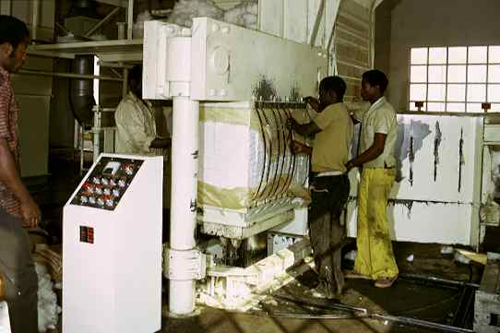
OVERVIEW
The agriculture-industrial sector, due to its productivity, contributed to place Angola among the most self-sufficient countries in basic products in the period of time before independence. It is a sector that simply doesn’t work, because agriculture has stopped supplying the essential raw materials.
OILS AND SOAPS
The sub-sector of oils and margarines comprises three units, whose production reached about 12.000 and 7.000 tonnes/year of vegetable oil, as well as 6.000 and 2.000 margarine tonnes/year in 1989 and 1992 respectively.
MILLING INDUSTRY (CORN, CASSAVA AND WHEAT FLOUR)
The sub-branch of bakeries (wheat) is responsible for 382.320 tonnes of the production, corresponding approximately to 80.5% of the total. However, to archive this bread production, the consumption of wheat flour is estimated at about 337.500 tonnes, of which 72.00 tonnes could be produced in the country.
This means that the remaining 265.500 tonnes have to be imported due to the weak capacity of local processing.
Cassava flour is produced in the informal sector through small mills and the production capacity is fairly insignificant. All the existing milling industries are under administration contracts and will soon be privatised.

SUGAR INDUSTRY
With the occupation of an area of about 13.800 hectares of sugarcane, Angola possessed four factories that produced about 110.000 tonnes/year, in 1985, having reached the historical value of 70.000 tonnes of commercial sugar in 1974.
TEXTILE INDUSTRY
The textile industry includes all the activities connected with cotton for clothing, and of cottonseed for the industry of foodstuffs (oils and fats).
