HOW TO INVEST IN ANGOLA - NATIONAL PRIVATE INVESTMENT AGENCY – ANIP
BUSINESS OPPORTUNITIES

THE CONSTRUCTION AND INFRASTRUCTURE SECTORS
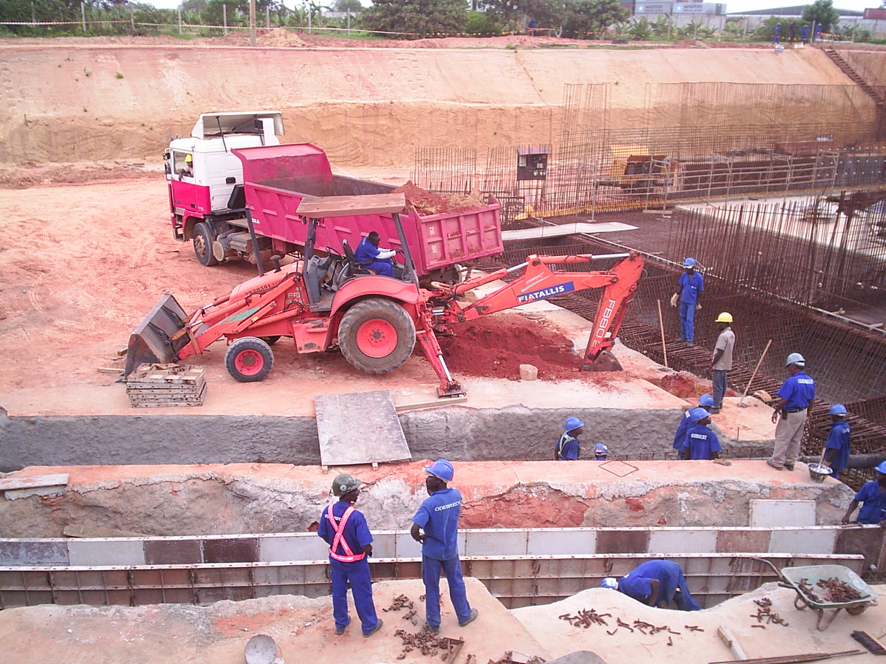
OVERVIEW
There is an urgent need for construction or rehabilitation of roads, houses, schools and industry.
Shortage of housing is a chronic problem that has led to widespread slum development particularly in and around the capital, Luanda, a city built to sustain a population of 700,000 and now home to around 4 million people.
MAIN PLAYERS:
• Portuguese companies are well established in Angola's construction sector, the major players are Soares da Costa, Teixeira Duarte, and Mota & Ca. These companies have the greatest share of the market construction contracts;
• The Brazilian Odebrecht group, already present in Angola in other areas for several years, has been positioning itself in the construction sector and is already winning contracts
• Dar Consultants (UK) Ltd, part of the Dar al-Handasah Group, and a member of the BCCB, is the government's favoured consultant on project construction and design.

HOW TO INVEST IN ANGOLA - NATIONAL PRIVATE INVESTMENT AGENCY – ANIP
CONSTRUCTION MATERIALS:
With very little in the way of domestic materials production, construction companies in Angola currently have to import most of their own materials and equipment

INFRASTRUCTURES:
• Almost the entire road network, both primary and secondary, is in poor or very poor condition;
• Port infrastructures are operating below capacity because of obsolete equipment and outdated working practices;
• Less than 5% of the railway system is currently operational;
• The main airports require considerable upgrading and/or repairs;
• The urban water supply and drainage systems currently reach only a small proportion of the population, and the existing systems are in poor condition;
• The rural environment lacks infrastructure to support production and transportation;
• The housing stock is highly degraded and falls well short of demand. The challenge is to address this, and to cope with a population growth of 7% per year;
• The construction and construction materials market is in its infancy and therefore undeveloped.
• There is insufficient monitoring and quality control. Materials and know how are in short supply.
HOUSING PROJECTS:
• Luanda Sul Self-financed Urban Infrastructure Programme
This is a major new housing project to provide houses for 5,000 families, with supporting infrastructure, at a new site 20 kms to the south of Luanda.
HOW TO INVEST IN ANGOLA - NATIONAL PRIVATE INVESTMENT AGENCY – ANIP
• Nova Vida
This US$100m project will provide 2,448 housing units (flats and houses) on a 26 square km site located 18 kms south of Luanda airport.
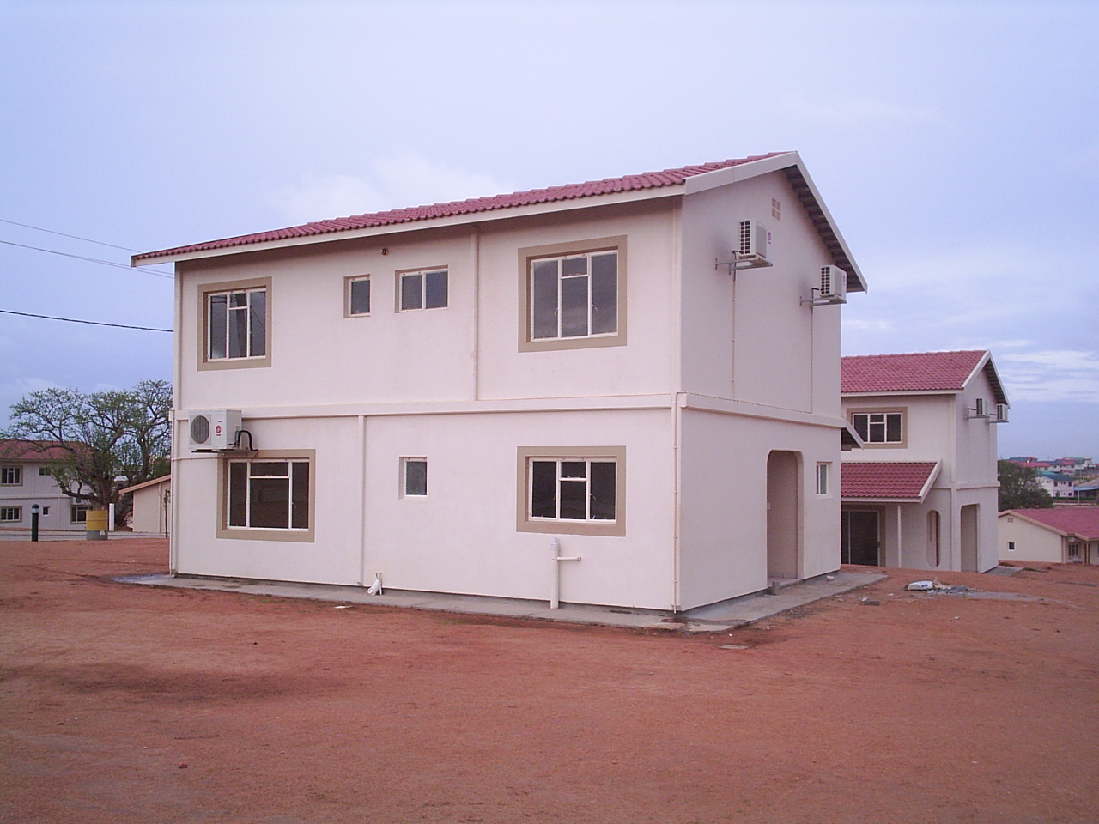

• Agostinho Neto University development
Work on stage one of the US$ 108.5m construction of the Luanda University campus. The campus is part of the state-run Agostinho Neto University, the country's only public higher education institution.
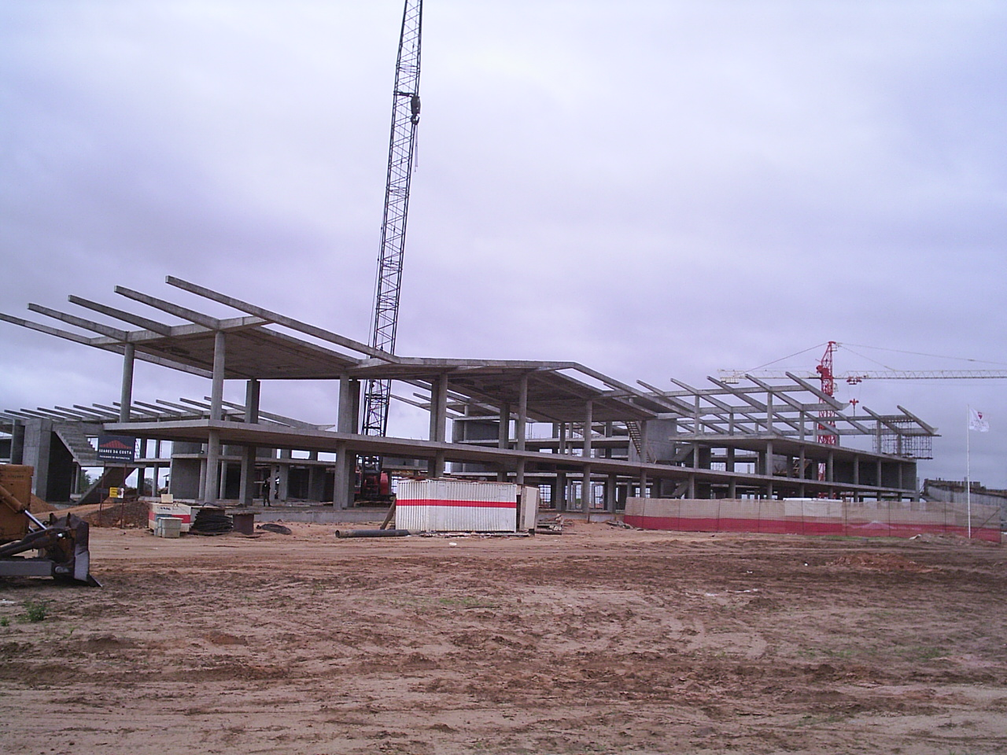
HOW TO INVEST IN ANGOLA - NATIONAL PRIVATE INVESTMENT AGENCY – ANIP
PROSPECTS:
• Estimates obtained from government sources indicate that the cost of implementing the strategic construction and public works programme is around US$9.9 billion over the ten year period 2000-2009, which implies an annual expenditure of US$990 million, equivalent to 11% of the country's GDP;
• Of the above US$9.9 billion, rehabilitation of the transportation infrastructure (roads, railways, bridges, airports) would consume more than half of the total at US$5.3 billion, with the remaining US$4.6 billion spent on social infrastructure projects such as schools, education, housing, urbanisation.

