HOW TO INVEST IN ANGOLA - NATIONAL PRIVATE INVESTMENT AGENCY – ANIP
THE OIL SECTOR
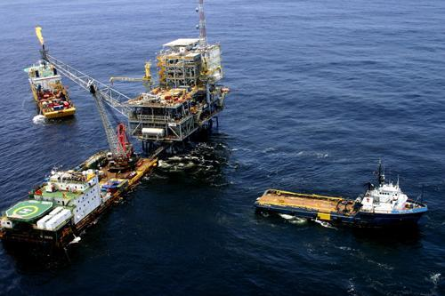
OVERVIEW
Angola is one of the major oil producing countries of Africa. After Nigeria, is the most significant producer in Sub-Saharan Africa with more than 1 million barrels per day. The crude oil production is expected to reach nearly 2 million barrels per day in 2008.

The Refinery Project
Much of the crude oil produced in Angola is of light sweet quality and can be marketed to refiners around the world. However, a significant portion of the new crude production in few years is expected to be heavy and acidic Kuito and Dalia. Due to the properties of these crude, they will have to be processed in a reside upgrading refinery which has appropriate metallurgy.
In order to monetize such crude to the maximum extent possible, the Angolan Government is proposing to develop a new refinery capable of processing this heavy acidic crude.
Preliminary studies show that the utilization of this kind of heavy acidic crude oil enhances the Refinery Project profitability.
Currently, there is a 57,500 barrels per stream day (BPSD) refining capacity in Angola. The major refinery, having a capacity of 45,000 BPSD, is in Luanda, operated by TotalFinaElf and partially fulfils the demand for refined products in Angola.
Malongo refinery, located in Cabinda province has an approximate capacity of 12,500 BPSD and is essentially used to support the oil activities in the region.
These refineries are not capable of processing the heavy acidic crude such as Kuito and Dalia. The capacity of the new refinery project is of 200,000 barrels per day.
The Sociedade Nacional de Combustíveis de Angola, Empresa Pública (SONANGOL E.P.), principal promoter of the project, was created in 1976 as the national oil company of Angola, It is 100% owned by the State and serves as the business arm of the Angolan Government, being responsible for coordinating and controlling all petroleum activities.
In this capacity, SONANGOL E.P. is currently leading the development activities for the New Refinery Project.
The Angolan LNG Project
Along with oil production, around 1.2 BSCFD of associated gas is produced of which, 60% is flared.
Flaring of associated gas represent a significant economic loss and combustion products make a major contribution to environment damage.
A major project will be implemented to reverse the current situation.
The Angolan LNG Project will:
• Facilitate fields development without flaring of the associated gas.
• Generate revenues from a resource that used to be considered as a by – product in Petroleum operations.
• Allow Sonangol to enter to a new business area.
• Be an anchor project for future opportunities in gas utilization and industrial development.
• Generate new jobs opportunities for nationals.

