HOW TO INVEST IN ANGOLA - NATIONAL PRIVATE INVESTMENT AGENCY – ANIP
THE TELECOMMUNICATIONS SECTOR

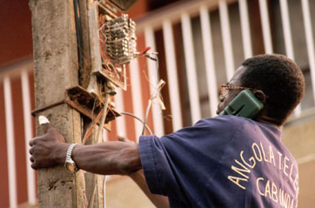
OVERVIEW
Fixed Telephone Market:
• Nation-wide the latent demand of fixed telephone is estimated at more than 500.000;
• In ten cities there are a total of only 291 public telephone boxes;
• Angola Telecom was the only player in the fixed telephony market. Two private firms were licensed: Telesel and Wezacom;
• Wezacom started operating with 5,000 lines, serving Luanda and Benguela with an initial investment of US$8,3 million;
• Telesel started operating with 12,000 lines, with an initial investment of US$2,26 million, initially in Luanda;
• Angola is a partner in the SA T3 that will link Africa to Portugal, which has cost Angola $ 24 million USD.

Mobile Telephone:
• There are currently only some 100,000 subscribers and the estimated demand is for double that number;
• Angola Telecom (Movicel) has 40% of the market, UNITEL the balance;
• Angola Telecom uses both analogue AMPS and digital CDMA systems and UNITEL uses GSM technology.
Satellite:
• Given the size of Angola and the destruction wrought by war, satellite is a logical transmission means. Angosat, which uses space rented from Intelsat in IS 605 located in the geostationary orbit 332.E AOR, provides this means, using 18 earth stations;
About 90% of the Angosat traffic is for Luanda. The rest of the traffic is Inter-provincial that requires a double hop via Luanda
Foreign Involvement:
• Italy granted US$20 million for telecommunications projects in Kwanza Sul, China for projects in Huila, Namibe and Lunda Norte, Japan through Sumitomo and Commuture Corporation;
• On the 16th Apri1 2003, Angola Telecom launched 10.600 new telephone lines in Luanda a project funded by Japan.
Internet Service Providers (lSPs):
• Internet services begin in Angola in 1996 when Pacomm was licensed to install the EBONET network. Now there are nine licensed ISPs, although only three are active. As well as EBONET, Sistec started Netangola in 1997 and NCR started Snet in 1998;
• Further development of internet facilities in Angola needs significant investment;
• Total national market is estimated at 25,000 subscribers in 2002.
THE MARKET & REGULATORY AUTHORITY
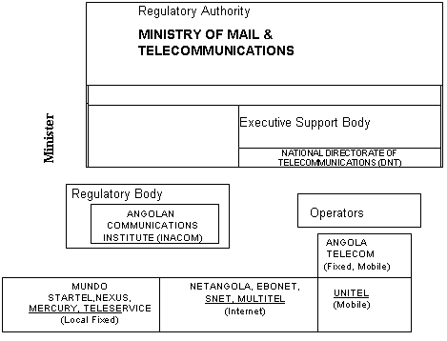
LEGAL FRAMEWORK
PURPOSE | REFERENCE Nº |  | COMMENTS
Law Defining Scope of Business Sectors | Law Nº5/02 of 16 /3 |  | Maintains basic network as absolute reserve only, enabling competition as far as services are concerned, including basic service as an extension of the basic network at a local level.
Basic Telecommunications Law | Law Nº 8/01 of 11/5 |  | Lays the groundwork for sector’s liberalization.
Regulating Access to Provision of Telecommunications  Services | Decree Nº 44/02 of 6/9 |  | Regulates liberalization of sector provided for in the higher-ranking laws, especially Basic Law.
Regulating Public Telecom-munications Services | Decree Nº 45/02 of 10/9 |  | Establishes rights and obligations for operators and users
Basic Private Investment Law | Law Nº 11/03 of 13/05 | 6.00%  All local administrative authorities
Privatization Law | Law Nº 10/94 of 31 of August | Reformulated by Law Nº 8/03 of 18/4, Law Amending Privatization Law.
PENETRATION OF SERVICES
 | SERVICE
 | FIXED |  | MOBILE |  | INTERNET
 | 2003 | 2005 | 2003 | 2005 | 2003 | 2005
LUANDA | X | X | X | X | X | X
BENGUELA | X | X | X | X | X | X
HUILA | X | X | X | X | X | X
HUAMBO | X | X | X | X |  | X
BIÉ | X | X |  | X |  | X
MALANGE | X | X |  | X |  | X
KUANZA SUL | X | X |  | X |  | X
HUIGE | X | X |  | X |  | X
KUANZA NORTE | X | X |  | X |  | X
BENGO | X | X | X | X |  | X
LUNDA NORTE | X | X |  | X |  | X
MOXICO | X | X |  | X |  | X
NAMIBE | X | X | X | X |  | X
CUNENE | X | X | X | X |  | X
KUANDO KUBANGO | X | X |  | X |  | X
LUNDA SUL | X | X |  | X |  | X
CABINDA | X | X | X | X | X | X
ZAIRE | X | X | X | X |  | X

NETWORK DEVELOPMENT PLAN (2001 - 2015)
Transmission Backbone (SDH):
• Fiber Optic: Main routing;
• Hertzian Beams: Secondary routing;
• Satellite: Remote and tertiary zones.

Switching (migration to NGN)
• Voice underpinned by TDM and IP;
• Data underpinned by IP;
• Circuits rented to corporate entities.

Inter-municipal and rural network
• VSAT – Independent of backbone;
• Local switching via PABX;
• Local network with FWA.

Access network
• Primary network in fiber optic;
• Secondary network in copper;
• Peri-urban network : Wireless Local Loop.

FIXED SERVICES DEVELOPMENT PROGRAM
Year | Population | Teledensity | Lines to Installed | Investment  (1000 USD)
2001 | 15,068,242 | 0.47% | 3,345 | 8,363
2002 | 15,549,371 | 0.47% | 3,511 | 8,778
2003 | 16,045,862 | 0.53% | 1,106 | 27,658
2004 | 16,558,207 | 0.59% | 12,721 | 31,803
2005 | 17,086,910 | 0.80% | 39,013 | 97,533
Up to 2010 | 19,994,692 | 2.52% | 310,162 | 775,405
Up to 2015 | 23,397,309 | 5.45% | 545,139 | 1,362,848
Total |  |  | 924,954 | 2,312,388
Average annual investment |  |  |  | 154,159
Average investment per line |  |  |  | 2,500

BASIC NETWORK DEVELOPMENT PROGRAM 2004 - 2008
INTEGRATED NETWORK
ACCESS NETWORK | SWITCHING | LONG-DISTANCE TRANSMISSION
ACCESS NETWORK | SWITCHING | RELAY | DEFINITIVE (BACKBONE)
In copper or wireless (WLL)  NB: Must be executed simultaneously with switching | TDM and NGN  Must be executed simultaneously with access networks | System complemented by Satellite:  -F2 land stations for provincial capitalsVSATs DAMA or other systems for local authorities. | Backbone in fiber optic
Vital aspect: Ensure financing for whole program

BASIC NETWORK DEVELOPMENT PROGRAM 2004 - 2008
BENCHMARK COSTS (USD)
ACCESS NETWORK | SWITCHING | LONG-DISTANCE TRANSMISSION |  | BUDGET FOR SERVICES
ACCESS NETWORK | SWITCHING | RELAY | BACKBONE | BUDGET FOR SERVICES
Underpinned by Backbone:  150,000 Lines  150,000 ∗ 1,500 = 225 million USD |  | F2 Land Stations  USD 6 million  VSATs Terminals  USD 15 million | 8,000 Km in Fiber Optic  8,000 ∗ 20,000 = 160 million USD | Consultants 16.24 million  Training 2.03 million  Tech. Assist. 3.045 million
BENCHMARK COSTS (USD)
225 million |  | 21million | 160 million | 21.315 million
TOTAL: 427.315 million

SAT3/WASC/SAFE PROJECT
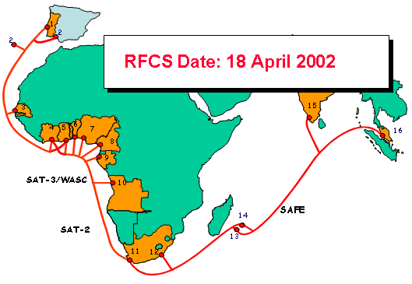 |  | Landing Points  1. Portugal  2. Spain/Canary Is.  3. Senegal  4. Côte d'Ivoire  5. Ghana  6. Benin  7. Nigeria  8. Cameroon  9. Gabon  10. Angola  11. South Africa (1)  12. South Africa (2)  13. Reunion  14. Mauritius  15. Malaysia

