HOW TO INVEST IN ANGOLA - NATIONAL PRIVATE INVESTMENT AGENCY – ANIP
THE TRANSPORTATION SECTOR

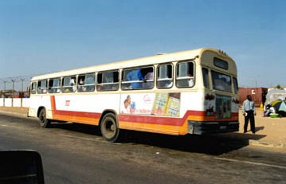
OVERVIEW
In every economy, the transportation infrastructure and transportation system itself, incorporating the road, rail, aviation and shipping components as a whole, constitute the core sector underpinning any development process.

CURRENT SITUATION:

• Destruction of a large part of infrastructure because of the war;
• Deterioration of infrastructure due to lack of maintenance;
• Technically out-of-date;
• Destruction and ageing of fleet;
• Weak maintenance structure;
• Low level of professional qualification.

STRATEGY:

• Construction of an integrated transportation network;
• Introduction of a role for privatization, so that resources managed by the State can be transferred to the private sector;
• Integration of Angolan transportation network into the SADC network;

• Creation of authorities on an institutional level for the planning of the road network;

• Creation of Public Institutes as regulatory bodies for different transportation subsectors .

POLICY:

• Be guided by the principle of “less State, a better State”;
• Open up corporate sector areas that, up until now, have remained the reserve of the State or of the state public sector;
• Lay groundwork for private capital to play a part in the sector.

OBJECTIVES:

• Guarantee the integrated functioning of all modes of transportation;
• Guarantee a suitable system of urban transportation in the principal cities, especially Luanda;
• Develop the 3 main corridors originating from ports by regenerating the CFL, CFB and CFM (rail companies);

• Revamp the shipping sector, bringing in private enterprise and an adequate administration to re-establish the competitiveness of national companies;
• Revamp and modernize ports : Luanda, Lobito, Namibe, Cabinda, Soyo and Porto Aboim;
• Modernize current air transportation system;
• Institutional reorganization and strengthening.

AREAS OF INVESTMENT – ROAD TRANSPORTATION:

• Liberalized activity
• Tax incentives exist for investments in:
o Urban public transportation (heavy);
o Inter-provincial and inter-municipal passenger transportation (heavy);
o Medium and long haul transportation of goods (intermediate and heavy);
• The implementation of incentives for investment in a personalized taxi system is being studied.

AREAS OF INVESTMENT – RAILWAYS:

• State ownership and operation, through the CFL, CFB and CFM (rail companies);
• Marked degradation of infrastructure and rolling stock;
• Constitute a priority for the Angolan Government;
• Area open to private investment in the concession process, arranging of funds, technical assistance and repairs, and supply of rolling stock, communications, etc.

• The government has approved a preliminary study, titled “ANGO FERRO”, to refurbish, upgrade, construct and extend the whole of Angola’s rail network, the implementation of which will be put in place in 4 phases:
I. Regeneration of current network;
II. Upgrading of network, bringing it into line with SADC and international standards;
III. Inter-connection of the different railways in Angola;
IV. Construction of new line, extension and link to neighboring States.

Angola: Current Railway Network

INCLUDEPICTURE "cid:007901c55a62$ad6c2dd0$6601a8c0@cp683548a" \* MERGEFORMATINET SHAPE \* MERGEFORMAT 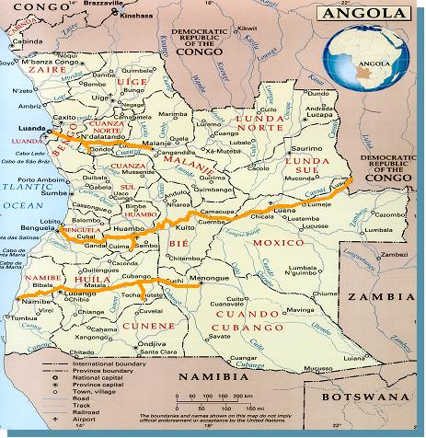 INCLUDEPICTURE "cid:007a01c55a62$ad6f3b10$6601a8c0@cp683548a" \* MERGEFORMATINET The Ango-Ferro Project (Phases)
INCLUDEPICTURE "cid:007b01c55a62$ad724850$6601a8c0@cp683548a" \* MERGEFORMATINET 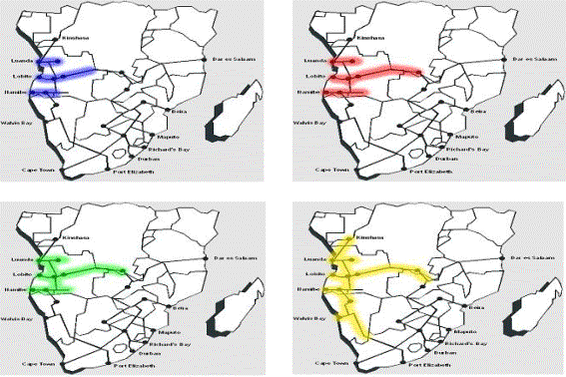 INCLUDEPICTURE "cid:007c01c55a62$ad724850$6601a8c0@cp683548a" \* MERGEFORMATINET 

AREAS OF INVESTMENT – DEVELOPMENT CORRIDORS:
• Malange, Lobito and Namibe;
• It is the government’s view that the 3 corridors warrant the same degree of priority and constitute an open area in which both public and private investment can operate, since they act as a support for the development of the national economy, access to the sea for land-locked countries, and stimulate regional development;

INCLUDEPICTURE "cid:007d01c55a62$ad73cef0$6601a8c0@cp683548a" \* MERGEFORMATINET SHAPE \* MERGEFORMAT 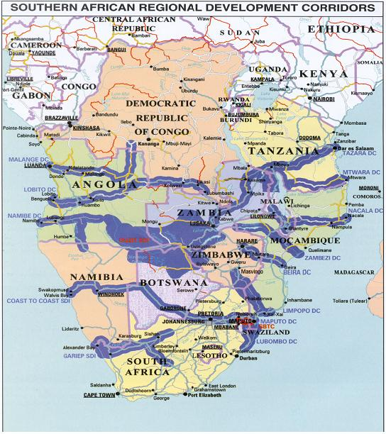 INCLUDEPICTURE "cid:007e01c55a62$ad755590$6601a8c0@cp683548a" \* MERGEFORMATINET 

AREAS OF INVESTMENT – PORTS

• Port system: Luanda, Lobito, Namibe, Cabinda, Soyo and Porto Amboim;
• Independent commercial companies;
• Leasing port: - Luanda;
• Operating port: - Lobito, Namibe, Cabinda, Soyo and Porto Amboim;
Area open to private investment in the concession process, arranging of funds, technical assistance, supply of equipment, communications, etc.

AREAS OF INVESTMENT – SHIPPING:
• Both coastal shipping and international maritime transportation in Angola are liberalized activities.

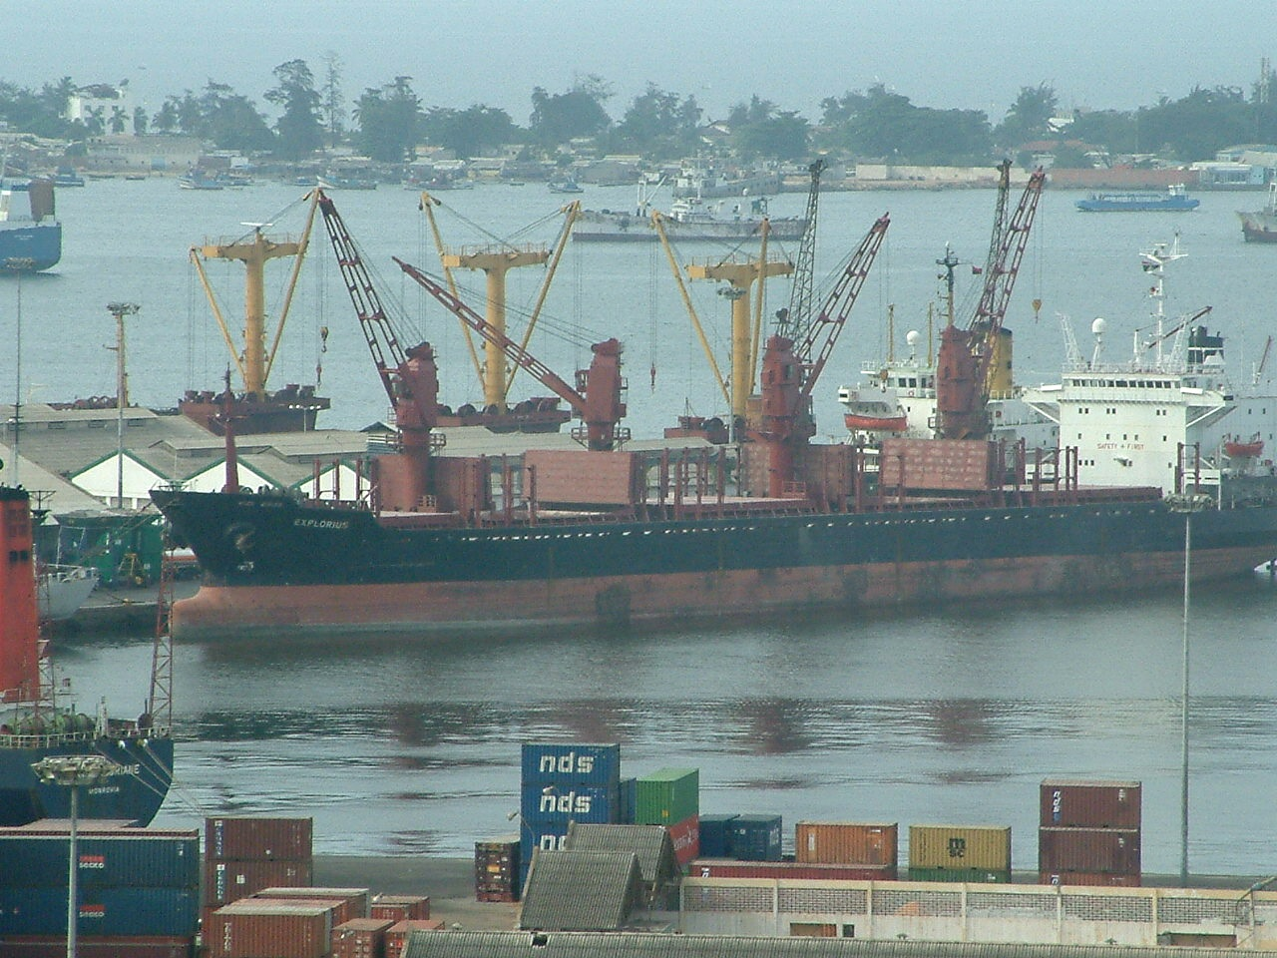

AREAS OF INVESTMENT – AVIATION

• Liberalized activity for domestic aviation;
• International air transportation is an activity conditioned by the exercise of traffic rights to be negotiated with the national flag-carrier.

In both cases ground services can be operated by private companies

AREAS OF INVESTMENT – AIRPORTS

• Airport infrastructures are the absolute reserve of the State and are operated by by Empresa Nacional de Navegação Aérea (ENANA);
• Private investment is possible in the infrastructure-refurbishment process and provision of services.

PROJECTS:

• Increase road-transportation capacity;
• Refurbishment of Luanda Railway (CFL);
• Refurbishment of Benguela Railway (CFB);
• Refurbishment of Moçâmedes Railway (CFM);
• Implementation of the SITLOB Project;
• Refurbishment of the Port of Lobito;
• Refurbishment of the Port of Namibe;
• Refurbishment of the Port of Amboim;
• Refurbishment of the Port of Soyo;
• Construction of Viana Dry Dock;
• Acquisition of Marine Navigational Aid equipment;
• Regeneration of aeronautical infrastructure;

• Acquisition of Aviation Navigational Aid equipment;

• Professional training

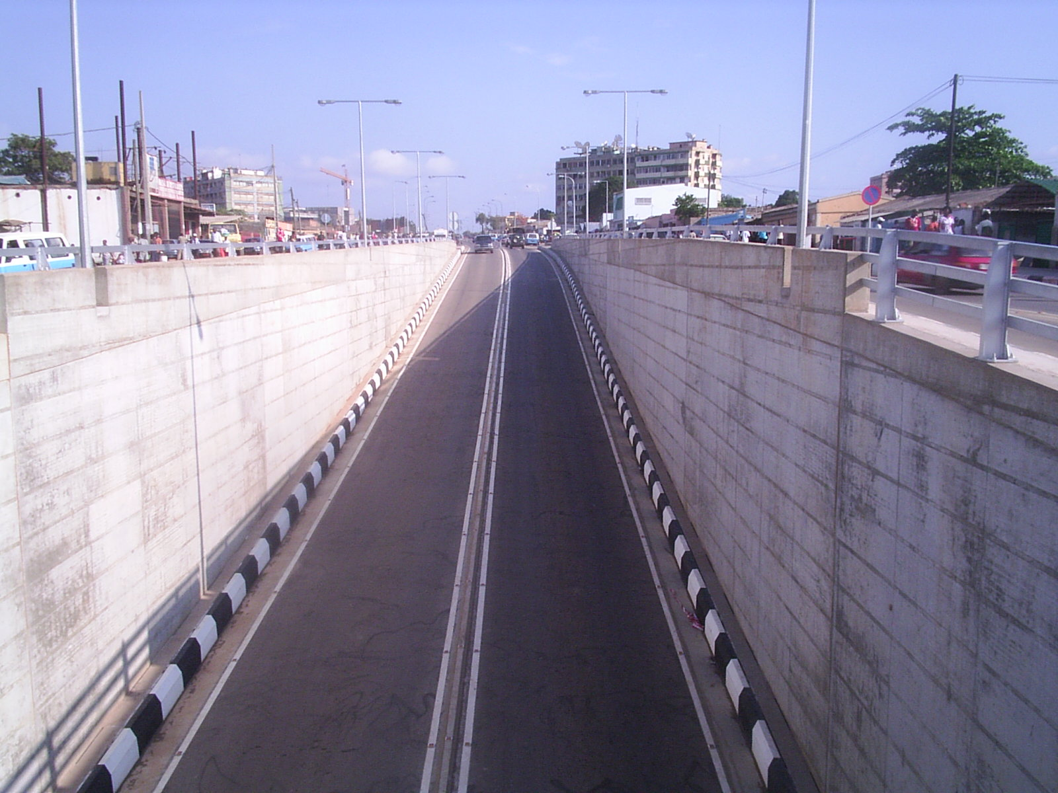

CONCLUSION:

The transportation sector considers private enterprise to be its strategic partner, which it can look to in helping with the regeneration, upgrade and expansion process of its infrastructure and services.

