HOW TO INVEST IN ANGOLA - NATIONAL PRIVATE INVESTMENT AGENCY – ANIP
TOURISM, HOSPITALITY AND SERVICES
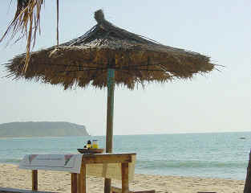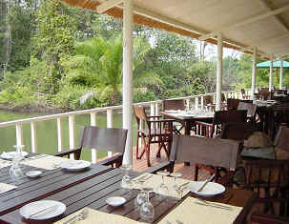
TOURISM
Angola is potentially a country ripe for the development of the tourism sector, offering the following:
• 1,650 km. of coastline, a long summer season and beautiful, natural sandy-beaches with excellent conditions for swimming and water sports;
• Rich and varied fauna with a system of parks and natural reservations;
• Fantastically beautiful, poster-inspiring, landscapes boasting mountains and waterfalls;
• Rivers with waterfalls, rapids, and lakes - some navigable.
National game parks and natural reserves constitute hubs of attraction for investment.
PROTECTED AREAS IN ANGOLA
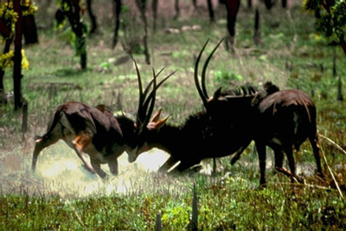
NATIONAL PARKS & NATURAL RESERVES
NAME  Quissama National Park  Bikuar National Park  Kangandala National Park  Iona National Park  Kameia National Park  Mupa National Park  Chimalavera Nat. Park  Luando Natural Reserve  Ilhéu Natural Bird Reserve  Moçâmedes Natural Reserve  Mavinga Natural Reserve  Luiana Natural Reserve  Bufalo Natural Reserve | PROVINCE  Bengo  Malange  Huíla  Namibe  Moxico  Cunene  Benguela  Malange/Bié  Luanda  Namibe  Kuando Kubango  Kuando Kubango  Benguela | AREA (KM²)  9,960  630  7,900  15,150  14,450  6,600  100  8,280  2  4,450  5,950  8,400  400 | MAIN SPECIES  Manatee, Red Palanca, Pacaça  Black Giant Palanca, Red Palanca  Elephant, Buffalo  Zebras, Guelengue, Lion, Ostrich  Cacu, Boi-Cavalo  Giraffe, Cahoma  Cabra de Leque  Black Giant Palanca  Migratory Birds  Ostrich, Cabra de Leque  Elephants, Palanca, Southwestern Palanca  Elephants, Palanca.  Southwestern P., Rhino, Black Bufalo

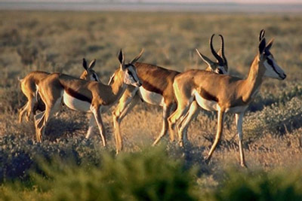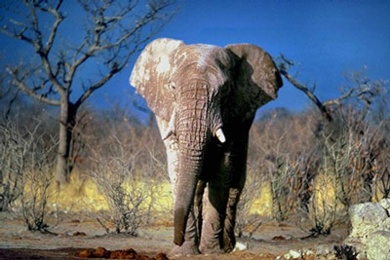

HOSPITALITY
About 50% of the hospitality sector’s infrastructure needs to be revamped. Of 105 hotels of varying categories, less than half of it are active, and even so, these are all located along the country’s coastal areas.
SERVICES
Services present exciting prospects, since trade and tourism are expanding. The transportation and communication sectors point to high potential, while banking and insurance began coming to the fore, especially after 1991.
- In 2005, 12 banks were in existence, of which six were private ones. Three of them are foreign banks;
- Two Investment Funds, FDES which is a development Fund and FIPA, the first venture Capital Fund in Angola;
- Two insurance companies operates - Empresa Nacional de Seguros de Angola ENSA and Angola Agora e Amanhã – AAA. The state monopoly ended in 2000 by law 1/00 of 3rd of February 2000;
Ensuring the availability of essential consumer goods, hindered by low national production, calls for the setting up and development of a solid commercial structure, integrating the production, import, transportation, and distribution segments.

